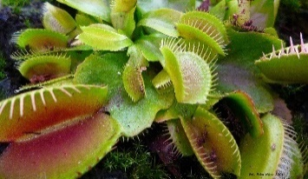


Peculiar Plants

Science
History
Geography
KNOWLEDGE FOCUS
Science

Here We Grow

 | Writing |  | Final Piece | Writing |  | Final Piece | Celebration:  Eat DT food together- picnic
Launch/Hook:  Short clip on peculiar plants. | P- inform  A- KS1  T- explanation  F- posters | Explicit Objectives:  conjunctions for cause and effect  - adverbs and adverbials for time  - prepositions | An explanation linked with the theme | P- write a narrative  A- Peers  T- narrative  F- story | Explicit Objectives:  -complex sentences with main and subordinate clauses  -inverted commas for dialogue  -paragraphs | A mystery, adventure or fantasy story | Celebration:  Eat DT food together- picnic
Maths Units:  Identify compare & order fractions; Non-unit fractions; Add & subtract fractions | Science - Working Scientifically  Reporting on findings from enquiries, using relevant scientific language, including oral and written explanations, displays or presentations of results and conclusions.  Taking accurate measurements using standard units, using a range of equipment, including thermometers and data loggers.  Identifying differences, patterns, similarities or changes related to simple scientific ideas and processes.  Plants  Identify and describe the functions of different parts of flowering plants: roots, stem/trunk, leaves and flowers.  Explore the requirements of plants for life and growth (air, light, water, nutrients from soil and room to grow) and how they vary from plant to plant.  Investigate the way in which water is transported within plants.  Explore the part that flowers play in the life cycle of flowering plants, including pollination, seed formation and seed dispersal.  Know that plants make their own food. |  |  |  |  |  | End Point Enquiry Question:  How we can we design an experiment to study what plants require for growth?
Enrichment Activities:
See menu
Text Drivers | Visits/Visitors | PSHE Day
The Secret Sky Garden  Peculiar Plants | Manchester Museum, Synagogue & Sing Fest | Tunnicliffe & Sports Week
DT
Cooking and Nutrition (Quiche and Coleslaw)

RE
Spirituality
How do music and silence express beliefs?
COMPUTING
Spreadsheets

PE
Athletics
Tri-Golf

MFL

Ice Creams
MUSIC
Sing Fest practice
Planet Exploration

