Vocabulary | Definition
Roots | Anchor the plant in the ground and absorb water and nutrients from the soil.
Stem | Transports water and nutrients to different parts of the plant.
Leaves | The place where photosynthesis takes place.
Petal | The separate leaves that form the outside part of a flower head and usually attract insects.
Flower | The part of a plant which allows it to reproduce.
Pollen | The product of a male part of a plant which allows it to produce seeds.
Nutrient | A substance that provides nourishment for growth. All living things need nutrition.
Pollination | The process by which pollen is transferred to the female parts of the plant which means the plants can make seeds and reproduce.
Evaporation | When a liquid turns to gas
Seed dispersal | The movement or transport of seeds away from the parent plant.
Photosynthesis | The process by which green plants use the sun’s energy from sunlight along with water and carbon dioxide to produce their own food in the form of glucose (sugar).

YEAR 3 KNOWLEDGE ORGANISER
Science - Plants
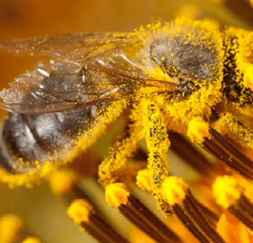
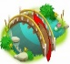What I should already know
- Seeds and bulbs grow into mature plants in the right conditions

- Plants need water, light and a suitable temperature to grow and stay healthy.

- Plants make their own food in their leaves using sunlight
Birds and insects play an important role in helping pollinate plants and dispersing their seeds, far and wide, so that young plants can grow strong.

