Year 3
Ancient Egyptians Enrichment Optional Activities
Pupils may choose to complete one or more activities from the grid below. We will celebrate any work brought in to share with the class over the course of the term.
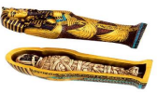  Design and make a tomb or coffin for an Egyptian mummy. | 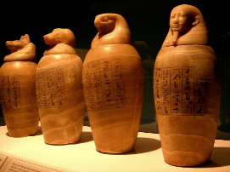  Create a Canopic jar | 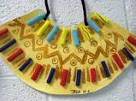  Design a piece of Egyptian jewellery.
  Research modern Egypt and create a travel brochure, advertising things to do there. | 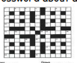  Create a wordsearch or crossword puzzle with an ancient Egyptian theme. | 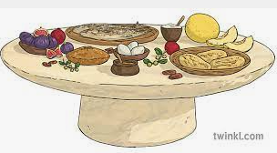  Find and make an Egyptian recipe.
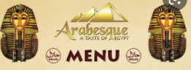  Write a menu for an Egyptian feast. | 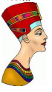  Write a fact file on a pharaoh. You may present this on paper or use your I.C.T. skills. | 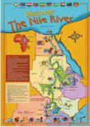  Design a fact file or poster about the River Nile.
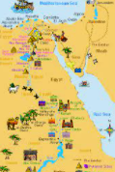  Draw a map or create a collage map of Egypt, showing important landmarks. | 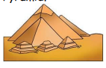  Build a pyramid | 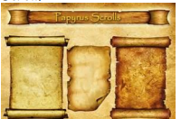  Make a papyrus scroll and write a message on it.

