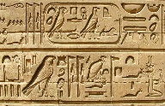
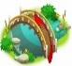
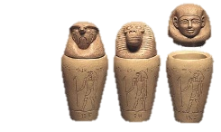
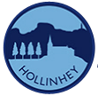
YEAR 3 KNOWLEDGE ORGANISER
History – Ancient Egyptians
Ancient Egyptians
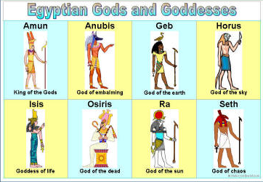
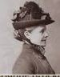
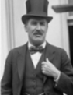
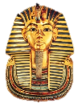
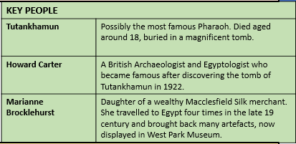
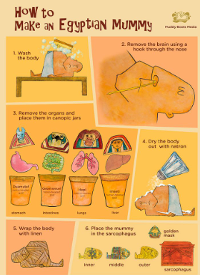
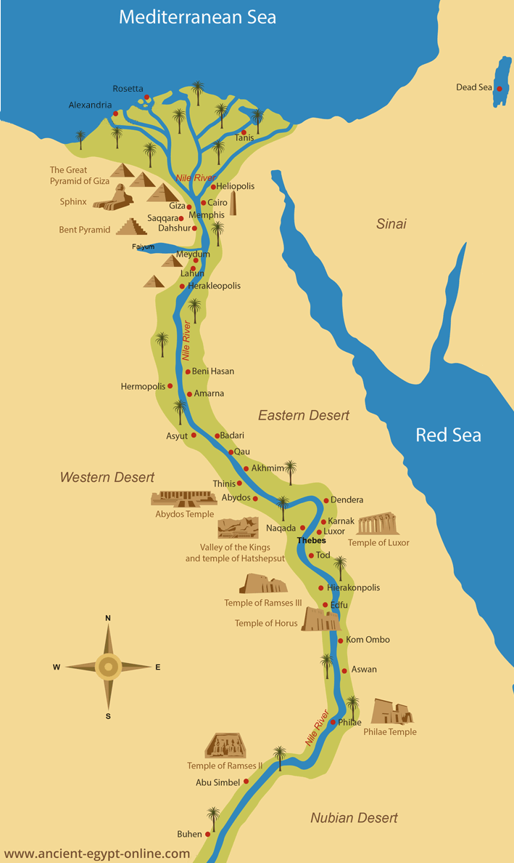
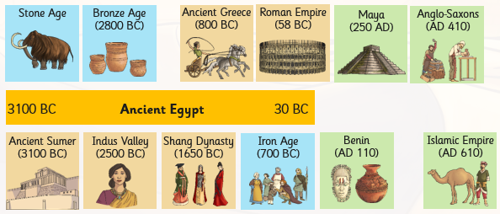
Term | Definition
Afterlife | The place where Egyptians believed they would go after they died.
Canopic jars | Special jars that held the organs of a mummy including the lungs, intestines, liver and stomach (above).
Egyptologist | An archaeologist who focusses Ancient Egypt. Howard Carter discovered Tutankhamun’s tomb.
Hieroglyphics | A type of writing that used a combination of pictures and symbols (above).
Mummification | The process of preserving a body after death in preparation for the afterlife.
Papyrus | A plant that grew on the banks of the Nile. It was used as an early version of paper.
Pharaoh | The supreme ruler of all of Ancient Egypt. The most important person in the Kingdom.
Sarcophagus | A large stone box that held a mummy’s coffin. Often richly decorated for Pharaohs.
Pyramid | Huge stone monument built as a tomb to bury the Pharaohs.

Prior Learning

Egypt is a country in the continent of Africa.
What life was like in Stone Age Britain
What life was like in Bronze Age Britain
What life was like in Iron Age Britain
The River Nile flows through the continent
of Africa.

It is the longest river in the world.

