Science Knowledge Organiser – Year 2 – Summer 1 Would You Like To Be A Zoologist?
What should I already know? |  | Key Vocabulary  Key Diagrams – examples of food chains  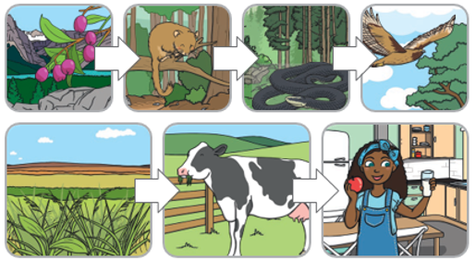
  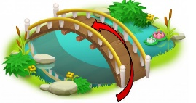
  Identify and name a variety of common wild and garden plants, including deciduous and evergreen trees.
  • Identify and describe the basic structure of a variety of common flowering plants, including trees.
  • Identify and name a variety of common animals including fish, amphibians, reptiles, birds and mammals.
  • Identify and name a variety of common animals that are carnivores, herbivores and omnivores.
  • Describe and compare the structure of a variety of common animals (fish, amphibians, reptiles, birds and mammals, including pets).
  • Observe changes across the four seasons.
  basic needs | Things we need to stay healthy like food, water, and shelter.
  dead | When something no longer lives.
  feed | Giving food to help someone or something grow.
  food | What we eat to get energy and grow.
  food chain | Shows what eats what in nature.
  living | When something is alive and can grow.
  move | Changing position or going from one place to another.
  never been alive | Things that have never lived, like rocks or water.
  shelter | A safe place to protect from weather or danger.
  suitable | Right or good for something.
  suited | Matching or fitting well.
Key Knowledge
All objects are either living, dead or have never been alive. Living things are plants (including seeds) and animals. Dead things include dead animals and plants and parts of plants and animals that are no longer attached e.g. leaves and twigs, shells, fur, hair and feathers.
An object made of wood is classed as dead. Objects made of rock, metal and plastic have never been alive.
Animals and plants live in a habitat to which they are suited. This means that animals have suitable features that help them move and find food. Plants have suitable features that help them to grow well. The habitat provides the basic needs of the animals and plants – shelter, food and water.
Within a habitat there are different micro-habitats e.g. in a woodland – in the leaf litter, on the bark of trees, on the leaves. These micro-habitats have different conditions e.g. light or dark, damp or dry. These conditions affect which plants and animals live there. The plants and animals in a habitat depend on each other for food and shelter etc. The way that animals obtain their food from plants and other animals can be shown in a food chain.

