Knowledge Organiser: Summer 1
Magic Garden
Key Vocabulary | Key Images
Root - The part of a plant that grows underground.  Flower – the part of a plant that is often brightly coloured and grows at the end of the stem.  Stem – the thin, upright part of a plant on which the flowers and leaves grow.  Leaf/leaves – the part of a tree or plant that are flat, thin and usually green. | Parts of a plant and parts of a tree  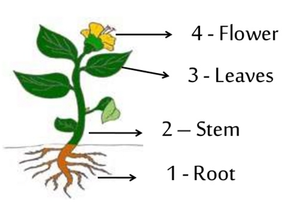  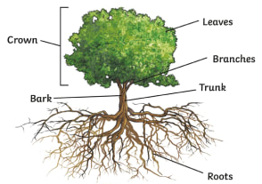
Prior Knowledge
Plants can grow.
Some experience of planting and seeing plants in area.
Key Knowledge
