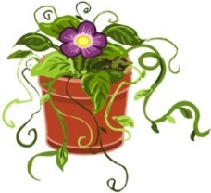
Year 1 ‘Magic Garden’ Enrichment Tasks

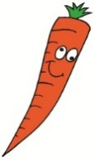  Make a feely bag of different fruit and vegetables. Can you guess what they are without peeking? | Go on a Wild Flower Hunt and make a list of what different flowers you find.  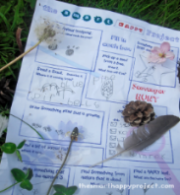 | Collect fruit and vegetable packaging that shows the country that the food comes from. Look at the world map - can you find the countries?  
Create a quiz all about flowers, plants and trees.  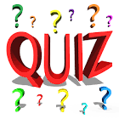 | 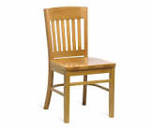  Look around your house and see how many things you can find that are made from trees or plants. Draw the things you find and label them. | Create a piece of artwork of a flower, plant or tree.  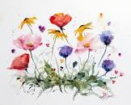
Write about why trees are so important in our world.  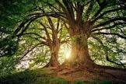 | Create an acrostic poem with the word… flower.  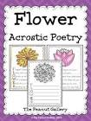 | Go on a local walk and take photographs of flowers, plants and trees that you see.  
Weekly phonics homework will continue to be set on Spelling Shed and a worksheet of either English or Maths in the yellow file.

