Key Knowledge
The story of ‘The Very Hungry Caterpillar is over 50 years’ old.
A Caterpillar can stay in a chrysalis between 5 and 21 days before emerging as a Butterfly.
Every animals and plant follows a life cycle.
We need food and water to survive.
What I may already know
- I can tell you names of different mini-beasts.
- I can tell you what an author does.
- I may know the life cycle of a butterfly.
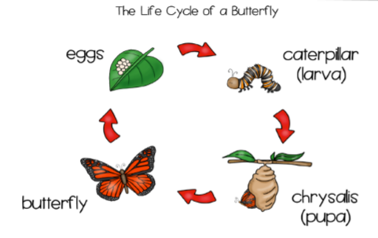
Key Vocabulary
insect | A creature that has a body with three segments that are protected by a hard shell. They have three pairs of legs and a pair of antennae.
caterpillar | A type of insect
chrysalis | A covering or case made by some animals to protect themselves when they develop into adults.
butterfly | A type of insect.
life cycle | A series of stages living things goes through during their life.
food | Something that can be eaten.
fruit | Part of a flowering plant that contains seeds

- How many legs does an insect have? |  | start | end |  |  | - A butterfly emerges from a… | start | end
2 |  |  |  |  |  | sleeping bag
4 |  |  |  |  |  | chrysalis
6 |  |  |  |  |  | under ground
8 |  |  |  |  |  | leaf
- Eric Carle is a… |  |  |  |  |  | - The life cycle of a butterfly has how many stage?
bus driver |  |  |  |  |  | 1
author |  |  |  |  |  | 4
artist |  |  |  |  |  | 5
teacher |  |  |  |  |  | 8
- Tick which of these mini-beasts have wings.
 | start |  | end |  |  |  | start | end
Ladybird |  |  |  |  | Spider
Slug |  |  |  |  | Earwig
Worm |  |  |  |  | Caterpillar

