History Knowledge Organiser – Year 2 – Spring 2 Would you go on a journey into the unknown?
What should I already know? |  | Key Vocabulary  Key People
  
  How to use time words to talk about events.
  How to order familiar events on a simple timeline.
  About events in my own experience that are important to me.
  About the past and present in my own life.
  How to ask questions such as: What was it like for people? What happened? How long ago?
  About some significant events: Remembrance Day & Armistice Day
  America | The country where the United States is located, known for its diverse culture and history.
  Astronaut | A person who travels into space using spacecraft.
  Explorer | Someone who travels to new places to discover and learn about them.
  Journey | A trip from one place to another.
  Apollo | A series of space missions conducted by NASA, including the first manned moon landing in 1969.
  Sailor | A person who works on ships or boats, often traveling across the seas.
  Sea of Tranquillity | A large, flat area on the moon where Apollo 11 landed in 1969.
  Moon | Earth's natural satellite that orbits around it.
  Voyage | A long journey, especially by sea or in space.
  Training | Preparation and learning to develop skills or knowledge for a specific task or activity.
  Legacy | Something passed down from the past, often with historical or cultural significance.
  Christopher Columbus | Neil Armstrong | Tim Peake
  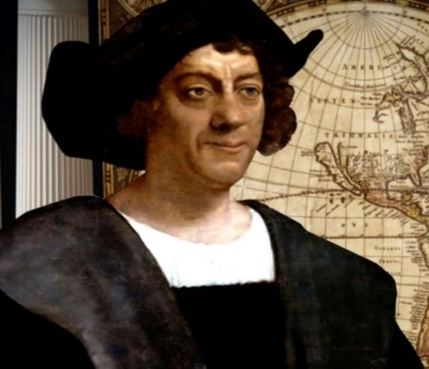 | 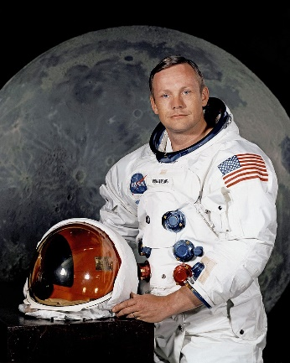 | 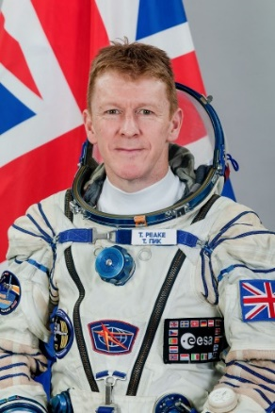
Key Knowledge
Christopher Columbus | - Christopher Columbus is his name in English but he was born in Italy in 1451.  - Christopher Columbus was a sailor.  - He became famous as the explorer who found new lands called ‘The Americas’. Actually, many people already lived there.
Neil Armstrong | - He flew fighter planes for the American Navy and later tested rocket-powered planes. He did all this before he became an astronaut.  - On the 20 July 1969, he became the first person to walk on the Moon.  - As he stepped onto the Moon, he said, “That’s one small step for man, one giant leap for mankind.”
Tim Peake | - Tim Peake became the first British astronaut in space for over 20 years when he blasted off for the International Space Station on 15th December 2015.  - As part of his training he has learnt Russian, spent 12 days under the sea and completed a winter survival mission.

