Year 2 – Optional Enrichment Tasks
Create a Timeline: Research and create a timeline showcasing the key events in the lives of Christopher Columbus, Neil Armstrong, and Tim Peake. Include important dates and significant achievements. | Design a Spacecraft: Use your imagination to design a spacecraft that could transport astronauts to the moon. Include labels and annotations explaining the different features and functions of your spacecraft. | Write a Diary Entry: Pretend you are Christopher Columbus embarking on his first voyage to the Americas. Write a diary entry describing your thoughts, feelings, and experiences during the journey.
Space Mission Poster: Design a poster advertising a space mission to the moon. Include information about the purpose of the mission, the spacecraft used, and the astronauts involved. | Biography Project: Choose one of the explorers (Christopher Columbus, Neil Armstrong, or Tim Peake) and create a biography about their life. Include details about their early life, achievements, and legacy. | Create a Model: Build a model of a spacecraft or a ship that could be used for exploration. Use materials such as cardboard, paper, and recycled materials to construct your model.
Map Exploration: Research and create a map showing the voyages of Christopher Columbus, highlighting the routes he took to reach the Americas. Include key landmarks and geographical features. | Interview an Astronaut: Write a list of interview questions that you would ask an astronaut, such as Neil Armstrong or Tim Peake. Imagine their responses and write a dialogue based on the interview. | Space Exploration Story: Write a short story set in space, featuring explorers embarking on a mission to discover new planets or galaxies. Use your imagination to create an exciting adventure story.

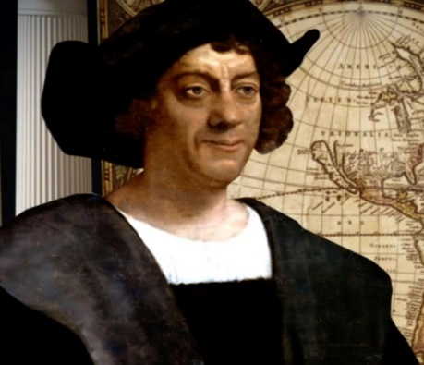 | 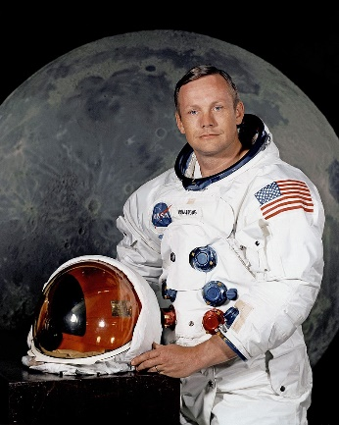 | 