Year 1 ‘Amazing Animals’ Enrichment Activities

  Go to the library and take out a book about an animal that you have never read before. |   Use the internet to do research and write some facts about your favourite animal. | 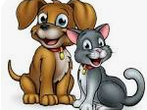  Write a set of instructions about how to care for a pet.
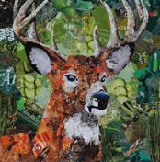  Make a mixed media collage of your favourite animal. | 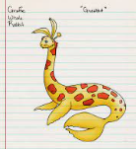  Create your own animal! Draw a picture and label the body parts. | 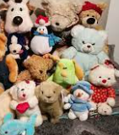  Make a zoo at home using all of your stuffed animals.
  Go on a walk in the local area and write a list of the animals that you see. |   Make a list of animals that are herbivores, omnivores and carnivores. |   Write your own animal riddle and get your friends and family to guess which animal you are describing.

Weekly phonics homework will continue to be set on Spelling Shed and an additional weekly sheet of either maths of English tasks.

