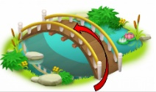
What I should already know:
I can name and describe people who are familiar to me.
Amazing Animals
Knowledge Organiser: Spring 2
Key Vocabulary |  |  | 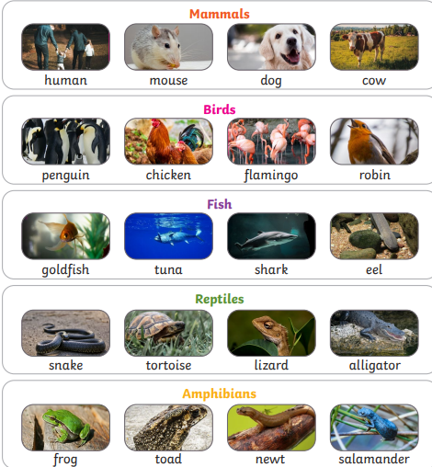
animals | A living thing that can feel and move.
fish | An animal that lives in water and breathes through gills.
amphibians | An animal able to live both on land and in water.
reptiles | A cold-blooded creeping animal, e.g. a snake, lizard or crocodile.
birds | An animal with feathers and wings, usually able to fly.
mammals | Any animal of which the female gives birth to live young.
herbivore | An animal that only eats plants.
carnivore | An animal that only eats meat.
omnivore | An animal that eats both plants and meat.
Key knowledge
I can name the five animal groups: fish, amphibians, reptiles, birds, mammals. |  | I can give examples of animals in each of the 5 animal groups: fish, amphibians, reptiles, birds, mammals.
Animals vary in many ways having different structures e.g. wings, tails, ears. They also have different skin coverings e.g. scales, feathers, hair. |  | Animals eat certain things - some eat other animals, some eat plants, some eat both plants and animals.

