Year 3
Iron Man Enrichment Activities

If you would like to choose activities from this menu, this work will be celebrated in a ‘Show and Tell’ style throughout the term.

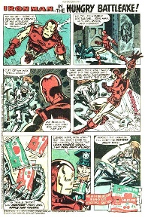  Create your own comic book hero story. | 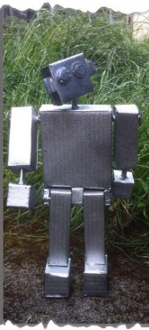  Create your own Iron Man model.  You might want to use junk modelling, clay, Lego, etc.  Be creative! | 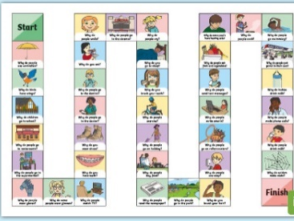  Create a game using your knowledge about forces. Including magnetism.
  Take photos of lots of different magnetic materials around your house. Try to find things which we haven’t discussed during our science lessons – unusual items! | 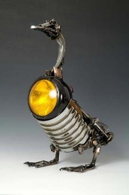  Collect lots of different metallic objects and make a model or collage with them. Give the creation a name. | Design an invention that uses magnets as part of its purpose. Think of something which would be useful to people.  Create a design and sheet and explain how it works.  Can you make a prototype?
Make a stop motion animation or trailer based on the story or about another robot. With an adults help, have a look on YouTube for ideas. I found some examples by searching, “The Iron Man by Ted Hughes Stop Motion” Here is an example:  https://www.youtube.com/watch?v=fZPb95ES0_Q | 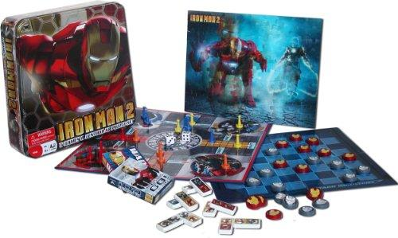  Create a game based on the story of Iron Man and the Space Bat Angel Dragon. It could be a board game or card game or a more physical game. Write the rules for the game. | 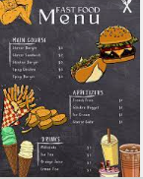    Create a delicious metal menu which the Iron Man would enjoy! Present it in a creative way.

