Key Vocabulary
Earth | The planet on which we live
United Kingdom | Where we live
seasons | We have 4 seasons and each have a different weather pattern
animals | A living organism that needs certain things to survive
map | a drawing of all or part of Earth's surface
tree | A tall woody plant with a stem known as a trunk
environment | Everything that is around us
Key Knowledge
There are 4 seasons: summer, winter, spring and autumn.
Scientists have recently estimated that there are approximately 8.7 million species of animal on Earth.
The United Kingdom (UK) is made up of England, Scotland, Wales and Northern Ireland.
Earth is made up of water and land.
What I might already know
I might be able to tell you where I live
I might be able name different animals
I might be able name some other countries
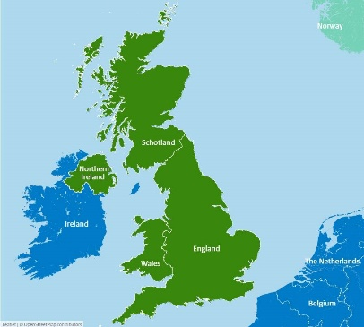
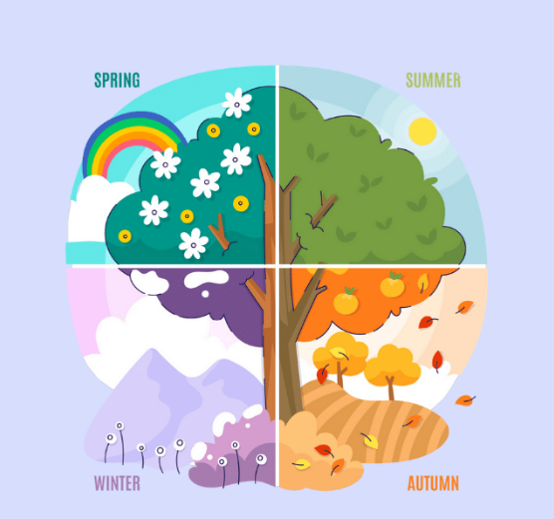
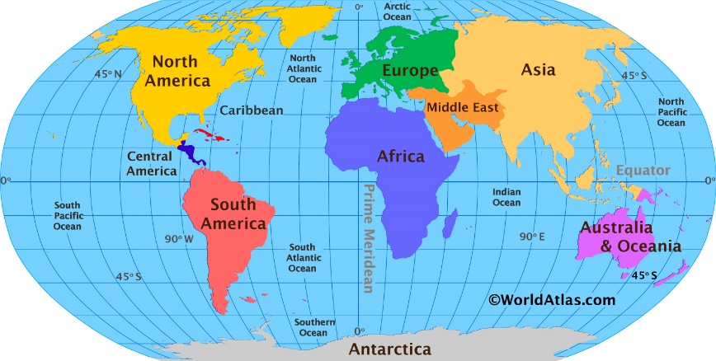
Spring 2 – Our Wonderful World

