Science Knowledge Organiser – Year 2 – Spring 1 What do we need to survive and thrive?
What should I already know? |  | Key Vocabulary  Key Diagrams
  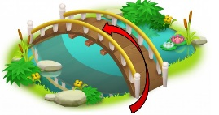
  · Identify and name a variety of common animals that are carnivores, herbivores and omnivores.
  • Identify, name, draw and label the basic parts of the human body and say which part of the body is associated with each sense.
  disease | An illness that makes people feel unwell
  exercise | Moving your body to stay fit and healthy
  germs | Bacteria we cannot see that can make us ill
  growth | When people, animals or plants get bigger and change over time
  hygiene | Keeping clean to stay healthy and stop germs spreading
  offspring | The babies of animals or humans
  reproduction | When animals or plants make new babies or young
  young/old stages | The different times in life, like being a baby, a child or an adult.
  The Eatwell Guide | Human Life Cycle
  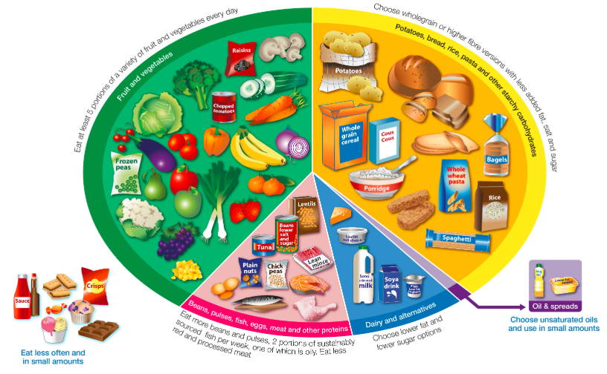 | 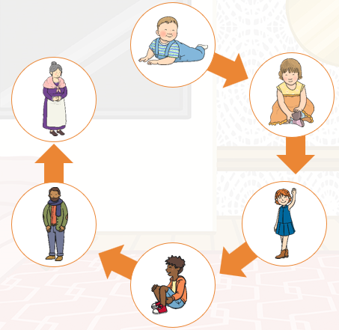
Key Knowledge

Animals, including humans, have offspring which grow into adults.
In humans and some animals, these offspring will be young, such as babies or kittens, that grow into adults.
In other animals, such as chickens or insects, there may be eggs laid that hatch to young or other stages which then grow to adults.
All animals, including humans, have the basic needs of feeding, drinking and breathing that must be satisfied in order to survive.
The young of some animals do not look like their parents e.g. tadpoles.
To grow into healthy adults, they also need the right amounts and types of food and exercise.
Good hygiene is also important in preventing infections and illnesses.

