History Knowledge Organiser – Year 2 – Spring 1 What do we need to survive and thrive?
What should I already know? |  | Key Vocabulary  Key People
  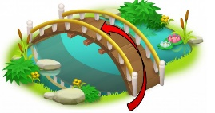
  I know how to label timelines with pictures, words or phrases.
  I know how to use dates to talk about people or events from the past.
  I know how to ask questions such as: What was it like for people? What happened? How long ago?
  I know about some significant events (Remembrance Day/Armistice Day)
  Crimean War | A war fought a long time ago between countries, including Britain
  disease | An illness that makes people feel unwell
  impact | The effect or change something has
  infection | When germs spread and make part of the body sore or sick
  injured | Hurt or harmed, often in a way that needs care
  military hospital | A place where soldiers are cared for when they are sick or hurt
  monarch | A king or queen who rules a country
  nurse | A person who cares for people who are sick or hurt
  Queen Victoria | A famous queen of Britain who ruled for a very long time (1837-1901)
  significant | Very important or special
  soldier | A person who fights in a war to protect their country
  Victorian | Something from the time when Queen Victoria was queen (1837-1901)
  WW1 | A huge war called the First World War that happened over 100 years ago (1914-1918)
  Florence Nightingale | Mary Seacole | Queen Victoria
  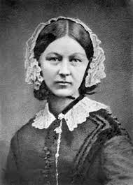 | 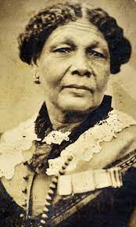 | 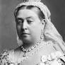
Key Knowledge

Florence Nightingale | - Nursed the injured soldiers in the Crimean War.  - Set up a nursing school to train women to be nurses.  - Inspired other women to be nurses.  - Changed how hospitals were run in England making them better and cleaner.
Mary Seacole | - Wanted to nurse the injured soldiers in the Crimean War but she was not allowed to help  - She had to raise the money herself so she could go and nurse the injured soldiers.
Hospitals in the Past | - Lack of cleanliness and organisation  - Limited medical knowledge  - Florence Nightingale introduced changes.

