Year 3
Fire and Earth Optional Enrichment Activities
If you would like to choose activities from this menu, this work will be celebrated in a ‘Show and Tell’ style throughout the term.

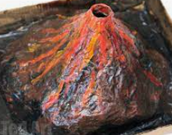  Design and build a volcano. You could use paper, cardboard or your own ideas! It could even explode! | 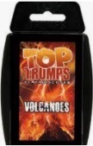  Make some Top Trumps cards using your research of rocks, soils, volcanoes or dragons. |   With someone at home, bake some Rock Cakes for your family or friends – they taste a lot nicer than they sound!
Recreate the different layers of soil using different materials. Be as creative as you like! | 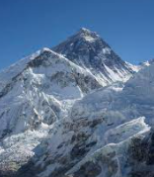  Find and record five fascinating facts about a famous mountain, such as Everest. | Find some stones and rocks from your locality. Weigh them and record their weights. Can you put them in ascending order?
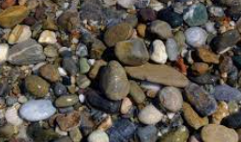  Complete a rock survey of your local area. Present your findings however you wish. For example, you could take photographs, create graphs or tables. | 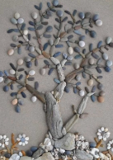  Collect lots of rocks and stones and create a piece of art work. | Recite a poem about volcanoes, rocks or dragons. Send in a video or perform it live to the class.
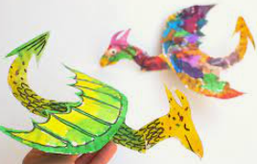  Create a piece of dragon or volcano artwork. You may want to draw, paint, collage  or sculpt. | Create a comic book story about dragons, volcanoes or rocks. | 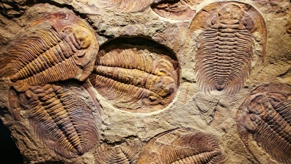  Create a PowerPoint about fossils.

