
Fire & Earth - Y3 Knowledge Organiser
PRIOR KNOWLEDGE
Spring 1st
2026
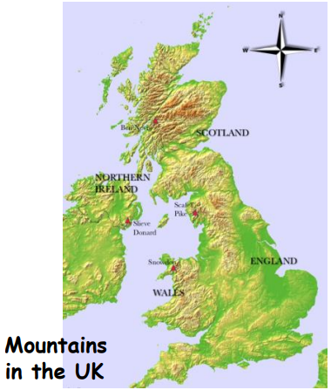
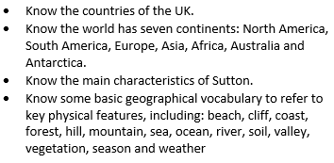
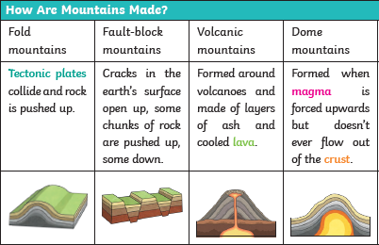

Most common type!
Key Vocabulary
erupt | to suddenly burst out causing lava to explode out of the earth’s surface
magma | extremely hot, liquid rock below the earth’s surface
lava | hot, liquid rock that flows from a volcano
tectonic plates | large pieces of the earth’s crust which join together like a jigsaw
summit | the highest point of a mountain
ridge | long, narrow top, connecting mountains
mountain | landform that rises prominently above its surroundings (generally larger than a hill)
mountain range | a series of mountains that are connected together
glacier | a slow moving mass or river of ice

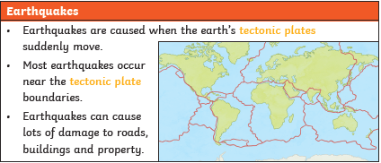

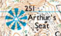
Height above sea level (m)



