Key Learning
Rock is a naturally occurring material
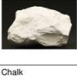
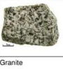
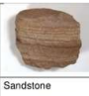
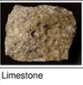
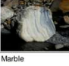
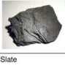
There are different types of rock e.g. sandstone, limestone, slate, etc. which have different properties
Rocks can be hard (like marble and granite) or soft (like sandstone and chalk)
Rocks have different sizes of grain or crystal
There are 3 types of rocks – Igneous (granite), Sedimentary (sandstone, chalk) and metamorphic (slate, marble)
They may absorb water (like sandstone and chalk)
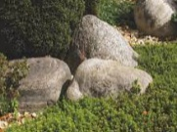
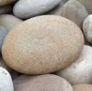
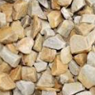
Rocks can be different shapes and sizes (stones, pebbles, boulders).
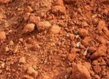
Soils are made up of ground pieces of ground down rock which may be mixed with plant and animal material (organic matter), along with water and air.
The type of rock, size of rock pieces and the amount of organic matter affect the property of the soil.
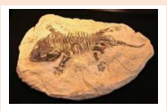
Some rocks contain fossils. Fossils were formed millions of years ago. When plants and animals died, they fell to the seabed. They became covered and squashed by other material. Over time the dissolving animal and plant matter is replaced by minerals from the water.


Prior Learning

Distinguish between an object and the material from which it is made
Identify and name a variety of everyday materials, including wood, plastic, glass, metal, water, and rock.
Describe the simple physical properties of a variety of everyday materials.
Compare and group together a variety of everyday materials on the basis of their simple physical properties.
Identify and compare the suitability of a variety of everyday materials, including wood, metal, plastic, glass, brick, rock, paper and cardboard for particular uses.

YEAR 3 KNOWLEDGE ORGANISER
Science – Rocks and Soils

Key Vocabulary
rock | The solid mineral material forming part of the earth’s surface.
peat | A type of soil made of dead plants that have not completely rotted.
texture | The feel or appearance of a surface
soil | The loose surface material that covers most land
absorb | 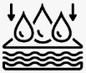  To take in or soak up
sediment | Matter that is carried by water or wind and deposited on the surface of the land or seabed.
organic | Created from living matter
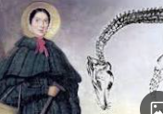
Mary Anning was a famous English palaeontologist and fossil collector.

