Science
Science Knowledge Organiser: Spring 1
Key Vocabulary |  | Key Knowledge
Instructions | A list of directions in order of how to complete a task or job. | Objects are made from different materials, depending on suitability for their use.
Material | What an object is made out of. | Identifying wood, plastic, glass, metal, water and rock as separate materials.
Wood | A natural material that comes from trees, normally brown in colour. | Objects change and develop over time, even within short periods such as living memory.
Plastic | A strong, -made material that is light and can be made into any shape or colour. | Materials can be grouped by their physical properties.
Plastic |  | Some materials occur naturally and some materials are man-made.
Plastic |  | Key Images
Glass | A material that is normally see through, and easily breakable. | 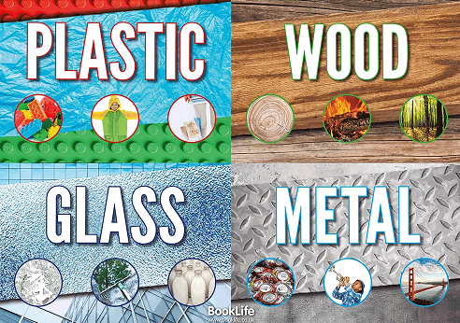
Metal | A strong, shiny, normally grey or silver material.
Structure | Something built for a specific purpose- ie a garage for a car,
Object | A material thing that can be seen, touched and held.

