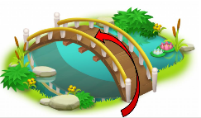
What I should already know:
That people play different roles in society.
That there are some similarities and differences between things in the past and now.
Toys and Games

Knowledge Organiser: Year- Spring 1

Key Vocabulary |  | Key Knowledge
Year | 365 days. | Children have always played with toys
Year | 365 days. | Toys have changed over the centuries because people have had new materials to work with. E.g. stone, wood, glass, clay, metal or plastic, electrics.
Century | One hundred years. | Our parents and grandparents will have played different games to us.
Past | A time before now. Things in the past have already happened. | Some toys and games may not be played with anymore because more exciting games have been invented.
Present | Happening or going on right now. | What could toys look like in the future?
Present | Happening or going on right now. | Toy Timeline
Future | A time after now. Things in the future have not happened yet. | 1902  Teddy Bear | 1949  Lego | 1959  Barbie | 1974  Rubiks Cube | 1993  Fidget Spinner | 2006  Nintendo Wii
Timeline | A list that shows things in the order they happened. | 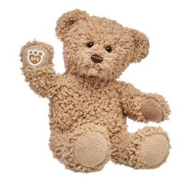 | 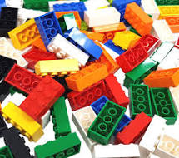 | 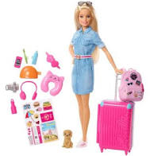 | 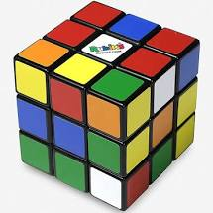 | 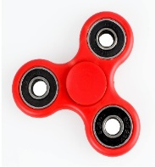 | 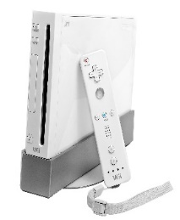
Living memory | Around 80 years.

