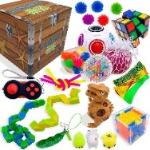
Year 1 – ‘Toys and Games’ Enrichment Tasks

Make a tea-party for your cuddly toys.  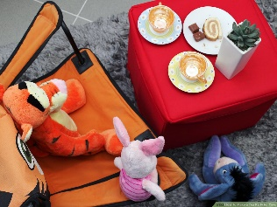 | Go on an adventure with your favourite toy. You could write a diary about it.  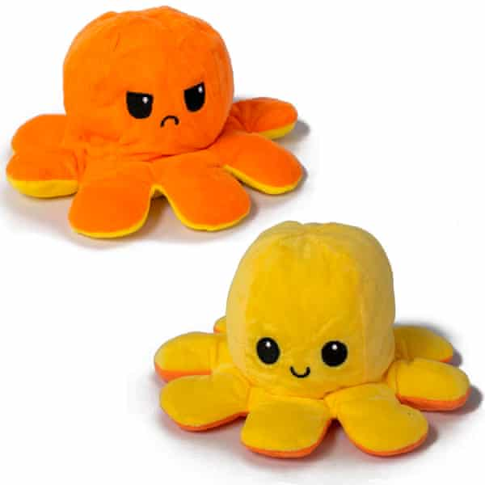 | Create a piece of artwork of your favourite toy.  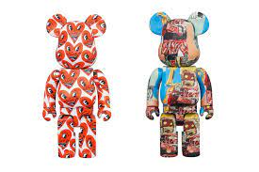
Create a quiz all about toys.  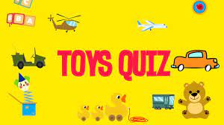 | 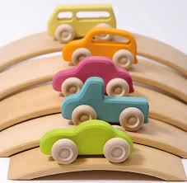  Look carefully at a group of toys and list all the materials they are made from. | Write down all the things you love about your favourite toy.  
Talk to someone about what their favourite toy was when they were younger.  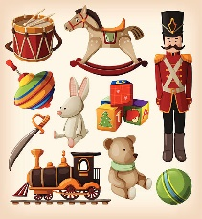 | Make a house, shelter or box for your toy to stay in.  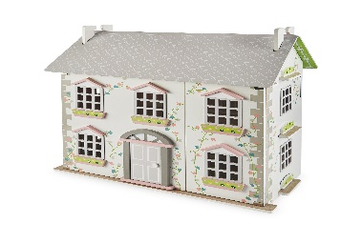 | Write an adventure story about your toy.  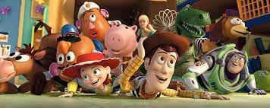
Weekly phonics homework will continue to be set on Spelling Shed.

