Key Vocabulary
Spring 1 – Traditional Tales
Traditional tale | A tale that has been retold over many years.
character | A person or an animal in a story
hero/heroine | The main character in a story, is usually good and well liked
villain | The opposite character to a hero. The villain could be mean, nasty or evil.
setting | Where the story is taking place
past | Something that has already happened
fiction stories | describes imaginary people and events
Key Knowledge
Traditional tales are stories from the past that have been retold over and over again.
Traditional tales usually start with ‘Once upon a time’ and end with ‘They lived happily ever after.’
Traditional tales may have mythical creatures or animals that can talk as characters.
There is often a hero/ heroine and a villain in traditional tales and the hero/ heroine defeats the villain.
Traditional tales are sometimes called fairy tales.

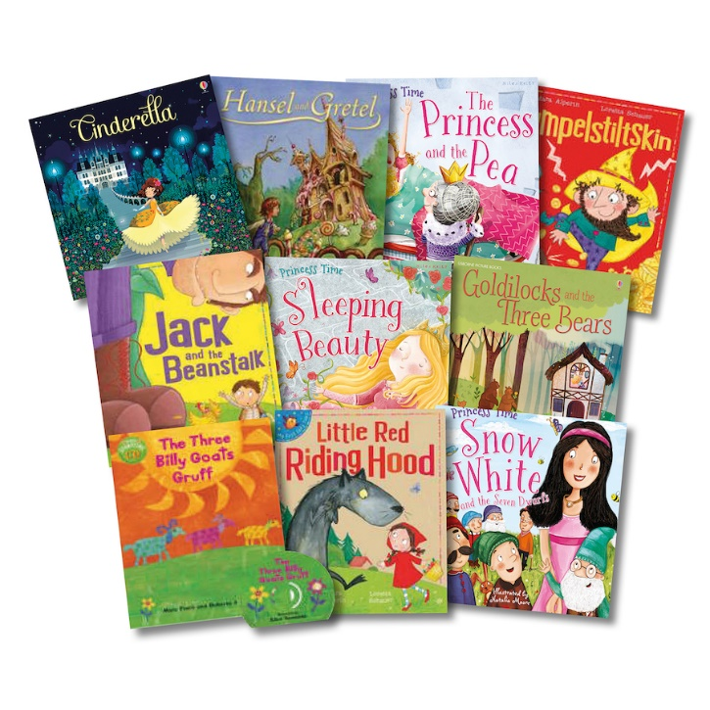

Key texts
The Gingerbread Man
The Three Little Pigs
Little Red Riding Hood
Jack and the Beanstalk
Snow White

What I might already know
- I might be able to name some characters from traditional tales.
- I may be able to name some features of a book (front cover, back cover ect)

