Key Learning
Animals need to eat in order to get the nutrients they need (unlike plants which can make their own food)
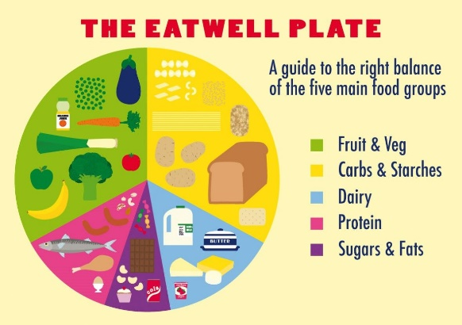
Food contains a range of different nutrients – carbohydrates (including sugars), protein, vitamins, minerals, fats, sugars, fibre and water – that are needed by the body to stay healthy.
A piece of food will often provide a range of nutrients.

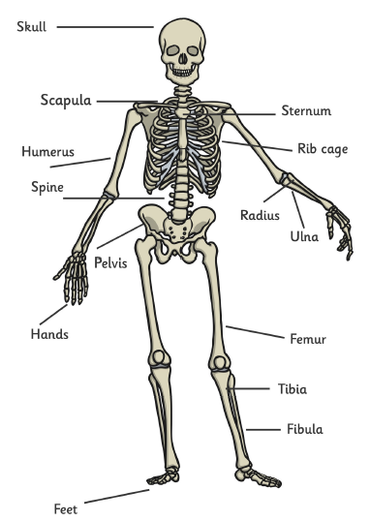
Humans, and some other animals, have skeletons and muscles which help them move and provide protection and support.
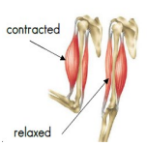
Muscles work in pairs and are attached at joints to allow the skeleton to move.



YEAR 3 KNOWLEDGE ORGANISER Science – Animals Including Humans
Prior Learning

Identify and name a variety of common animals including fish, amphibians, reptiles, birds and mammals.
Identify and name a variety of common animals that are carnivores, herbivores and omnivores.
Describe and compare the structure of a variety of common animals (fish, amphibians, reptiles, birds and mammals, including pets).
Find out about and describe the basic needs of animals, including humans, for survival (water, food and air).
Describe the importance for humans of exercise, eating the right amounts of different types of food, and hygiene.

Elsie Widdowson (1906-2000) was a British dietician and nutritionist who loved experiments. She wrote a book which told us for the first time what energy and nutrition was in different foods. She also played a key role in wartime rationing.

Key Vocabulary
nutrition | The study of food and how it works in your body. It includes carbohydrates, fats, protein, vitamins and minerals.
nutrients | Proteins, carbohydrates, fats, minerals, vitamins and water (the things the body needs to function).
carbohydrates | The main source of energy for our bodies (rice, potatoes, pasta and bread).
protein | Repairs and builds muscles and organs (fish, meat, eggs and cheese).
fat | Stored for energy and creates a layer of fat to keep us warm (chocolate, sweets, butter, oil, cream).
vitamins and minerals | These help us to grow, form bone and muscle and prevent infection (fruit and vegetables).
fibre | Plant material that cannot be digested by the human body. Helps the digestive system to move through the intestines and push waste material out of the body. Found in beans and vegetables.
skeleton | A strong structure made of bone which supports us so we can stand, protects internal organs from damage and allows movement.
muscle | An organ of the body which allows for the body to move as they are attached to the skeleton.


