Year 1 Enrichment Activities – Ablaze!
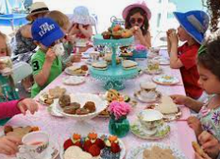  Bake some cakes and have a tea party! | 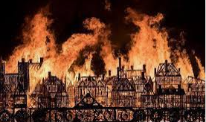  Use the internet to do research and write some facts about the Great Fire of London. |   Write a diary entry about your day.
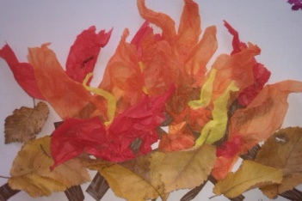  Make a fire collage. | 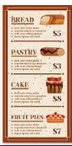  Design your own bakery menu. | Build a model of St Paul’s Cathedral.  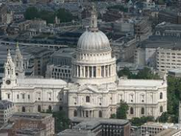
  Be an eyewitness. Go on a walk in the local area and write a list of things you see. | 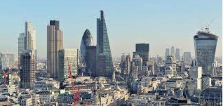  Draw a picture of the London skyline. | Pretend you are King Charles II and design your own crown.  

Weekly phonics homework will continue to be set on Spelling Shed and an additional weekly sheet of either English or maths.

