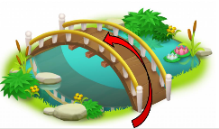
What I should already know:
That people play different roles in society.
That there are some similarities and differences between things in the past and now.
London is the capital city of England.
Ablaze!

Knowledge Organiser: Year 1- Autumn 2

Key Vocabulary |  | Key Knowledge
Bakery | A place where bread and cakes are made or sold. | People  Christopher Wren – architect who designed a monument to remember the Great Fire of London  Samuel Pepys – eyewitness of the fire who recorded the information in his diary.  King Charles II- King of England during the fire.
Monument | A statue/ building made to remember someone or something important. | The fire started on 2nd September 1666 in a bakery on Pudding Lane. It lasted for 5 days.
Diary | A book where people write their thoughts and things that have happened to them. | The fire spread easily because:  - It was hot and it hadn’t rained for months.  - Houses were built mainly from wood and straw.  - Houses were built close together.
Leather bucket | A leather container used for carrying water. | The fire burnt down over 13,000 homes. When these homes were rebuilt they were made from bricks instead of wood.
Leather bucket | A leather container used for carrying water. | Key Locations
Firebreak | An empty area that is hard for fire to cross. | Pudding Lane Bakery | St Pauls Cathedral | River Thames
London | The capital city of England | 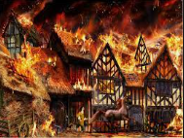 | 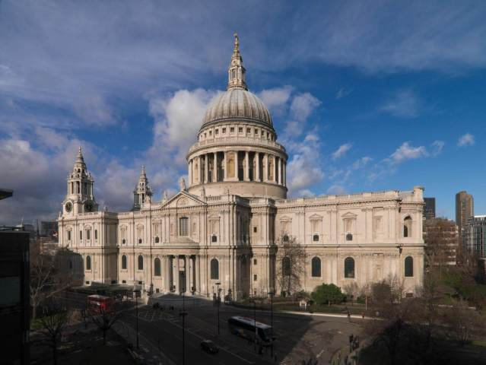 | 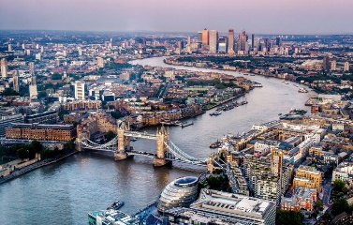
Flammable | Something that can be set on fire easily and quickly.
Eyewitness | A person who saw something happen and can describe the events.

