Year 1 Enrichment Activities– Island Life
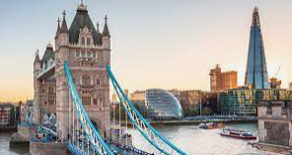  Look at photographs of London and draw some of your favourite buildings. | 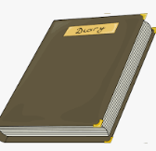  Keep a diary of the weather each day for a week. | 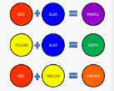  Practice mixing primary colours (blue, yellow, green, red) to make secondary colours then paint a picture using the colours you made.
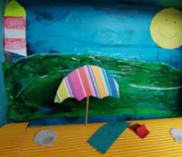  Make your own model island using items you can find around the house. | 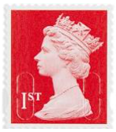  Design your own stamp. | 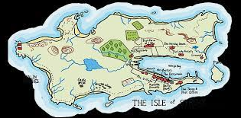  Create a piece of artwork of an island.
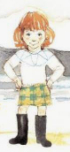  Draw a picture of Katie Morag using descriptions from the books we have read. | Create an autumnal piece of art using mixed media.  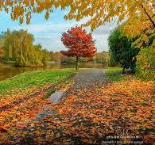 | Write your own story about Katie Morag.  