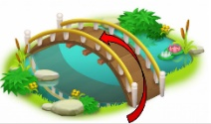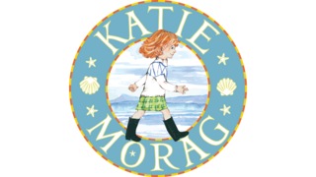

**Prior Knowledge**

Our school and homes are in England.

Be able to discuss countries or places that pupils may have visited in the United Kingdom.

**Island Life**

**Knowledge Organiser: Autumn 1**

|  |  |  |
| --- | --- | --- |
| Key Vocabulary |  | Key Locations |
| Capital City | The location of a country’s government. | England |
| City | A big, busy place where many people live. | Scotland |
| Coast | Where the land meets the sea. | Wales |
| Country | A part of the world with its own people and laws. | Northern Island |
| Key Maps/Symbols |
| Countryside | The land outside towns and cities where there are fields, woods or farms. | |  |  | | --- | --- | | UK map showing regions and capitals | UK map showing seas | |  | [Image result for uk map with seas](http://www.google.co.uk/url?sa=i&rct=j&q=&esrc=s&source=images&cd=&ved=2ahUKEwj-5oD2oM3jAhUFQBoKHUjfA0wQjRx6BAgBEAU&url=http://www.yourchildlearns.com/online-atlas/british-isles-map.htm&psig=AOvVaw2LiED8ZUE5VNhgBgpDEeu9&ust=1564047447305439) | |
| Sea | A large area of salty water. |
| Town | A place in which people live that is larger than a village but smaller than a city. |
| Village | A small place where people live in a countryside area. |
| Key Knowledge |  |
| Capital cities | England – London  Northern Ireland – Belfast  Scotland – Edinburgh  Wales - Cardiff |
| Parts of the United Kingdom | 3 countries (England, Scotland and Wales) and 1 ‘region’ (Northern Ireland), together making up 1 country. |
| Seas of the United Kingdom | Atlantic Ocean, English Channel, Irish Sea, North Sea |
| UK | Short for United Kingdom. |
|  | |