Science Knowledge Organiser – Autumn 1: The Human Body and The Senses
Key Vocab |  | Key Images
sight | Your eyes let you see things around you. | 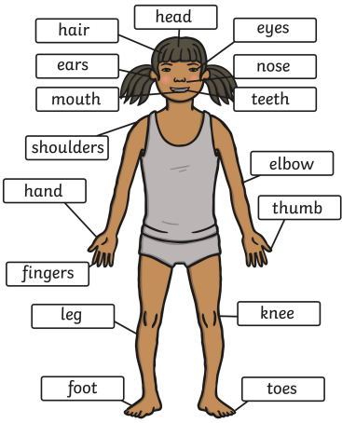
hearing | Your ears let you listen to things around you.
touch | Your skin gives you the sense of touch. You can tell if something is wet or dry or smooth or rough without touching it.
taste | Your sense of taste comes from your tongue. There can be tastes you like and tastes you don’t like. | 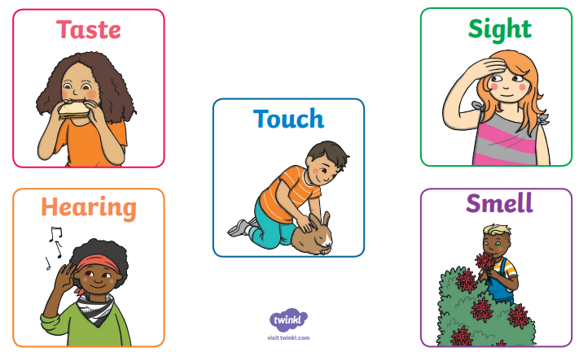
smell | Your sense of smell comes from your nose. Sometimes there are nice smells and sometimes there are not nice smells.

