|  |  |  |  |  |  |
| --- | --- | --- | --- | --- | --- |
| **Communication and Language**   * Listen and Join in with daily nursery rhymes and stories. All of me rhyme. * Develop listening skills through large and small group activities. * Communicate wants, needs and interests as confidence increases.   Share thoughts and interests, what do I like what makes me happy.  Join in with experiments, creative and critical thinking, asking questions.  Fingerplay - Humpty Dumpty Clipart - Full Size Clipart (#3472848 ...Small Phonics groups to commence after half term | | **Physical Development**   * Support and encourage independence with Handwashing, Toileting, pouring own drinks. * Try new foods, learn about our senses. * Preschool Potty Cliparts - Flush The Toilet Clipart, HD Png ...Learn about our bodies and what keeps us healthy. * Learn to move in different ways, running, jumping, avoid obstacles. * Manipulate materials, build and construct   To create themselves, families, homes.  Disco Doh sessions | | **Personal, Social and Emotional Development**   * Gain confidence leaving main carer and settle into Nursery. * Learn about themselves, similarities and differences. * Treasure files, pictures of family, pets. * Get to know the Nursery routine * A Parent's Review of ClassDojoIntroduce Colour Monster to talk about and explore feelings.   Build relationships  Learn to take turns through  Circle time, games and  Activities. Mini Mentors, Safety Monitors | |
| **Literacy**  Focus Books- Marvellous me, Odd dog out, Colour Monster, 10 tiny fingers 10 tiny toes.   * Share favourite books from home. * Listen to and join in with stories daily * Joins in with nursery rhymes * Create an “All about us” book together * Enjoy making marks with purpose. * Take home library to share stories at home. | **Mathematics**   * Begin to learn mathematical concepts such as more-Less big- small, Tall short. * Touch count objects through games and rhymes. * Counts actions * Talks about the shapes of objects * Plays with shapes and makes constructions. | | **Understanding the World**   * Learn and talk about themselves * Talk about their family and their home. * Learn about the world, different homes, different families, Community walks, visitors. People who help us. * Use role play and toys to represent their experiences. * Little Explorers Forest experience each week. | | **Expressive Arts and Design**   * Join in with nursery rhymes and songs. * Enjoy moving to music (Favourite songs, instruments) * Use different media to create and represent themselves and their family. * Role play Home corner   Jabberjacks Music and movement each week |

|  |  |  |  |  |  |
| --- | --- | --- | --- | --- | --- |
| **Communication and Language**  **LA 30-50**   * Listens to stories with increasing attention and recall * Joins in with repeated refrains and anticipates key events and phrases in rhymes and stories   **U 30-50**   * Responds to simple instructions, e.g. to get or put away and object   **S 30-50**   * Use vocabulary focused on objects and people that are of particular importance to them * Uses talk to connect ideas, explain what is happening and anticipate what might happen next, recall and relive past experiences | | **Physical Development**  **M&H 30-50**   * Moves freely with pleasure and confidence in a range of ways, such as slithering, shuffling, rolling, crawling, walking, running, jumping, skipping, sliding and hopping. * Draws lines and circles using gross motor movements * Holds a pencil between thumb and two fingers, no longer using whole-hand grasp   **HSC 30-50**   * Gains more bowel and bladder control and can attend to toileting needs most of the time themselves * Can tell adults when they are hungry or tired or when they want to rest | | **Personal, Social and Emotional Development**  **SCSA 30-50**   * Can play in a group, extending and elaborating play ideas, e.g. building up a role-play activity with other children   **MFB 30-50**   * Is more outgoing towards unfamiliar people and more confident in new social situations * Can select and use activities and resources with help * Welcomes and values praise for what they have done   **MR 30-50**   * Aware of own feelings, and knows that some actions and words can hurt others’ feelings * Begins to accept the needs of others and can take turns and share resources, sometimes with support from others. * Can usually tolerate delay when needs are not immediately met, and understands wishes may not always be met. | |
| **Literacy**  **R 30-50**   * Enjoys rhyming an rhythmic activities * Shows awareness of rhyme and alliteration * Joins in with stories and poems, one-to one and also in small groups * Joins in with repeated refrains and anticipates key events and phrases in rhymes and stories * Recognisees familiar words and signs such ad own name and advertising logos. * Listens to stories with increasing attention and recall   **W 30-50**   * Sometimes gives meaning to marks as they draw and paint * Ascribes meanings to marks that they see in different places | **Mathematics**  **N 30-50**   * Uses some number names and number language spontaneously * Uses some number names accurately in play * Recites numbers in order to 10 * Shows curiosity about numbers by offering comments or asking questions * Realises not only objects, but anything can be counted, including steps, claps or jumps   **SSM 30-50**   * Shows an interest in shape and space by playing with shapes or making arrangements with objects * Shows interest in shape by sustained construction activity or by talking about shapes or arrangements * Beginning to talk about the shapes of everyday objects, e.g. *round* and *tall* | | **Understanding the World**  **PC 30-50**   * Shows interest in lives of the people who are familiar to them * Remembers and talks about significant events in their own experience * Knows some of the things that make them unique, and can talk about some of the similarities and the differences in relation to friends or family   **T 30-50**   * Knows how to operate simple equipment * Shows skill in making toys work by pressing parts or lifting flaps to achieve effects such as sound, movements or new images | | **Expressive Arts and Design**  **EMM 30-50**   * Enjoys joining in with dancing and ring games * Sings a few familiar songs * Taps out simple repeated rhythms * Understands that they can use lines to enclose a space, and then begin to use these shapes to represent objects   **BI 30-50**   * Uses movement to express feelings * Creates movement in response to music * Makes up rhyming * Engages in imaginative role-play based on own first hand experiences * Uses available resources to create props o support role play |

|  |  |
| --- | --- |
| family | People whom we might live with, or are related to |
| friends | People that we like to socialise with, that we probably share similar interests with |
| home | Where you live, probably with your family |
| interests | Another way of saying what things we like and what we like to do |

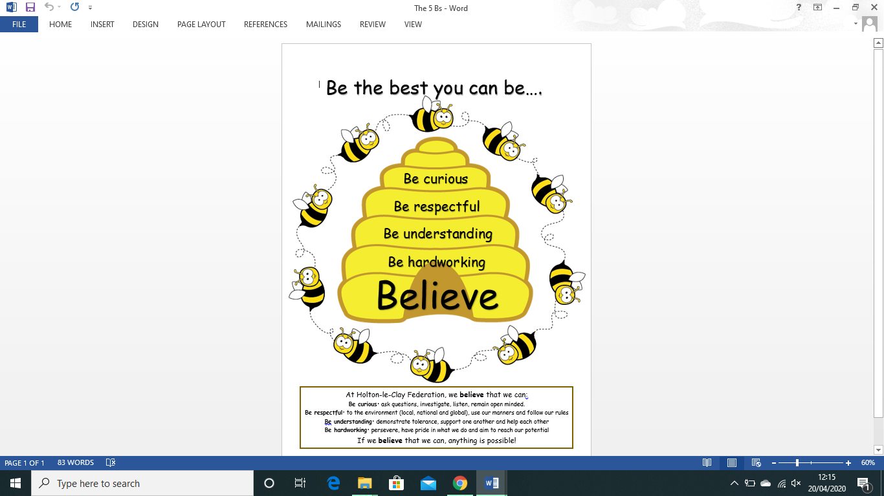 Useful vocabulary we might need to know:

|  |
| --- |
| **Questions we could ask**.  Who is the tallest in my family, how do I know this?  Who is in my family, not just the people I live with?  Where did my Mum/ Dad live?  What other questions could we ask? |

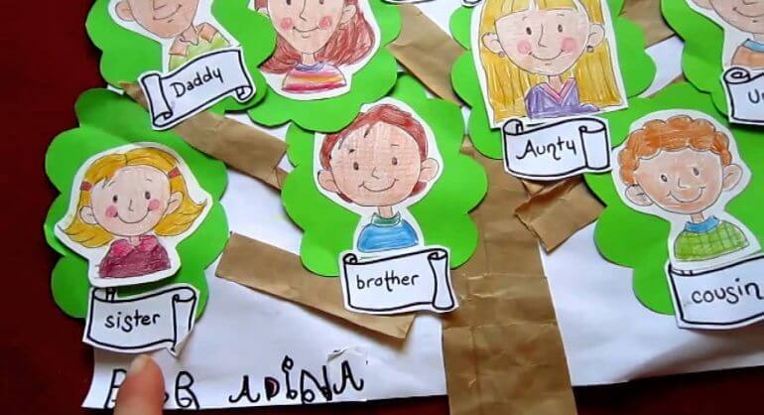

**Home Project**

Over the next half term we are challenging you to make your own family tree. You can be as adventurous in how you do this as you like. I wonder how many people you will be able to find out about and how many you already know. You may want to ask the grown-ups around you to help you.

**Note to parents**: Please do not panic! This is something which we hope you will find as fun as the children. Children can use a variety of media to record what they find out, draw pictures, take photographs and put them on Evidence Me, create a scrapbook or a poster. At the end we would like to see a simple, or extended – whatever you can support – family tree. Thank you for taking the time to support your child’s learning, but most of all enjoy it and have FUN! Please ask if you are uncertain.

