Long Term Goals at Hollinhey Nursery

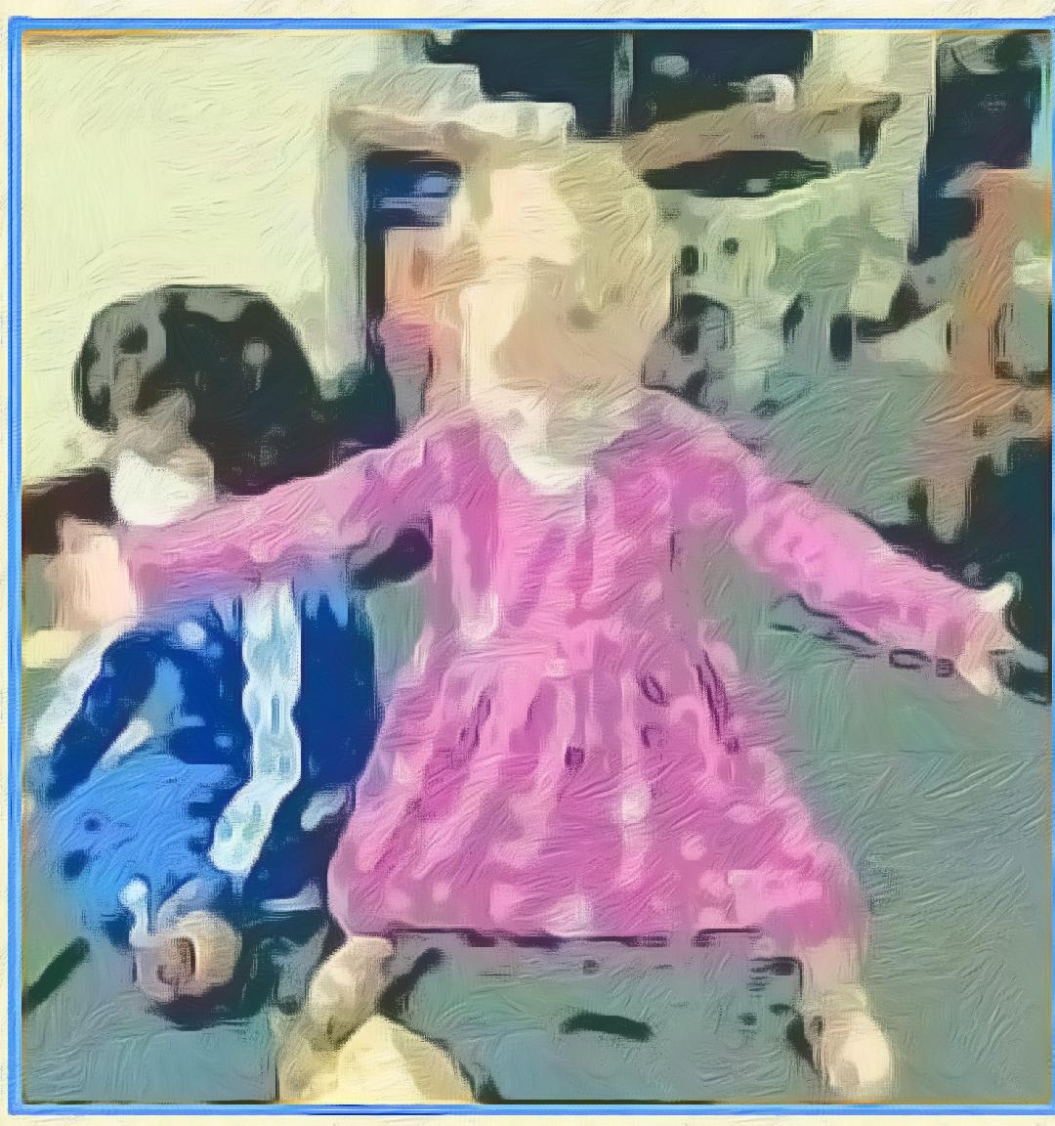    PSED  To become a ‘Sparkly Star’ who happily greets and interacts with others, sharing thoughts and resources patiently; valuing self and others and willing to persist and not be daunted by failure. |   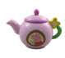  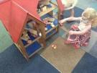  C&L & Roleplay  To become a ‘Happy Chatter’ in everyday play and focussed sessions, showing the ability to follow instructions, concentrate, think through and extend ideas and real and imaginary thoughts with others. |   PD Outdoor  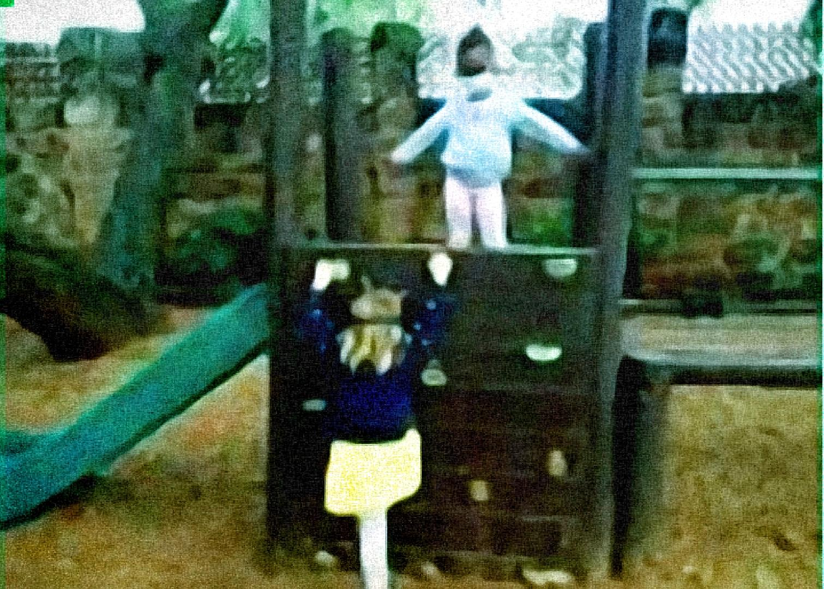  To become a confident ‘Risk Taker’ and develop body strength when climbing up, across and down various parts of the climbing frame, whizzing around the track on the trike and digging and building various items to construct. |   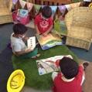  Literacy  To become a ‘Book Worm’ enthusiast and readily access them for pleasure, turning pages individually, describing characters, scenes and outcomes in illustrations and recognising some symbols and letters of personal interest in their environment including digital material.
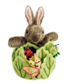  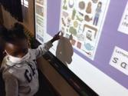  Phonics  To become a Phase 1 ‘Superhero Listener’ with radar hearing, discerning, remembering, sequencing and creating dynamic sounds in everyday play, with awesome rhyme awareness and a handy robot twist action for segmenting and blending orally. |   Pre-Writing Skills  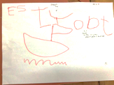  To become a ‘Funky Finger’ enthusiast who builds up hand and whole-body strength through adventurous play, to be able to enjoy mark making readily and confidently with a good grip. | 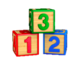  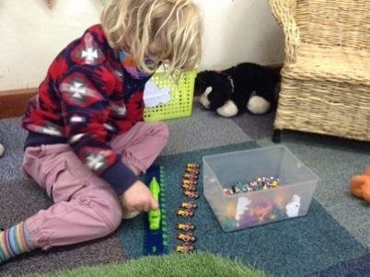  Maths  To be able to use the ‘Collected Treasure” of embedded mathematical knowledge and language naturally in everyday play. Subitising, counting and representing marks to at least 5 and matching, measuring and comparing all sorts. | 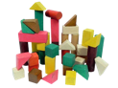  Construction  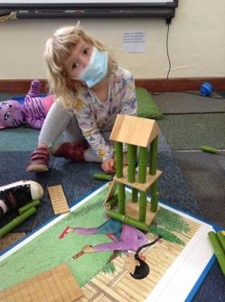  To build a ‘Crafty Construction’ model that has multilayers of purposefully positioned pieces and spaces between.
  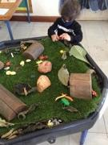  KUW  To become an ‘Intrepid Explorer’ who investigates challenges with an inquiring mind and uses a breadth of vocabulary and investigative tools to observe, remember, explain and predict. | 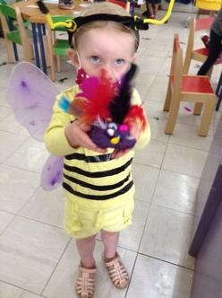  EAD Art  To become a ‘Creativity Expresser’ who develops ideas using embedded skills, techniques and knowledge of experiences and artists to represent and complete their dreams. | 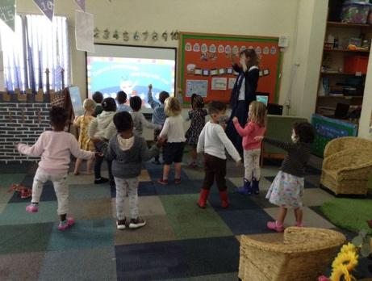  EAD-Music & Dance  To become a little “Music Jiver’ who can discern a few instruments, attempt to play them loudly, softly, fast and slowly whilst developing an ear for rhythm. | 

