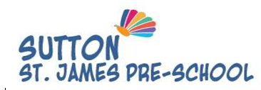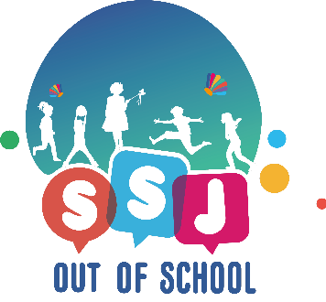



Friday 6th June 2025

Dear Parent/Carers

I write to inform you about the exciting news that Sutton St James Pre-school and Sutton St James out of School club (SSJOOS) will be amalgamating with Hollinhey Primary School.   From September onwards we will now be called Hollinhey Primary and Nursery School.

As a parent/carer you will notice very little difference as both settings will continue to provide the excellent high standards of care and education.  The same teams of people will continue to work across both settings with your children.  The few changes that will happen will be more around consolidating our systems with regards to bookings and payments, we will inform you of any changes in due course, so please be patient with us whilst we work together on this.

Should you wish for any further information please contact SSJOOS or the school who will be happy to answer any questions as we look forward to the next steps of this journey together.

Regards

Steve Wheeldon (Assistant CEO Aspire Educational Trust)

Caroline Massey (Acting Headteacher Hollinhey Primary School)

Lucy Riley (Sutton St James Pre-school Manager)