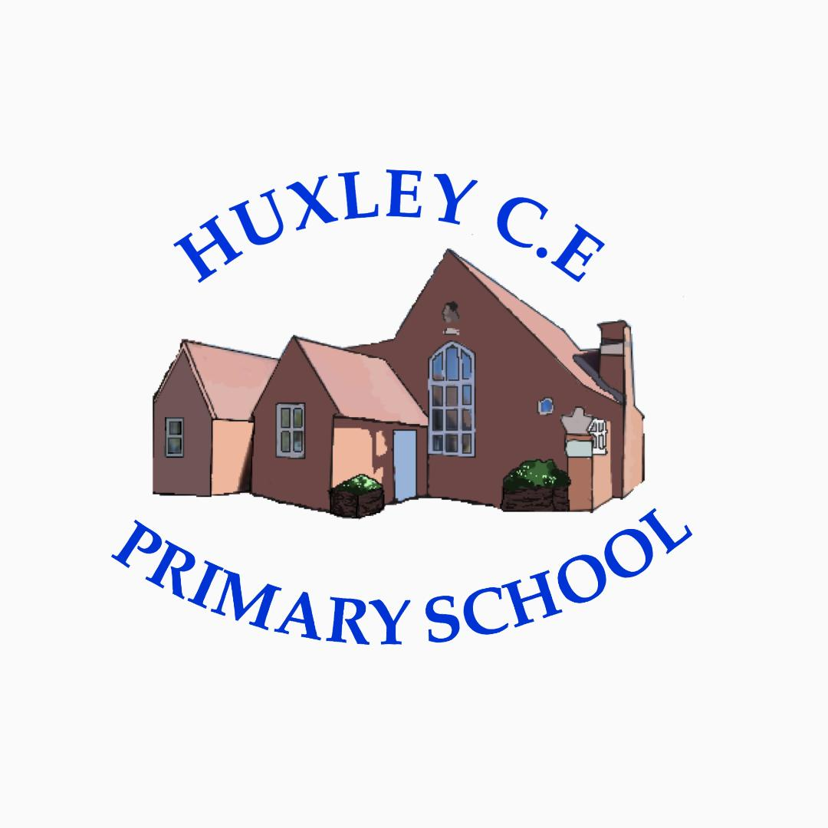

Curriculum-
ART and DT Policy
2024-2026
(Reviewed earlier should any changes to T&L or curriculum structure change)

Art & Design and Design & Technology Policy

Introduction
At Huxley C.E. Primary School, we believe that Art & Design (Art) and Design & Technology (D&T) are vital parts of children’s education. They encourage creativity, critical thinking, and problem-solving, while fostering enjoyment, self-expression, and resilience. This policy sets out our approach to teaching and learning in Art and D&T, in line with the National Curriculum for England (2014).

We use the Kapow Primary scheme of work, which provides a clear progression of knowledge and skills across all year groups, ensuring coverage of statutory requirements and opportunities for creativity and innovation.

Curriculum Intent

School Vision

Supporting our pupils to feel SAFE, SECURE and UNDERSTOOD

Our Christian vision, which is threaded through all aspects of school life, is:

With God's love, we can fly.

We aim high and embrace life in all its fullness.

Our school vision bible verse-

"those who trust in the Lord, they will find new strength. They will soar high on wings like eagles."- Isaiah 40:31

Our intent is to ensure that children leave primary school with the knowledge, skills, and confidence to express themselves, innovate, and solve problems creatively.

Aims of the ART/DT Curriculum (NC aims and personalised aims for our children)
The National Curriculum aims to ensure that all pupils:
Art & Design
- Enable pupils to produce creative work, exploring ideas and recording experiences.
- Develop proficiency in drawing, painting, sculpture, and other techniques.
- Foster evaluation skills by analysing and discussing their own work and that of others.
- Increase knowledge of great artists, craft makers, and designers.
- Appreciate the historical and cultural development of art forms.
Design & Technology
- Develop creative, technical, and practical expertise.
- Apply knowledge and understanding to design and make purposeful, functional products.
- Build and test ideas, making improvements through evaluation.
- Develop skills in a range of materials, tools, and technologies, including computing and food technology.
- Understand nutrition and learn how to cook.

Curriculum Implementation

- Curriculum Design: We follow the Kapow Primary scheme of work to ensure a clear progression of knowledge and skills across all year groups.
- Timetabling: Art and D&T are taught on a termly rotation, ensuring each subject receives dedicated focus throughout the year.
- Teaching Approaches: Lessons include modelling, practical exploration, and opportunities for reflection. Children are encouraged to take creative risks and develop resilience.
- Assessment: Teachers assess formatively through observation, questioning, and outcomes in sketchbooks and project work, tracking progress against the Kapow framework.
- Cross-Curricular Links: Where appropriate, Art and D&T are linked with other subjects such as history, science, geography, and PSHE.
- Inclusivity: Lessons are accessible to all children, with adaptations and scaffolding provided to support SEND learners.
- Resources: A wide range of high-quality materials and equipment is available, with specialist resources managed by subject leaders. Health and safety guidelines are followed at all times.
- Enrichment: Annual Art & D&T Gallery, showcasing work completed in school and at home, including contributions from home learning (for flexi-schooled children). Opportunities for visits, workshops, and participation in competitions.
- Professional Development of Staff and Use of Resources- Staff have access to inbuilt CPD through Kapow

Parental involvement
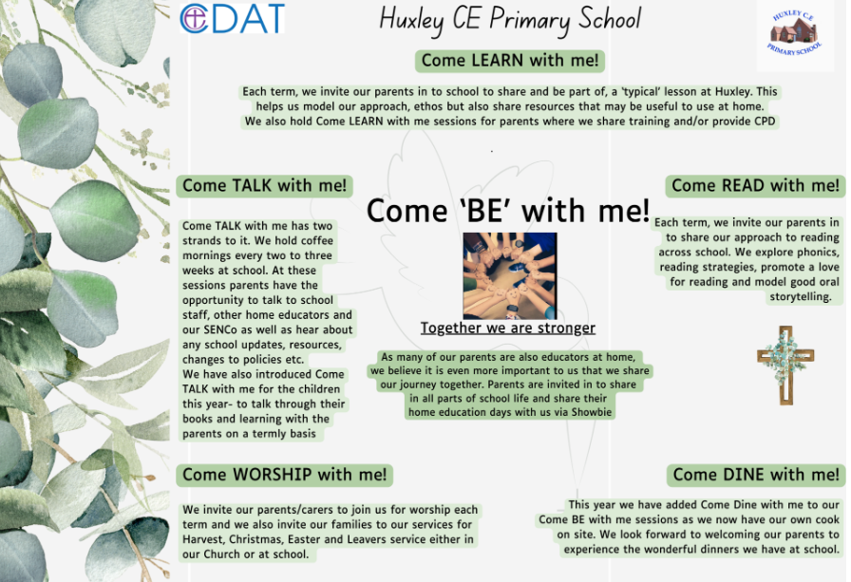
Due to the nature of our provision and our offer of flexi schooling, our parents and carers are considered as joint educators and therefore parental engagement is even more integral to our approach.

Things we do to help engage our parents in learning-
- The ‘Come Be’ with me programme above means that parents are engaged in all aspects of school life- we have subject specific Come Learn with me sessions too.
- Online Platform for sharing resources, videos and supporting work for days when children are not onsite but also to help guide learning across the term
- All overviews and weekly rotation/hours documents are shared with parents
- We have coffee mornings every 2- 3 weeks to ‘touch base’ with our parents on a variety of school development areas and use these to share new resources, learning activities or research in different subject areas too
- Parent consultation afternoons

Curriculum Impact

• Pupil Outcomes: Children demonstrate creativity, technical skills, and the ability to evaluate and improve their work.
• Progression: Teachers track skills and knowledge to ensure children are building on prior learning year by year.
• Confidence and Enjoyment: Pupils develop resilience, take creative risks, and enjoy expressing themselves through art and design.
• Cultural Capital: Children gain knowledge of artists, designers, and makers, as well as an understanding of how creativity contributes to society.
• Celebration of Work: Outcomes are displayed in classrooms, across the school, and celebrated in our annual gallery.
Monitoring is carried out by subject leaders through planning reviews, book looks, pupil voice, and observation of teaching and learning. This ensures consistency and impact across the school.

