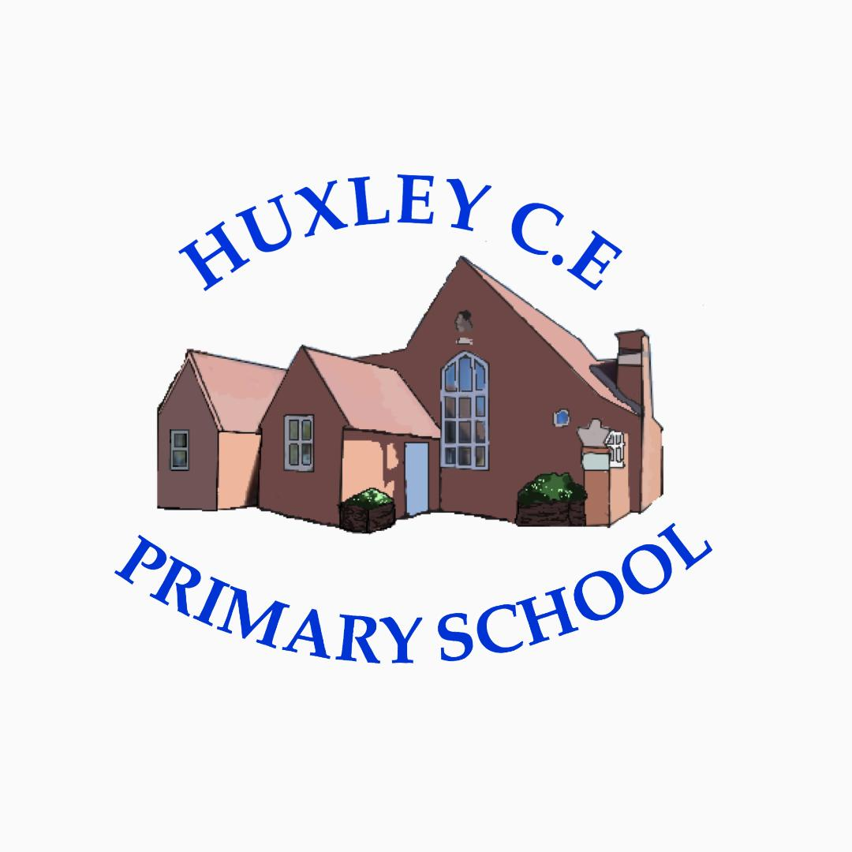

Curriculum-
Religious Education Policy

Religious Education Policy

Curriculum Intent

School Vision

Supporting our pupils to feel SAFE, SECURE and UNDERSTOOD

Our Christian vision, which is threaded through all aspects of school life, is:

With God's love, we can fly.

We aim high and embrace life in all its fullness.

Our school vision bible verse-

"those who trust in the Lord, they will find new strength. They will soar high on wings like eagles."- Isaiah 40:31

Vision for Religious Education at Huxley
Our vision for Religious Education at Huxley CE Primary School mirrors our whole school vision, that is that at Huxley, we aim to:
- Provide a caring, inclusive Christian community where all feel valued and secure.
- Share a vision and work in collaboration with all members of the school community towards a common goal.
- Enable every child to recognise and achieve his/her full potential so he/she can become a happy, confident and productive member of society.
- Provide time and individualised, creative learning experiences, both in the classroom and beyond, in response to the children's needs and interests, in order to develop enquiring minds and curiosity about the world around us.
- Develop the 'whole' child, nurturing social, spiritual and cultural understanding, to inform tolerance and instill strong Christian moral values which will guide each child's social conscience in his/her present and future choices.
- Develop confident children equipped with the skills and adaptability necessary to succeed in the modern world.

Curriculum Intent
Aims for teaching Questful Blackburn Diocesan/Chester Diocesan RE Curricula at Huxley
In teaching the Questful/Chester Diocese RE Curricula, we aim to ensure that our school Christian values are at the heart of all teaching and learning and that all pupils:
- Gain a rich, deep knowledge and understanding of Christian beliefs and practices, through biblical texts and theological ideas, enabling them to make progress throughout EYFS, KS1/2
- Are engaged and challenged through the exploration of concepts and questions
- Find out about a wide range of world faiths (and no faith); their beliefs, traditions, practices and views
- Understand that texts, beliefs, rituals and practices can help give us an identity and support in difficult circumstances
- Appreciate diversity
- Respect that religion has a continuing influence on our cultural heritage and on the lives of individuals and societies through different times, cultures and places
- Can explore and share their own religious, spiritual beliefs and thinking, through open and free discussion – making informed choices and developing their own commitments and values
- Reflect on work and shared discussion in a responsible and respectful manner
- Recognise common beliefs and practices between different faiths

Curriculum Implementation
The planning of the curriculum is organised in three phases:
- long term planning which shows the organisation of the topics across the year for each year group, and the coverage and progression of knowledge, skills and understanding; In RE we follow the Questful scheme, from the Blackburn Diocesan Board of Education and the Chester Diocesan scheme of work.
- medium term planning which demonstrates the progression of knowledge, skills and understanding within each topic; Questful covers EYFS, KS1, Lower KS2 and Upper KS2 and the Chester Diocesan planning is organised into individual year groups. –
- short term planning which explains and shows how children will build on their existing understanding, with the new learning specified as focused learning objectives for each RE lesson alongside subject specific vocabulary. RE is taught weekly and throughout the school year.

Curriculum Organisation
Our school curriculum for RE meets the requirements of the 1988 Education Reform Act (ERA). The ERA stipulates that RE is compulsory for all children. The ERA allows parents to withdraw their child from RE classes if they so wish, following discussion with the headteacher. The RE curriculum forms an important part of our school’s spiritual, moral, social and cultural teaching. It also promotes education for citizenship. The ERA states that the RE syllabus should reflect the fact that the religious traditions in Great Britain are in the main Christian, and that it should, take account of the teachings and practices of other major religions. Therefore, we teach Christianity, Judaism, Hinduism, Buddhism and Islam. Approximately 60% of our RE teaching is based upon Christianity. Huxley’s long-term RE planning also takes into consideration the Flexi-school nature of our setting. Plans ensure that pupils take part in at least the statutory number of sessions of RE each school year, whilst the revisiting of learning regularly and the use of knowledge and skills across the curriculum helps to embed learning in each child’s memory.

Our curriculum is based upon the Diocese of Blackburn’s resource, Questful, whilst also incorporating aspects of the Chester Diocese curriculum. We follow a 2-year rolling programme in Years 1/2, 3/4 and 5/6, while EYFS follow a curriculum which links to the EYFS goals. All learners are included in our RE sessions, with suitable provision made for those with SEND or with a greater depth of knowledge of the areas we cover.

Through each unit of work, our pupils consider a key question and have a focus concept. In the Christianity units, the focus concepts each define a key aspect of ‘The Biggest Story’ which is the overarching narrative of the Bible and children progress in their understanding of these year on year. Reflection is built into lessons and children have space to contemplate their own ways of seeing, living, thinking, believing and belonging in the world. As part of our RE provision, pupils are given the opportunities to meet believers, visit places of worship, investigate religious artefacts and other enrichment activities. Pupil’s work is recorded in their RE books with opportunities to show their understanding creatively, for example through art, story mapping, writing poems or songs and drama. Acorns and Oaks classes also have a large class RE book which contains examples of discussion and work. Pupil voice is an important part of our RE and SMSC work at Huxley and we have an active Ethos group in school.

Worship at Huxley C of E Primary School
We have a programme of worship at Huxley, which link with our school values:
Monday – Worship linked to My Happy Mind themes
Tuesday – worship led by Rev. Rhodes
Wednesday – Fruits and Shoots/Huxley ‘High 5’s’
Thursday – Worship through Song
Friday – Picture News

Professional Development of Staff and Use of Resources
At Huxley, there is a commitment to develop staff and ensure they are supported to provide the best quality teaching possible. CPD is key to ensuring pedagogical knowledge and understanding, as is the ability to ensure inclusive lessons. Any notes or ideas from relevant staff CPD is logged on the school PADLET for all staff to access. The subject leader supports staff in the planning and delivery of RE lessons. Regular book looks, discussion and staff meetings keep the subject leader up-to-date with RE throughout Huxley. There are resources to support quality planning and delivery of RE, as well as ideas for lessons contained within long term plans. On-line resources and web-sites are also a good tool to enrich the RE curriculum.

Parental involvement
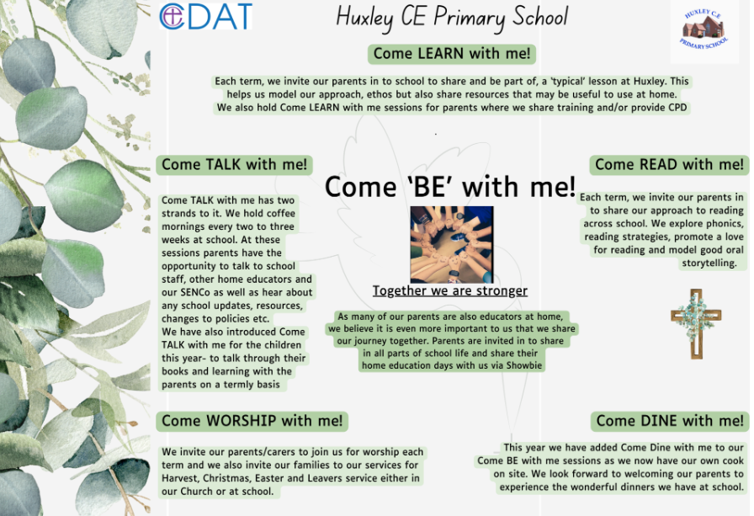
Due to the nature of our provision and our offer of flexi schooling, our parents and carers are considered as joint educators and therefore parental engagement is even more integral to our approach.

Things we do to help engage our parents in learning-
- The ‘Come Be’ with me programme above means that parents are engaged in all aspects of school life- we have subject specific Come Learn with me sessions too.
- Online Platform for sharing resources, videos and supporting work for days when children are not onsite but also to help guide learning across the term
- All overviews and weekly rotation/hours documents are shared with parents
- We have coffee mornings every 2- 3 weeks to ‘touch base’ with our parents on a variety of school development areas and use these to share new resources, learning activities or research in different subject areas too
- Parent consultation afternoons
Curriculum Impact
At Huxley, we aim to support each child in becoming a respectful, hard-working, shining star of the future through teaching, modelling and providing opportunities for the pupils to become understanding and respectful young people, who are engaged in their learning and display positive attitude.
Through the teaching of RE at Huxley, staff also provide opportunities for children to gain spiritual, moral, social and cultural values by:
- Finding meaning and purpose when looking at the world; exploring the influence of family, friends and media on choices made
- Considering relationships with different people and with God, developing skills necessary for living and working in a community
- Valuing those relationships and beginning to develop a sense of belonging and self-awareness
- Developing their own views and accepting and respecting the views of others
- Studying issues such as justice, tolerance and rules (law)
- Enjoying time with friends, meeting new people (e.g. visitors), being creative and learning about different cultures
Formative Assessment
At Huxley, we assess children’s learning in RE in different ways. In EYFS, the children cover and are assessed through their work in communication and language, personal, social and emotional development, literacy, understanding the world and expressive arts and design. In KS1 and 2, new learning builds on children’s prior knowledge and understanding. Through individual, group and class discussion, staff can make informal judgements about each child’s knowledge and understanding. Relevant vocabulary is taught as part of each session, which children should be able to access and apply with increasing confidence as they progress through each key stage. Observations and children’s responses in individual and class books allows teachers to decide next steps for further progression; giving verbal feedback or through the marking of work. At the end of each unit of work, children complete a Learning Map, which helps to show their knowledge and understanding. There is also a ‘ladder’ of expectation and achievement for staff to assess children’s work, which covers all abilities and offers further challenge if required.
Monitoring of impact (including role of governors)
- Pupil Voice
- Book Looks- weekly book look cycle in staff meetings
- Headteacher pop in’s/Learning Walks
- Come Talk with me- book talks
- Knowledge Trees
- Subject Leader Time
- Governor Termly Learning Walks
- Allocated Governor subject specific roles (TBC once new LGB established)
- Trust SIP visits
Reference to other relevant policies:
This policy links to other school policies, including: Behaviour and Relationships, Teaching and Learning Policy, Marking policy, PSHE policy

Policy review- Jan 2026

