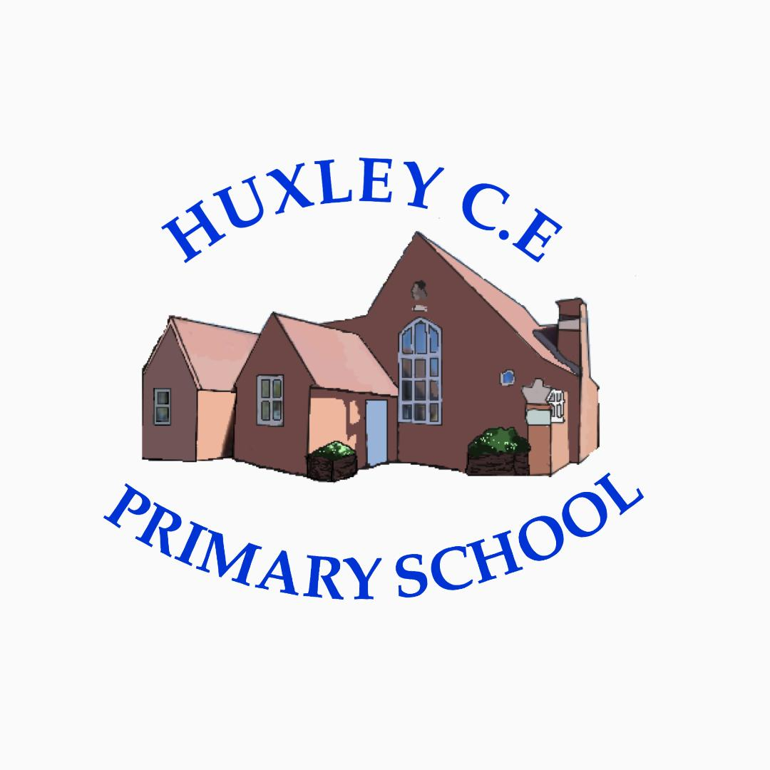

Curriculum-
PSHE
(Personal, Social and Health Education)

PSHE Policy

Curriculum Intent

School Vision

Supporting our pupils to feel SAFE, SECURE and UNDERSTOOD

Our Christian vision, which is threaded through all aspects of school life, is:

With God's love, we can fly.

We aim high and embrace life in all its fullness.

Our school vision bible verse-

"those who trust in the Lord, they will find new strength. They will soar high on wings like eagles."- Isaiah 40:31

Vision for PSHE Education at Huxley
Our vision for PSHE Education at Huxley CE Primary School mirrors our whole school vision, that is that at Huxley, we aim to:
Have PSHE at the core of what we do, supporting our school vision and enabling our children to become independent, confident, healthy and responsible members of our school and then society, as well as developing each child intellectually, morally, socially and spiritually.
Link our PSHE work with Zones of Regulation, Acts of Worship and Huxley High 5’s, as well as out outdoor enrichment and well-being activities.
Curriculum Intent
Aims for teaching PHSE through Jigsaw at Huxley
In teaching the PSHE curriculum, we aim to ensure that we encompass the guidelines from the National Curriculum and that our school values are at the heart of all teaching and learning and that all pupils:
- Learn and hold dear both British values, (Examples at end of the policy) and our own school values.
- Feel that the PSHE that we teach helps in improving their physical, mental and social well-being.
- Enhance the children’s skills in becoming caring, respectful and confident individuals who have an appreciation of what it means to be a positive member of a diverse, multicultural society and who have a good understanding of how to stay safe, healthy and develop good relationships.
- Should be equipped with a sound understanding of risk and with the knowledge and skills necessary to make safe and informed decisions.
- Receive drug education, financial education, sex and relationship education (SRE) and understand the importance of physical activity and diet for a healthy lifestyle.

Curriculum Implementation
The planning of the curriculum is organised in three phases:
- long term planning which shows the organisation of the topics across the year for each year group, and the coverage and progression of knowledge, skills and understanding; In PSHE we follow the Jigsaw scheme, which can support staff in planning their teaching in personal, social and health education.
- medium term planning which demonstrates the progression of knowledge, skills and understanding within each topic; Jigsaw covers each year group in the primary phase, in the following way:
Autumn 1: Being Me in My World
Autumn 2: Celebrating Difference
Spring 1: Dreams and Goals
Spring 2: Healthy Me
Summer1: Relationships
Summer2: Changing Me (which includes relevant RSE for each year group)
- short term planning which is organised and delivered by teaching staff, using the materials provided.

Curriculum Organisation
The PSHE curriculum at Huxley, forms an important part of our school’s spiritual, moral, social and cultural teaching, (see Jigsaw notes at end of the policy). It also promotes education for citizenship.

Our curriculum is based upon the Jigsaw PSHE resource and we follow a 2-year rolling programme in Years 1/2, 3/4 and 5/6, while EYFS follow a curriculum which links to the EYFS goals. All learners are included in our PSHE sessions, with suitable provision made for those with SEND or with a greater depth of knowledge of the areas we cover.

Through each ‘jigsaw’ piece, our pupils consider a focus area. Any written work is recorded in individual PSHE books with opportunities to show their understanding creatively, for example through art, story mapping, writing poems and reflection, however the programme also allows for paired and group discussion of examples of photographs, feelings and scenarios, which may not be recorded in written form.

Our PSHE policy is informed by existing DfE guidance:
● Keeping Children Safe in Education (statutory guidance)
● Respectful School Communities: Self Review and Signposting Tool (a tool to support a whole school approach that promotes respect and discipline)
● Equality Act 2010 and schools
● SEND Code of Practice: 0 to 25 years (statutory guidance)
● Mental Health and Behaviour in Schools (advice for schools)
●Social, emotional and mental wellbeing in primary and secondary education. (NICE guidance)
● Promoting and supporting mental health and wellbeing in schools and colleges (guidance for schools and colleges)
● Promoting Fundamental British Values as part of SMSC in schools
● The Jigsaw Programme is aligned to the PSHE Association Programmes of Study for PSHE

It includes all the statutory requirements for Relationships, Health Education and Sex Education included in the Changing Me Puzzle unit

Professional Development of Staff and Use of Resources
At Huxley, there is a commitment to develop staff and ensure they are supported to provide the best quality teaching possible. CPD is key to ensuring pedagogical knowledge and understanding, as is the ability to ensure inclusive lessons. Any notes or ideas from relevant staff CPD is logged on the school PADLET for all staff to access. The subject leader supports staff in the planning and delivery of PSHE lessons. Regular book looks, discussion and staff meetings keep the subject leader up-to-date with PSHE throughout Huxley. There are resources to support quality planning and delivery of PSHE, as well as ideas for lessons contained within long term plans. On-line resources and web-sites are also a good tool to enrich the PSHE curriculum, as are the enrichment lessons and days we value at Huxley.

Parental involvement
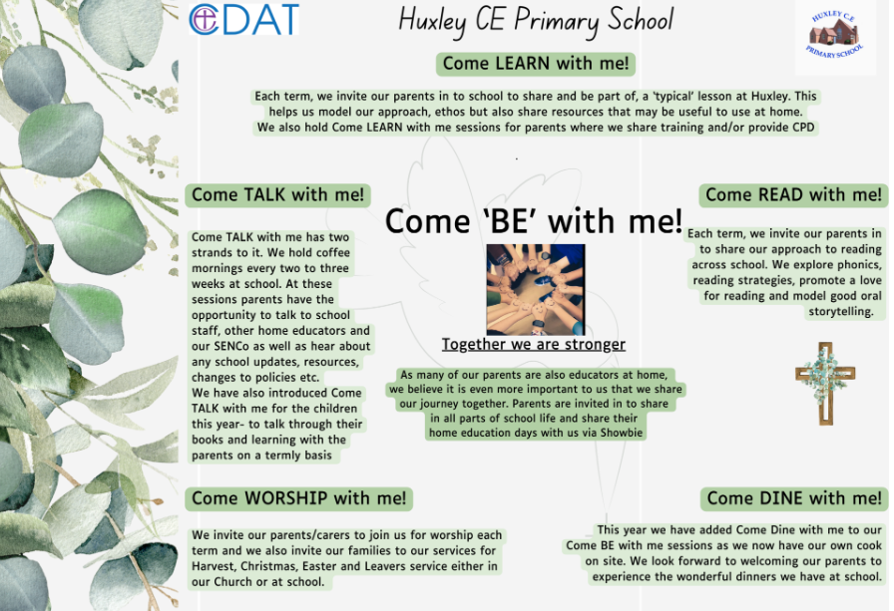
Due to the nature of our provision and our offer of flexi schooling, our parents and carers are considered as joint educators and therefore parental engagement is even more integral to our approach.

Things we do to help engage our parents in learning-
- The ‘Come Be’ with me programme above means that parents are engaged in all aspects of school life- we have subject specific Come Learn with me sessions too.
- Online Platform for sharing resources, videos and supporting work for days when children are not onsite but also to help guide learning across the term
- All overviews and weekly rotation/hours documents are shared with parents
- We have coffee mornings every 2- 3 weeks to ‘touch base’ with our parents on a variety of school development areas and use these to share new resources, learning activities or research in different subject areas too
- Parent consultation afternoons

Curriculum Impact
At Huxley, we aim to support each child in becoming a respectful, hard-working, shining star of the future through teaching, modelling and providing opportunities for the pupils to become understanding and respectful young people, who are engaged in their learning and display positive attitude.
The impact of our PSHE teaching is evident in school life as a whole – in pupils’ good behaviour, their attitudes to learning and their respect, care and understanding for and of, each other.
By the time children leave Huxley, we would like them to:
- be able to approach a range of real-life situations and apply their skills and attributes to help navigate themselves through modern life
- be on their way to becoming healthy, open-minded, respectful, socially and morally responsible, active members of society
- appreciate difference and diversity
- have the skills to talk about their emotions and begin to manage same
- have some skills to help look after their mental health and well-being
- be able to develop positive, healthy relationships with their peers
- understand the physical aspects involved in RSE at an age-appropriate level
- have respect for themselves and others.
Formative Assessment
At Huxley, we assess children’s learning in PSHE in different ways. In EYFS, the children cover and are assessed through their work in communication and language, literacy and understanding the world. In KS1 and 2, new learning builds on children’s prior knowledge and understanding. Through individual, group and class discussion, circle time sessions, pupil voice and worship, staff can make judgements about each child’s knowledge and understanding.

Monitoring of impact (including role of governors)
- Pupil Voice
- Book Looks- weekly book look cycle in staff meetings
- Headteacher pop in’s/Learning Walks
- Come learn with me
- Subject Leader Time
- Governor Termly Learning Walks
- Allocated Governor subject specific roles (TBC once new LGB established)
- Trust SIP visits
Reference to other relevant policies:
This policy links to other school policies, including: Safeguarding, SRE, Behaviour

