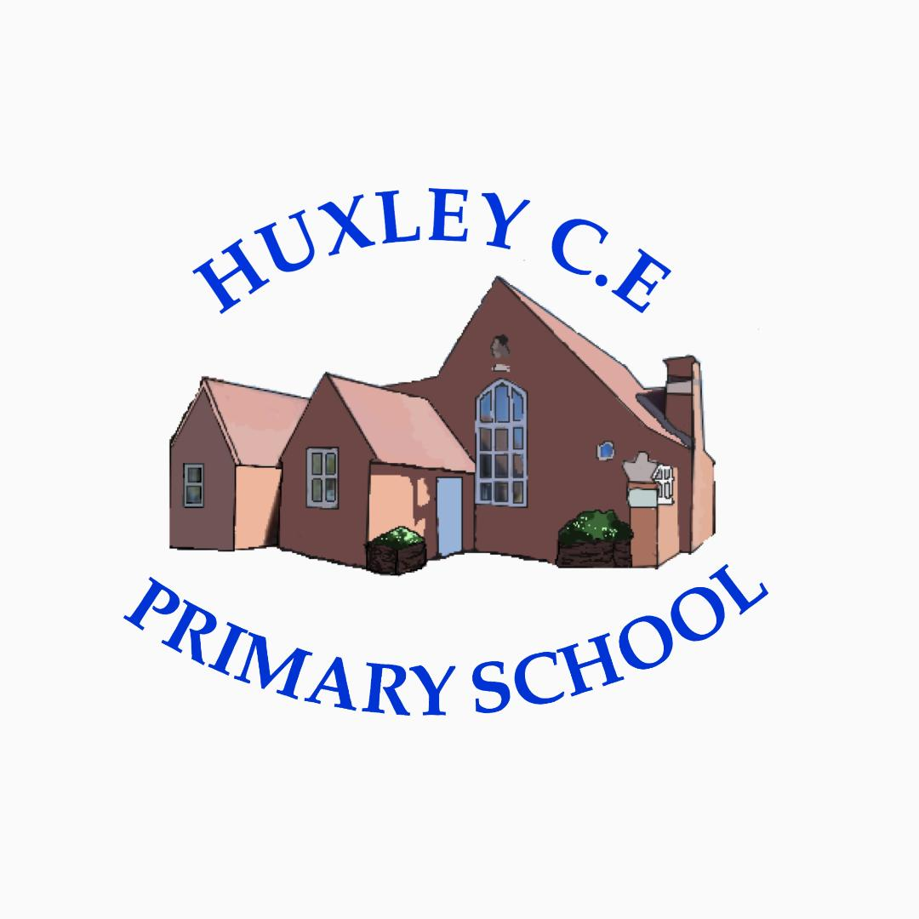

Curriculum-
History Policy

History Policy

School Vision

Supporting our pupils to feel SAFE, SECURE and UNDERSTOOD

Our Christian vision, which is threaded through all aspects of school life, is:

With God's love, we can fly.

We aim high and embrace life in all its fullness.

Our school vision bible verse-

"those who trust in the Lord, they will find new strength. They will soar high on wings like eagles."- Isaiah 40:31

Curriculum Intent
Vision for History
Here at Huxley CE Primary School, we aim to ignite an interest of the past, seeing it as real, live and interesting. During the early years the children are introduced to the recent past, relating to the lifestyles or parents and grandparents in the local area. For us it is important to bring history to life as much as possible.
As the children progress through the school they learn about significant people, events and places from both the recent and more distant past. Children have the opportunity to ask questions and research answers for themselves in their history topics. They learn about past events and that history can be seen by different people in different ways at different times.

Aims of the Curriculum
The National Curriculum aims to ensure that all pupils:
- know and understand the history of these islands as a coherent, chronological narrative, from the earliest times to the present day: how people’s lives have shaped this nation and how Britain has influenced and been influenced by the wider world
- know and understand significant aspects of the history of the wider world: the nature of ancient civilisations; the expansion and dissolution of empires; characteristic features of past non-European societies; achievements and follies of mankind
- gain and deploy a historically grounded understanding of abstract terms such as ‘empire’, ‘civilisation’, ‘parliament’ and ‘peasantry’
- understand historical concepts such as continuity and change, cause and consequence, similarity, difference and significance, and use them to make connections, draw contrasts, analyse trends, frame historically-valid questions and create their own structured accounts, including written narratives and analyses
- understand the methods of historical enquiry, including how evidence is used rigorously to make historical claims, and discern how and why contrasting arguments and interpretations of the past have been constructed
- gain historical perspective by placing their growing knowledge into different contexts, understanding the connections between local, regional, national and international history; between cultural, economic, military, political, religious and social history; and between short- and long-term timescales.

The aim of history teaching here at Huxley CE Primary School is to stimulate the children’s interest, curiosity and understanding about the past. Through the curriculum, pupils will gain a knowledge and understanding of Britain’s past and that of the wider world. We teach children a sense of chronology and through this develop a sense of identity and an awareness of the challenges of their time. Teaching should equip children to ask questions, think critically, weigh evidence and develop perspective and judgement. History teaching should help pupils to understand the complexity of pupil’s lives, the process of change, the diversity of societies and the relationship between different groups.

In EYFS History is taught as an integral part of the topic work through child-initiated and adult led activities. The children are given the opportunity to find out about past and present events in their own lives, and those of their families and other people they know. In EYFS History makes a significant contribution to developing a child’s understanding of the world through activities such as looking at pictures of famous people in History or discovering the meaning of new and old and past and present in relation to their own lives.

In Key Stage 1 pupils will develop an awareness of the past, using common words and phrases relating to the passing of time. Children will have the opportunity to use a range of materials and resources to enhance their learning and development within history. They should know where the people and events they study fit within a chronological framework and identify similarities and differences between ways of life in different periods. They will use a wide vocabulary of everyday historical terms. They should ask and answer questions, choosing and using parts of stories and other sources to show that they know and understand key features of events. They should understand some of the ways in which we find out about the past and identify different ways in which it is represented.

In Key Stage 2 pupils will continue to develop a chronologically secure knowledge and understanding of British, local and world history, establishing clear narratives within and across the periods they study. Children will have the opportunity to use a range of materials and resources to enhance their learning and development within history. They will note connections, contrasts and trends over time and develop the appropriate use of historical terms. They will regularly address and sometimes devise historically valid questions about change, cause, similarity and difference, and significance. They will construct informed responses that involve thoughtful selection and organisation of relevant historical information. They will learn how our knowledge of the past is constructed from a range of sources and that different versions of past events may exist, giving some reasons for this.

Curriculum Implementation

Curriculum Organisation

At Huxley, our History Curriculum is carefully planned and sequenced in line with the Foundation Stage Statutory Framework and Development Matters in the Early Years and the National Curriculum throughout KS1 and KS2. Historical knowledge is taught explicitly in History lessons so that children know more, remember more and can do more.

From EYFS to Year 6, we use Rising Stars History as our main tool for supporting teaching and learning in History. This helps us to ensure the progression of skills and knowledge.


History Curriculum Overview
 | Term
 | Autumn 1 | Autumn 2 | Spring 1 | Spring 2 | Summer 1 | Summer 2
EYFS and Y1/2  Cycle A |  | History: My Family History  What was life like when our grandparents were children? |  | History: The Greatest Explorers  Who were the greatest explorers? |  | History: Great Inventions – Transport  How did the first flight change the world/Why were the Rainhill trials important?
EYFS and Y1/2  Cycle B |  | History: Bonfire Night and the Great Fire of London  Should we still celebrate Bonfire Night/Did the Great Fire make London a better or worse place? |  | History: Holidays  How have holidays changed over time? |  | History: Our Local Heroes  Who are our local heroes?
Y3/4  Cycle A | History: The Stone Age  What was new about the New Stone Age? |  | History: The Bronze Age and the Iron Age  Which was more impressive – the Bronze Age or the Iron Age? |  | History: Local History  Why should we preserve our locality?
Y3/4  Cycle B |  | History: Crime and Punishment  How has Crime and Punishment changed over time? |  | History: Roman Britain  What happened when the Romans came to Britain? |  | History: The Ancient Egyptians  How much did the Ancient Egyptians achieve?
Y5/6  Cycle A | History: The Ancient Greeks  What did the Greeks do for us? |  | History: Journeys  What makes people go on a journey? |  | History: The Impact of War  Did WWI or WWII have the biggest impact on our locality?
Y5/6  Cycle B |  | History: The Vikings  Would the Vikings do anything for money? |  | History: The Anglo-Saxons  Was the Anglo-Saxon period really a Dark Age? |  | History: The Maya Civilisation  Why should we remember the Maya?

Planning
The planning of the curriculum is organised in three phases:
- long term planning which shows the organisation of the topics across the year, with a two-year cycle for Year 1/2, Year 3/4, and Year 5/6 and the coverage and progression of knowledge, skills and understanding. As seen in the curriculum overview above.
- medium term planning which demonstrates the progression of knowledge, skills and understanding within each topic.
- short term planning which teachers choose the learning outcomes for the groups of children they teach. Planning can be highlighted from the Rising Stars planning documents.

History is predominantly taught on the core days of Tue, Wed or Thurs. For flexi-learners the work covered on a Monday and Friday can be accessed by parents and children at home via Showbie. Any work completed at home, can be sent to teachers via Showbie or children can bring their learning into school.

At Huxley, high expectations are expected from teachers, teaching assistants and children in planning, teaching and learning, to ensure the needs of all are met, progress is made and children can achieve their maximum potential from their individual baseline.

Professional Development of Staff and Use of Resources
At Huxley, there is a commitment to develop staff and ensure they are supported to provide the best quality teaching possible. CPD is key to ensuring pedagogical knowledge and understanding, as is the ability to ensure inclusive lessons. Any notes or ideas from relevant staff CPD is logged on the school PADLET for all staff to access. The subject leader supports staff in the planning and delivery of History. Regular book looks, discussion and staff meetings keep the subject leader up-to-date with History throughout Huxley.

Parental involvement
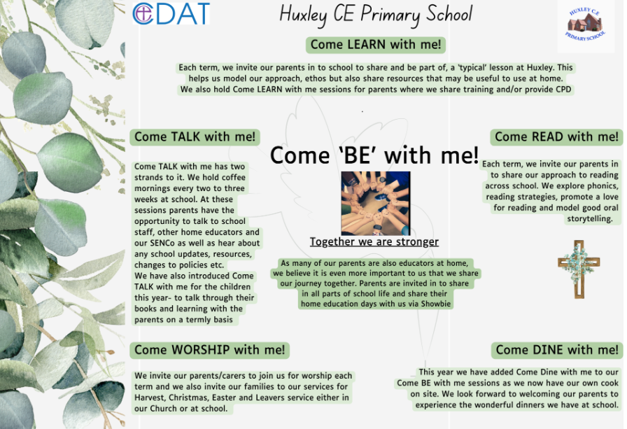
Due to the nature of our provision and our offer of flexi schooling, our parents and carers are considered as joint educators and therefore parental engagement is even more integral to our approach.

Things we do to help engage our parents in learning-
- The ‘Come Be’ with me programme above means that parents are engaged in all aspects of school life- we have subject specific Come Learn with me sessions too.
- Online Platform for sharing resources, videos and supporting work for days when children are not onsite but also to help guide learning across the term
- All overviews and weekly rotation/hours documents are shared with parents
- We have coffee mornings every 2- 3 weeks to ‘touch base’ with our parents on a variety of school development areas and use these to share new resources, learning activities or research in different subject areas too
- Parent consultation afternoons

Curriculum Impact
Our curriculum enables children to develop a chronological understanding of British history from the Stone Age to the present day. They will have had opportunities to draw comparisons with the achievements of the earliest world civilizations and their influences on the wider world.
By the end of Year 6, we want our children to be able to use a wide range of historical sources to ask and answer questions about the past and be able to understand the limitations of different types of resources so that our learners are prepared for their History learning beyond Key Stage 2.
Children will have an understanding and perspective about our locality and some of the challenges and achievements that have shaped the local area in which we live.

Formative Assessment
The material in Rising Stars History is written in such a way that assessment is an integral part of activities. The learning objectives for each session and activity are used as the basis for assessment, the criteria for which are outlined in the assessment section of the planning.
In EYFS, ELG objectives with history content from the ‘Understanding the World’ specific area of the EYFS curriculum are used as assessment tools.

In Key Stage 1 and 2, assessment statements are differentiated so that teachers can assess the progress of different groups in their classroom, suggesting how the teacher could assess pupils to find out whether they are at ‘Working Towards’, ‘At Expectations’ or ‘Exceeding’ using the progression grids within the Rising Stars Progression Frameworks.

The children all complete a Knowledge Tree at the start and end of each unit which demonstrates previous knowledge and then learnt knowledge.

Monitoring of impact (including role of governors)
- Pupil Voice
- Book Looks- weekly book look cycle in staff meetings
- Headteacher pop in’s/Learning Walks
- Come Talk with me- book talks
- Knowledge Trees
- Subject Leader Time (add in subject specific here if relevant)
- Governor Termly Learning Walks
- Allocated Governor subject specific roles (TBC once new LGB established)
- Trust SIP visits
Reference to other relevant policies
This policy links to other school policies, including: Teaching and Learning policy and Marking policy.

Policy review- Jan 2026

