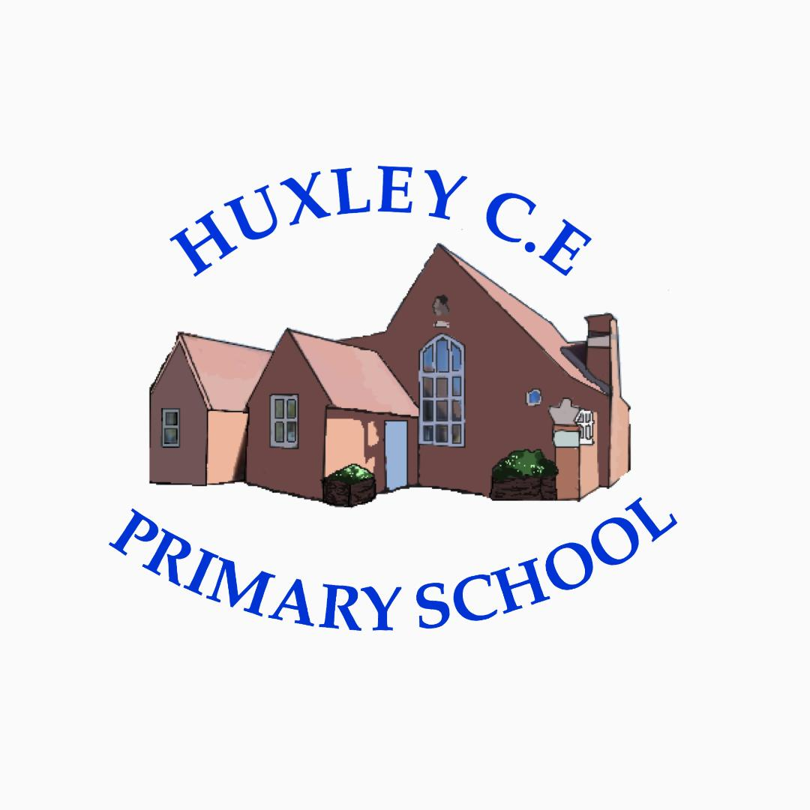

Curriculum-
Geography Policy

Geography Policy

School Vision

Supporting our pupils to feel SAFE, SECURE and UNDERSTOOD

Our Christian vision, which is threaded through all aspects of school life, is:

With God's love, we can fly.

We aim high and embrace life in all its fullness.

Our school vision bible verse-

"those who trust in the Lord, they will find new strength. They will soar high on wings like eagles."- Isaiah 40:31

Curriculum Intent
Vision for Geography
At Huxley CE Primary School we believe that Geography stimulates curiosity and imagination and we aim to build upon the child's ‘personal geography’ by developing geographical skills, understanding and knowledge through studying places and themes. At Huxley, Geography is a valued part of the curriculum as it provides a means of exploring, appreciating and understanding the world in which we live and how it has evolved. Geography explores the relationship between the Earth and its people.

Aims of the Curriculum
The National Curriculum aims to ensure that all pupils:
- Develop contextual knowledge of the location of globally significant places – both terrestrial and marine – including their defining physical and human characteristics and how these provide a geographical context for understanding the actions of processes
- Understand the processes that give rise to key physical and human geographical features of the world, how these are interdependent and how they bring about spatial variation and change over time
- Are competent in the geographical skills needed to:
-Collect, analyse and communicate with a range of data gathered through experiences of fieldwork that deepen their understanding of geographical processes
-Interpret a range of sources of geographical information, including maps, diagrams, globes, aerial photographs and Geographical Information Systems (GIS)
-Communicate geographical information in a variety of ways, including through maps, numerical and quantitative skills and writing at length.
At Huxley CE Primary School geography involves:
- Undertaking fieldwork in the local area.
- Comparing and contrasting landforms, land uses, weather, seasons and ecosystems.
- The use of secondary sources e.g. photos, books, media and videos, to obtain geographical information.
- Following directions using positional and directional language, also using these to direct others.
- Expressing and evaluating views on the attractive and unattractive features of the environment, e.g. tidiness, noise, building on greenbelt land.
- Naming the physical features of places, e.g. mountain, sea, beach, factory, valley.
- Using developing language to talk about their work e.g. route, scale, tide, erosion, climate, temperate, continent. Developing geographical skills of: making observations and measuring, recording observations through maps, talk, and writing, taking photographs, sketches and diagrams.
- Using maps, globes, atlases and interpreting photographs.
- Help the children appreciate the variety of responses to the same basic needs (ethnic, cultural and economic) and to imagine what it might be like to experience life in other places.

Key ‘golden threads’ are covered and repeated throughout the curriculum. These are: 'climate/weather’, 'settlement', ‘landscape’, ‘locality’ and ‘sustainability’.

In EYFS, children will develop awareness of their immediate environment, recognise places on maps and aerial photos, make their own simple maps and explore and contrast other places through images, video and stories. ELG objectives with geography content are mapped against Key Stage 1 objectives to ensure teaching is sequential throughout the school, building upon the children’s prior learning.

In Key Stage 1 children will develop their knowledge about the United Kingdom and their own locality. They’ll learn how to use maps, atlases and globes as well as learn simple compass directions. The children will also study seasonal and daily weather patterns in the United Kingdom and look at the hot and cold areas of the world in relation to the equator and the North and South Poles.

In Key Stage 2 children will build upon their knowledge of the U.K through studying regions, counties and topographical Features. The children will extend their knowledge to beyond the United Kingdom and will study Europe as well as North and South America. They will begin to look at similarities and differences of human geography such as types of settlement and land use. They will also study physical geography elements such as climate zones, rivers, mountains, volcanoes and earthquakes. Children will continue to use maps, atlases and globes and will use the 8 points of the compass in their work. They will start to consider the use of four and six figure grid references and ordinance survey maps.

Curriculum Implementation

Curriculum Organisation

At Huxley, our Geography Curriculum is carefully planned and sequenced in line with the Foundation Stage Statutory Framework and Development Matters in the Early Years and the National Curriculum throughout KS1 and KS2. Geographical knowledge is taught explicitly in geography lessons so that children know more, remember more and can do more.

From EYFS to Year 6, we use Rising Stars Geography as our main tool for supporting teaching and learning in Geography. This helps us to ensure the progression of skills and knowledge.


Geography Curriculum Overview
 | Term
 | Autumn 1 | Autumn 2 | Spring 1 | Spring 2 | Summer 1 | Summer 2
EYFS and Y1/2  Cycle A | Geography: Our Local Area  What's it like where we live? |  | Geography: People and their Communities  Where in the world do these people live? |  | Geography: Animals and their Habitats  Where do our favourite animals live?
EYFS and Y1/2  Cycle B | Geography: Seasons  What are seasons? |  | Geography: Journeys – Food  Where does our food come from? |  | Geography: Our Wonderful World  What are the seven wonders of our world?
Y3/4  Cycle A |  | Geography: The Americas  Can you come on a Great American Road Trip? |  | Geography: Earthquakes and Volcanoes  How does the Earth shake, rattle and roll? |  | Geography: Our World  Where on Earth are we?
Y3/4  Cycle B | Geography: Climate and Weather  Why is climate important? |  | Geography: Rivers and the Water Cycle  How does the water go round and round? |  | Geography: Coasts  Do we like to be beside the seaside?
Y5/6  Cycle A |  | Geography: South America – The Amazon  What is life like in the Amazon? |  | Geography: Protecting the Environment  Are we damaging our world? |  | Geography: Our World in the Future  How will our world look in the future?
Y5/6  Cycle B | Geography: Changes in our Local Environment  How is our country changing? |  | Geography: Journeys – Trade  Where does all our stuff come from? |  | Geography: Europe – A Study of the Alpine Region  Where should we go on holiday?

Planning
The planning of the curriculum is organised in three phases:
- long term planning which shows the organisation of the topics across the year, with a two-year cycle for Year 1/2, Year 3/4, and Year 5/6 and the coverage and progression of knowledge, skills and understanding. As seen in the curriculum overview above.
- medium term planning which demonstrates the progression of knowledge, skills and understanding within each topic.
- short term planning which teachers choose the learning outcomes for the groups of children they teach. Planning can be highlighted from the Rising Stars planning documents.

Geography is predominantly taught on the core days of Tue, Wed or Thurs. For flexi-learners the work covered on a Monday and Friday can be accessed by parents and children at home via Showbie. Any work completed at home, can be sent to teachers via Showbie or children can bring their learning into school.

At Huxley, high expectations are expected from teachers, teaching assistants and children in planning, teaching and learning, to ensure the needs of all are met, progress is made and children can achieve their maximum potential from their individual baseline.

Professional Development of Staff and Use of Resources
At Huxley, there is a commitment to develop staff and ensure they are supported to provide the best quality teaching possible. CPD is key to ensuring pedagogical knowledge and understanding, as is the ability to ensure inclusive lessons. Any notes or ideas from relevant staff CPD is logged on the school PADLET for all staff to access. The subject leader supports staff in the planning and delivery of Geography. Regular book looks, discussion and staff meetings keep the subject leader up-to-date with Geography throughout Huxley.

Parental involvement
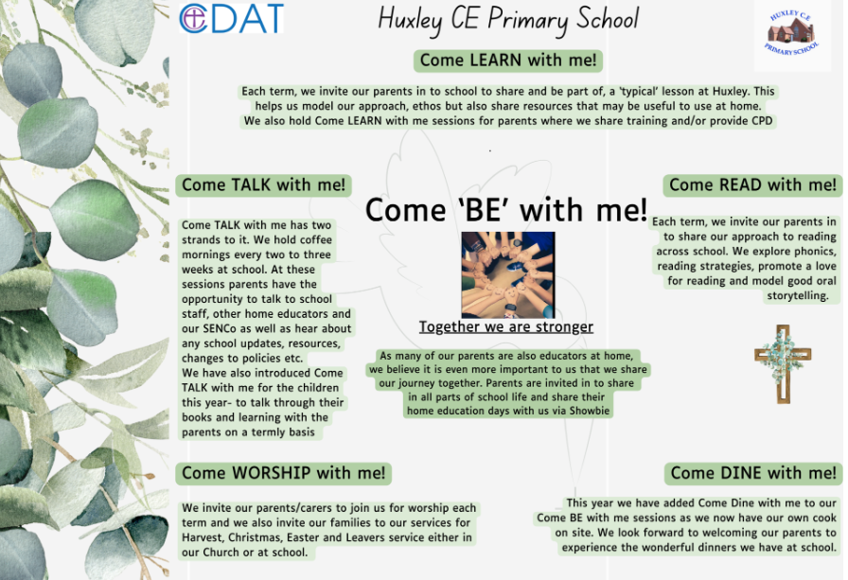
Due to the nature of our provision and our offer of flexi schooling, our parents and carers are considered as joint educators and therefore parental engagement is even more integral to our approach.

Things we do to help engage our parents in learning-
- The ‘Come Be’ with me programme above means that parents are engaged in all aspects of school life- we have subject specific Come Learn with me sessions too.
- Online Platform for sharing resources, videos and supporting work for days when children are not onsite but also to help guide learning across the term
- All overviews and weekly rotation/hours documents are shared with parents
- We have coffee mornings every 2- 3 weeks to ‘touch base’ with our parents on a variety of school development areas and use these to share new resources, learning activities or research in different subject areas too
- Parent consultation afternoons

Curriculum Impact
We aim for our children to be confident geographers who are able to demonstrate their knowledge and understanding of the world around them and the wider world through the application of their geographical skills.

Formative Assessment
The material in Rising Stars Geography is written in such a way that assessment is an integral part of activities. The learning objectives for each session and activity are used as the basis for assessment, the criteria for which are outlined in the assessment section of the planning.
In EYFS, ELG objectives with geography content from the ‘Understanding the World’ specific area of the EYFS curriculum are used as assessment tools.

In Key Stage 1 and 2, assessment statements are differentiated so that teachers can assess the progress of different groups in their classroom, suggesting how the teacher could assess pupils to find out whether they are at ‘Working Towards’, ‘At Expectations’ or ‘Exceeding’ using the progression grids within the Rising Stars Progression Frameworks.

The children all complete a Knowledge Tree at the start and end of each unit which demonstrates previous knowledge and then learnt knowledge.

Monitoring of impact (including role of governors)
- Pupil Voice
- Book Looks- weekly book look cycle in staff meetings
- Headteacher pop in’s/Learning Walks
- Come Talk with me- book talks
- Knowledge Trees
- Subject Leader Time (add in subject specific here if relevant)
- Governor Termly Learning Walks
- Allocated Governor subject specific roles (TBC once new LGB established)
- Trust SIP visits
Reference to other relevant policies
This policy links to other school policies, including: Teaching and Learning policy and Marking policy.

Policy review- Jan 2026

