

Curriculum-
Maths Policy

Maths Policy

School Vision

Supporting our pupils to feel SAFE, SECURE and UNDERSTOOD

Our Christian vision, which is threaded through all aspects of school life, is:

With God's love, we can fly.

We aim high and embrace life in all its fullness.

Our school vision bible verse-

"those who trust in the Lord, they will find new strength. They will soar high on wings like eagles."- Isaiah 40:31

Vision for Maths
At Huxley, our vision for Maths reflects our school vision. We endeavour to ensure that children acquire a long-term, secure, adaptable understanding of mathematics. Our aim is to ensure pupils are secure in each element of Mathematics before advancing onto the next. Due to the nature of our school offer, it is vital to ensure that the fundamental basics underpinning a good grasp of Mathematics are embedded and secure before moving on.

Through Maths at Huxley, we aim:
- to promote enjoyment of learning through practical activity, exploration and discussion;
• to develop confidence and competence with numbers and the number system;
• to develop the ability to solve problems through decision-making and reasoning in a range of contexts;
• to develop a practical understanding of the ways in which information is gathered and presented; to explore features of shape and space, and developing measuring skills in a range of contexts;
• to help children understand the importance of mathematics in everyday life.
• to become fluent in the fundamentals of mathematics, including through varied and frequent practice with increasingly complex problems over time, so that pupils develop conceptual understanding and the ability to recall and apply knowledge rapidly and accurately.
• to reason mathematically by following a line of enquiry, conjecturing relationships and generalisations, and developing an argument, justification or proof using mathematical language.

Curriculum Intent

Aims of the Curriculum
The National Curriculum aims to ensure that all pupils:
- become fluent in the fundamentals of mathematics, including through varied and frequent practice with increasingly complex problems over time, so that pupils develop conceptual understanding and the ability to recall and apply knowledge rapidly and accurately
- reason mathematically by following a line of enquiry, conjecturing relationships and generalisations, and developing an argument, justification or proof using mathematical language
- can solve problems by applying their mathematics to a variety of routine and non-routine problems with increasing sophistication, including breaking down problems into a series of simpler steps and persevering in seeking solutions

Our curriculum embraces the National Curriculum aims, and provides guidance to help pupils to become:
Visualisers – we use the Concrete Pictorial Abstract approach to help pupils understand mathematics and to make connections between different representations.
Describers – we place great emphasis on mathematical language and questioning so pupils can discuss the mathematics they are doing and, in doing so, support them to take ideas further.
Experimenters – as well as being fluent mathematicians, we want pupils to love and learn more about mathematics in the world around them.

Curriculum Implementation

Curriculum Organisation
From EYFS to Year 6, we use White Rose Maths as our main tool for supporting teaching and learning in Mathematics. This helps us to ensure the progression of skills and knowledge.
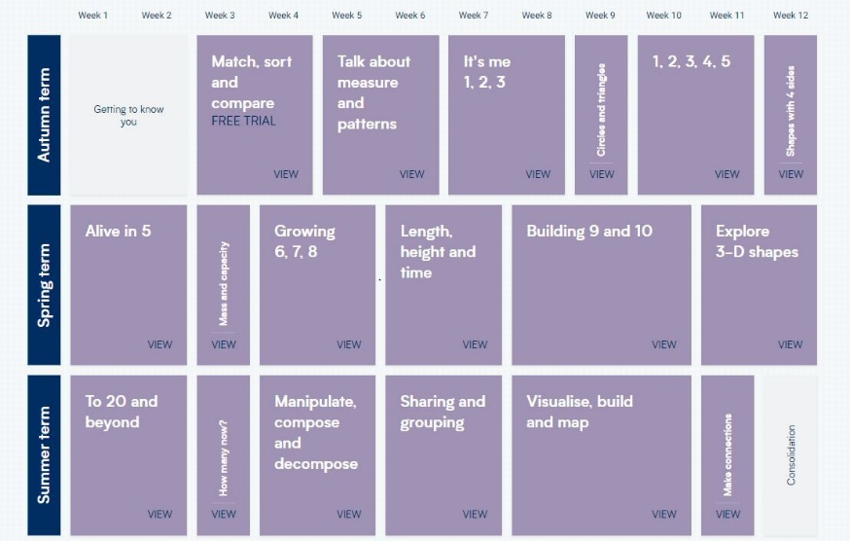
EYFS

Year 1 (red) and Year 2 (blue)
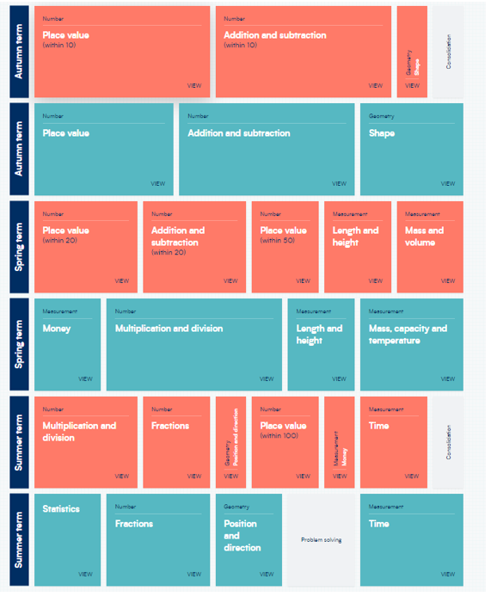
Year 3 (orange) and Year 4 (green)
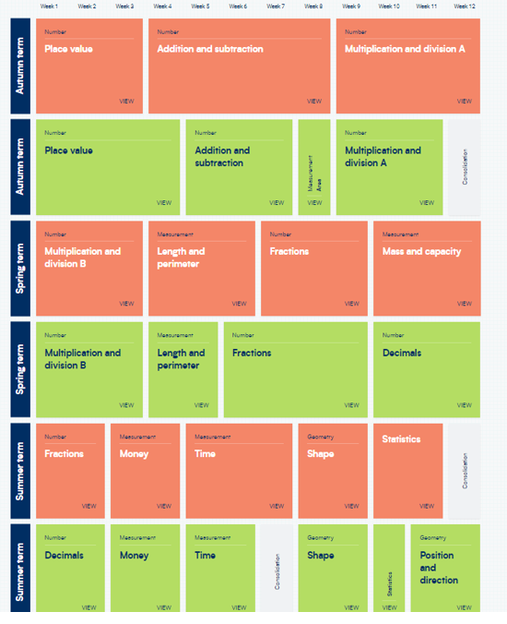

Year 5 (purple) and Year 6 (blue)
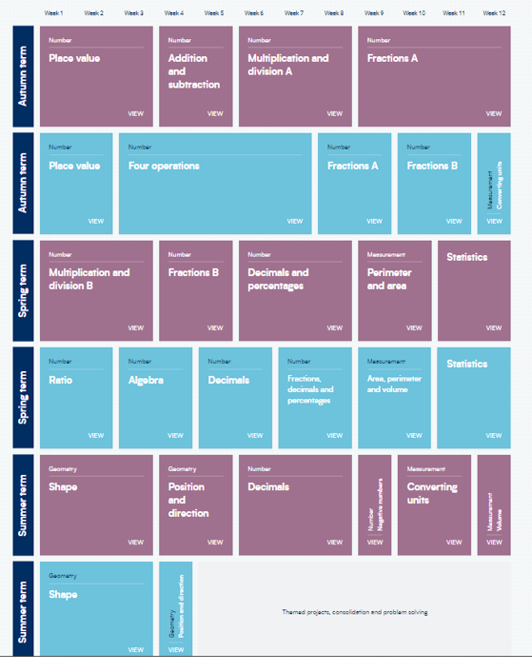

Planning
The planning of the curriculum is organised in three phases:
- long term planning which shows the organisation of the topics across the year for each individual year group, and the coverage and progression of knowledge, skills and understanding. As seen above in the curriculum maps from White Rose Maths.
- medium term planning which demonstrates the progression of knowledge, skills and understanding within each topic.
- short term planning which teachers choose the learning outcomes for the groups of children they teach. Planning can be highlighted from the WRM planning documents.

Maths is taught Monday-Friday in class to children who access school full-time. For flexi-learners the work covered on a Monday and Friday can be accessed by parents and children at home and is supported by the White Rose ‘Maths Practice Journal’. Additional material is also put on Showbie. Any work completed at home, can be sent to teachers via Showbie or children can bring their learning into school.

At Huxley, high expectations are expected from teachers, teaching assistants and children in planning, teaching and learning, to ensure the needs of all are met, progress is made and children can achieve their maximum potential from their individual baseline.

Professional Development of Staff and Use of Resources
At Huxley, there is a commitment to develop staff and ensure they are supported to provide the best quality teaching possible. CPD is key to ensuring pedagogical knowledge and understanding, as is the ability to ensure inclusive lessons. Any notes or ideas from relevant staff CPD is logged on the school PADLET for all staff to access. The subject leader supports staff in the planning and delivery of Mathematics. Regular book looks, discussion and staff meetings keep the subject leader up-to-date with Maths throughout Huxley.

Parental involvement
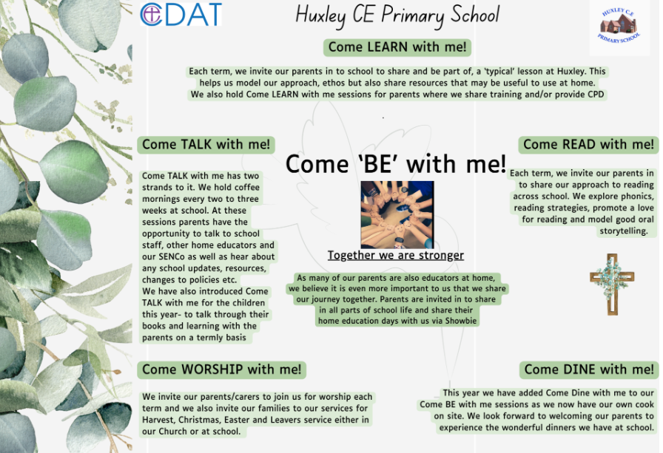
Due to the nature of our provision and our offer of flexi schooling, our parents and carers are considered as joint educators and therefore parental engagement is even more integral to our approach.

Things we do to help engage our parents in learning-
- The ‘Come Be’ with me programme above means that parents are engaged in all aspects of school life- we have subject specific Come Learn with me sessions too.
- Online Platform for sharing resources, videos and supporting work for days when children are not onsite but also to help guide learning across the term
- All overviews and weekly rotation/hours documents are shared with parents
- We have coffee mornings every 2- 3 weeks to ‘touch base’ with our parents on a variety of school development areas and use these to share new resources, learning activities or research in different subject areas too
- Parent consultation afternoons

Curriculum Impact
We aim for our children to be confident mathematicians who are able to make links to the wider world and apply their Maths skills in real life contexts. We see learners who are able to use their skills and understanding to problem solve and tackle reasoning questions within the classroom and beyond.

Formative Assessment
Assessment for Learning is fundamental to raising standards and enabling children to reach their potential. Assessment in Mathematics takes place daily using a range of strategies such as on the spot verbal feedback, discussions with children and marking and feedback of recorded work. Children are given time to respond to feedback and marking. All corrected work is re-marked to ensure it is correct. Teaching staff can then make informed decisions about each individual child’s next steps.
Assessment of learning is formally completed at the end of each unit of work, using assessment materials created by White Rose Maths. Teachers use assessment information to inform their planning. Formal assessment points in Maths are:
- Baseline assessment for EYFS children
- Assessment against the ELG’s at the end of EYFS.
- End of Key Stage 1 SAT’s
- Year 4 tests (CDAT)
- Year 4 Multiplication Tables Check
- End of Key Stage 2 SAT’s
- Termly Star Assessments

Monitoring of impact (including role of governors)
- Pupil Voice
- Book Looks- weekly book look cycle in staff meetings
- Headteacher pop in’s/Learning Walks
- Come Talk with me- book talks
- Knowledge Trees
- Subject Leader Time (add in subject specific here if relevant)
- Governor Termly Learning Walks
- Allocated Governor subject specific roles (TBC once new LGB established)
- Trust SIP visits
Reference to other relevant policies
This policy links to other school policies, including: Teaching and Learning policy and Marking policy.

Policy review- Jan 2026

