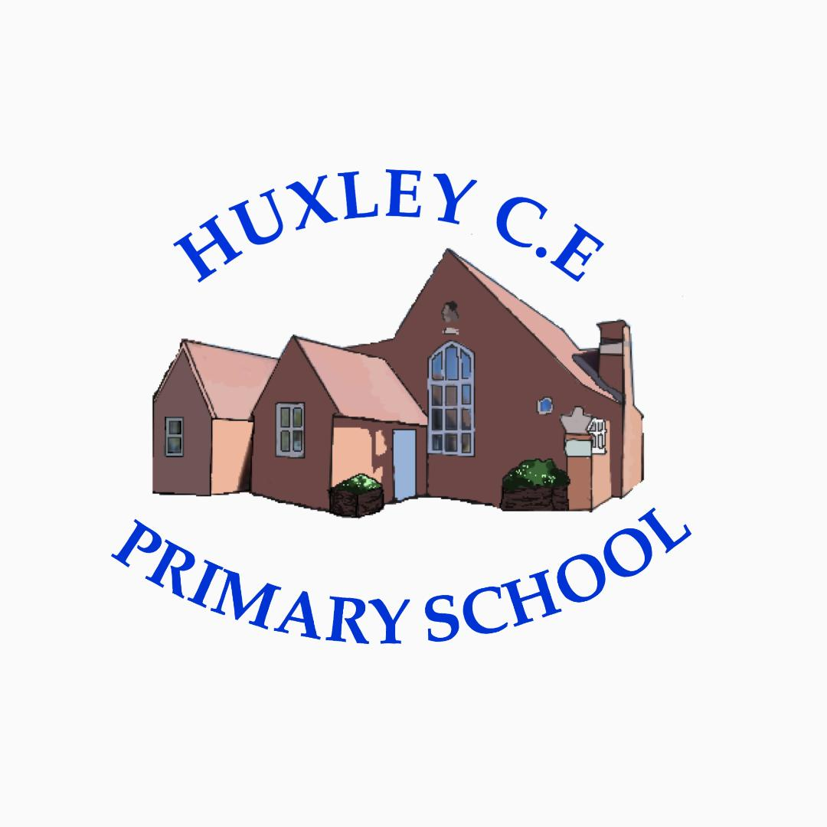

Curriculum-
English

English Policy

Curriculum Intent

School Vision

Supporting our pupils to feel SAFE, SECURE and UNDERSTOOD

Our Christian vision, which is threaded through all aspects of school life, is:

With God's love, we can fly.

We aim high and embrace life in all its fullness.

Our school vision bible verse-

"those who trust in the Lord, they will find new strength. They will soar high on wings like eagles."- Isaiah 40:31

Vision for English Education at Huxley
Our vision for English Education at Huxley CE Primary School mirrors our whole school vision, that is that, at Huxley, we aim to:
- Immerse children in a range of texts and genres for reading and writing effectively, for purpose and audience, which we hope allows them to become independent readers and writers, who set high expectations for themselves, while feeling supported and secure in their surroundings.
- Ensure that we embed all National Curriculum requirements, whilst keeping the needs of each learner in mind. Our curriculum allows staff to plan and resource learning which reflects our pastoral care in meeting the needs and aspirations of all of our pupils.
- Give the children meaningful opportunities to engage, discuss, process and progress in their learning.
Curriculum Intent
Aims for teaching English through texts from Literacy Tree at Huxley
In teaching the English curriculum, we aim to ensure that we encompass the objectives from the National Curriculum and that our school values are at the heart of all teaching and learning and that all pupils:
- Are motivated to use the examples of high-quality, diverse literature to support their growth in reading and writing through building curiosity and interest using drama, discussion and lessons planned to meet their needs.
- Are encouraged to speak to a range of audiences through everyday learning and enrichment activities, acquiring a wide and rich vocabulary.
- Using speaking and listening skills to elaborate on their ideas, make formal presentations, debate and demonstrations to peers.
- Enjoy sharing books and reading independently and regularly; reading easily, fluently and with good understanding.
- Build their comprehension skills through well-planned guided reading sessions.
- See writing as interesting and useful, while understanding that it is a communication tool.
- Are given the opportunity to plan, draft, revise, edit and present their writing in a range of ways, writing clearly, accurately and coherently, adapting style for a range of audiences and purposes.
- Can incorporate correct punctuation and grammar into their writing.

Curriculum Implementation
The planning of the curriculum is organised in three phases:
- long term planning which shows the organisation of the topics across the year for each year group, and the coverage and progression of knowledge, skills and understanding; In English we follow the National Curriculum objectives and the Literacy Tree scheme, which can support staff in planning teaching in reading, writing and spelling, as well as home learning.
- medium term planning which demonstrates the progression of knowledge, skills and understanding within each topic; Literacy Tree covers EYFS, KS1 (Years 1 and 2), Lower KS2, (Years 3 and 4) and Upper KS2, (Years 5 and 6).
- short term planning which teachers choose the learning outcomes for the groups of children they teach. Planning can be highlighted from the Literacy Tree plans or typed up by teachers and shared with appropriate support staff.

English is taught Monday-Friday in class to children who access school full-time. For flexi-learners the work covered on a Monday and Friday is up-loaded to Showbie each week for parents and children to access at home. On Mondays, the children focus on comprehension skills and on Fridays, they continue working from the class text. Any work completed at home, can be sent to teachers via Showbie or children can bring their learning into school to be put in their books.

Phonics is taught using the Read, Write, Inc programme, starting in Reception. Groups are taught by teachers and teaching assistants each Teusday, Wednesday and Thursday morning. Children not in RWI groups access spelling, punctuation and grammar (SPaG) during these times and follow the National Curriculum.

At Huxley, high expectations are expected from teachers, teaching assistants and children in planning, teaching and learning, to ensure the needs of all are met, progress is made and children can achieve their maximum potential from their individual Baseline.

Professional Development of Staff and Use of Resources
At Huxley, there is a commitment to develop staff and ensure they are supported to provide the best quality teaching possible. CPD is key to ensuring pedagogical knowledge and understanding, as is the ability to ensure inclusive lessons. Any notes or ideas from relevant staff CPD is logged on the school PADLET for all staff to access. The subject leader supports staff in the planning and delivery of English lessons. Regular book looks, discussion and staff meetings keep the subject leader up-to-date with English throughout Huxley. There are resources to support quality planning and delivery of English, as well as comprehensive lesson plans contained within long term plans. On-line resources and web-sites are also a good tool to enrich the English curriculum.

Parental involvement
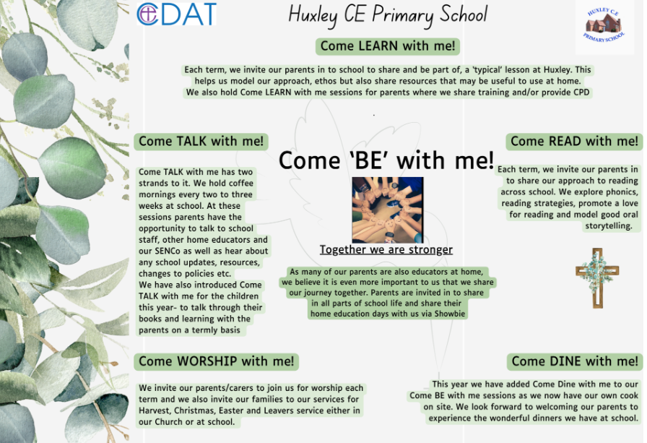
Due to the nature of our provision and our offer of flexi schooling, our parents and carers are considered as joint educators and therefore parental engagement is even more integral to our approach.

Things we do to help engage our parents in learning-
- The ‘Come Be’ with me programme above means that parents are engaged in all aspects of school life- we have subject specific Come Learn with me sessions too.
- Online Platform for sharing resources, videos and supporting work for days when children are not onsite but also to help guide learning across the term
- All overviews and weekly rotation/hours documents are shared with parents
- We have coffee mornings every 2- 3 weeks to ‘touch base’ with our parents on a variety of school development areas and use these to share new resources, learning activities or research in different subject areas too
- Parent consultation afternoons

Curriculum Impact
At Huxley, we aim to support each child in becoming a respectful, hard-working, shining star of the future through teaching, modelling and providing opportunities for the pupils to become understanding and respectful young people, who are engaged in their learning and display positive attitude.

Formative Assessment
At Huxley, we assess children’s learning in English in different ways. In EYFS, the children cover and are assessed through their work in communication and language, literacy and understanding the world. In KS1 and 2, new learning builds on children’s prior knowledge and understanding. Through individual, group and class discussion, staff can make judgements about each child’s knowledge and understanding.
- Baseline assessment for Reception children
- Year 1 phonics check
- Year 4 tests (CDAT)
- End of Key Stage 2 SAT’s
- Termly Star Assessments
- Half-termly Read, Write, Inc assessments

Monitoring of impact (including role of governors)
- Pupil Voice
- Book Looks- weekly book look cycle in staff meetings
- Headteacher pop in’s/Learning Walks
- Come read with me/Come learn with me
- Subject Leader Time
- Governor Termly Learning Walks
- Allocated Governor subject specific roles (TBC once new LGB established)
- Trust SIP visits
Reference to other relevant policies:
This policy links to other school policies, including: Marking policy

English Curriculum at Huxley CE Primary School
At Huxley, we use a two-year cycle for Years 1/2, 3/4 and 5/6, as well as a programme for EYFS
Cycle A – Year 2024-2025
EYFS
Autumn term 2024 |  | Spring term 2025 |  | Summer term 2025
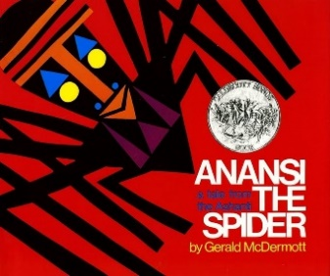 | 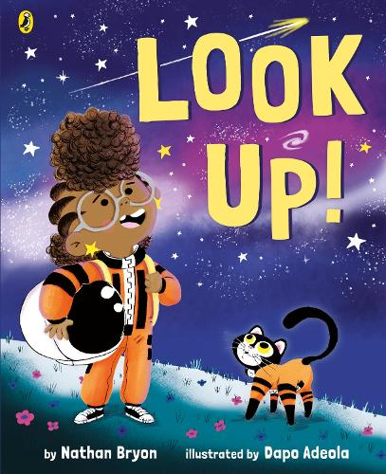 | 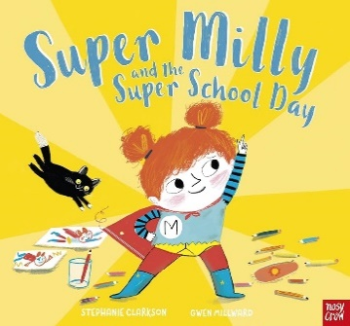
Booklets about spiders Labels and captions, call-and-response poems, descriptive posters, simple explanations | Non-chronological reports Dialogue, diaries, re-telling (oral dictation), mini-autobiography, ship’s log | Alternative character version Letters of encouragement; a retelling; song lyrics and job applications

Cycle A – Year 2024-2025
Yr1/2
Autumn term 2024 |  | Spring term 2025 |  |  | Summer term 2025
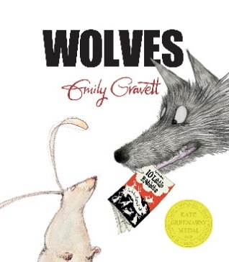 | 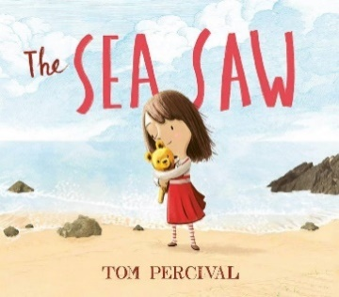 |  | 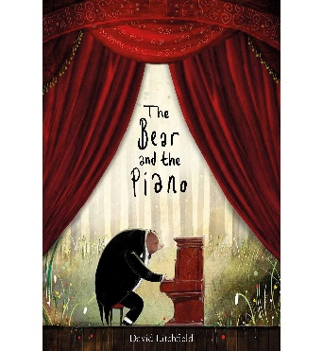
Non-chronological leaflets Captions, information writing, character descriptions and comparisons | Own version narrative Writing in role, notes of advice, missing posters, diary entries, letters of thanks |  | Own version narratives about bravery Letters of advice, short news reports, writing in role, retellings, information posters

Cycle A – Year 2024-2025
Yr3/4
Autumn term 2024 |  | Spring term 2025 |  | Summer term 2025
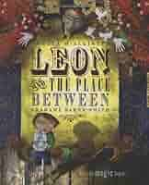 | 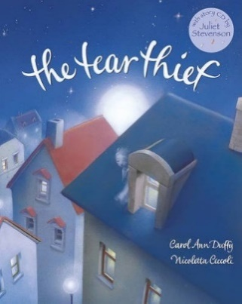 | 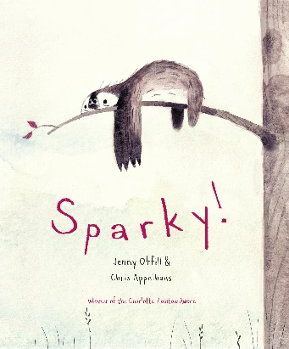 | 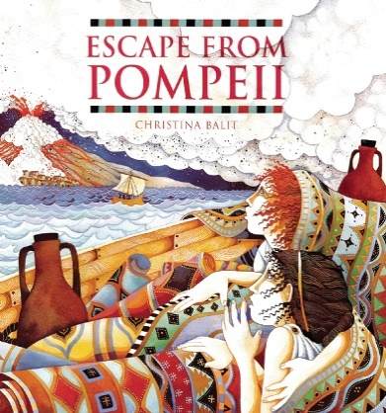
Fantasy narratives Persuasive posters, setting descriptions, thought bubbles/diaries, dialogue | Newspaper article Shared poems, diary entries, persuasive posters, letters of explanation, discussions | Own traditional tales Short news reports, diaries, character descriptions, adverts | Newspaper reports Setting descriptions, diaries, letters, thought bubbles  Links with Geography
Guided Reading choices
Autumn term 2024 | Spring term 2025 | Summer term 2025
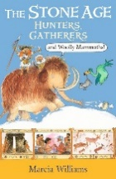 Link to History | 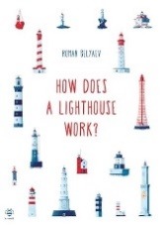

Cycle A – Year 2024-2025
Yr5/6
Autumn term 2024 |  | Spring term 2025 |  | Summer term 2025
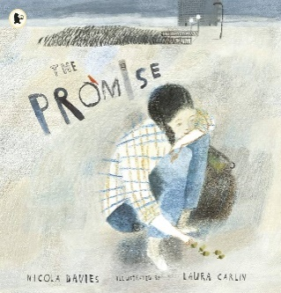 | 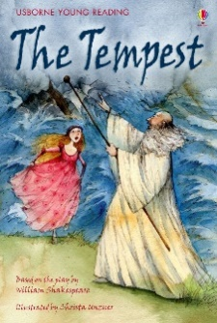 | 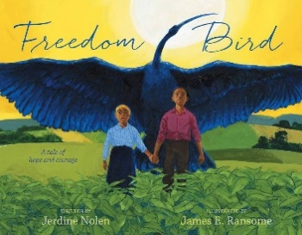 | 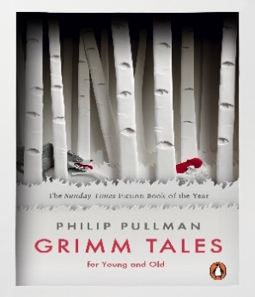
Narrative poem sequels Promises, extended thought bubbles, diary entries, letters in role, figurative captions, summary poems | Playscripts Setting descriptions, character descriptions, diaries, dialogue | Biographies Non-narrative poems, explanations, dialogue, postcards, letters of advice, descriptions, recounts, narrative poems | Own version traditional tales Retellings, character studies, monologues, character comparisons

Guided Reading choices
Autumn term 2024 | Spring term 2025 | Summer term 2025
 Link to history | 