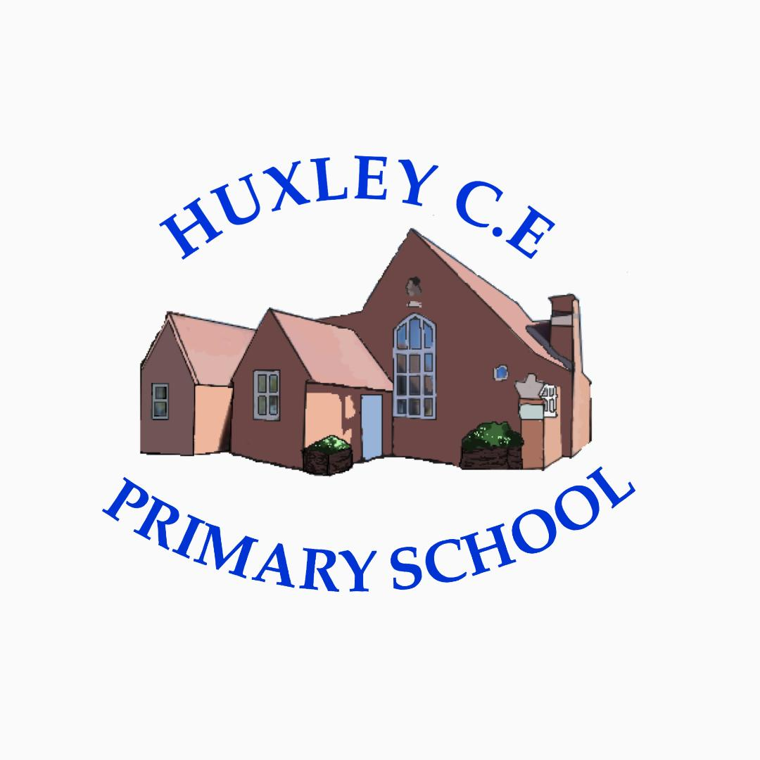

Curriculum-
Science Policy

Science Policy

Curriculum Intent

School Vision

Supporting our pupils to feel SAFE, SECURE and UNDERSTOOD

Our Christian vision, which is threaded through all aspects of school life, is:

With God's love, we can fly.

We aim high and embrace life in all its fullness.

Our school vision bible verse-

"those who trust in the Lord, they will find new strength. They will soar high on wings like eagles."- Isaiah 40:31

Vision for Science at Huxley
At Huxley, Science is an inspiring and practical subject where children are encouraged to develop their natural curiosity: to ask questions and find answers. Our progressive curriculum, which encourages the children to question the world around them, enables each child to develop scientific knowledge and conceptual understanding through the specific disciplines of biology, chemistry and physics.

As they progress through our curriculum, children will develop disciplinary knowledge (scientific skills) to enable them to work scientifically. Essential to this process is the development of scientific vocabulary. They will be encouraged to use appropriate vocabulary accurately, both when speaking and in their writing. As they progress through school, they will be able to recognise different types of scientific enquiry and plan when to use them. At every stage, children will be encouraged to communicate scientific concepts clearly and accurately, linking their understanding to the world around them.

Throughout each unit, links are made with the wider curriculum, particularly in maths, reading, writing and the use of ICT. Children will have opportunities to extend their writing to encompass a range of genre and read for information, for research and for pleasure.

Schemes of Work are coherently planned and sequenced towards sufficient substantive and disciplinary knowledge for future learning.
Substantive Knowledge: this is the concepts, laws, theories and models which are referred to in the national curriculum as 'scientific knowledge and conceptual understanding'.
Substantive knowledge is organised into the 3 subject disciplines: biology, chemistry and physics.

Disciplinary Knowledge: this is referred to in the national curriculum as 'working scientifically' and it includes knowing how to carry out practical procedures.

By learning substantive and disciplinary knowledge, pupils not only know 'the science'; they also know the evidence for it and how this evidence is gained.

Aims of the Curriculum
The National Curriculum aims to ensure that all pupils:

- develop scientific knowledge and conceptual understanding through the specific disciplines of biology, chemistry and physics
- develop understanding of the nature, processes and methods of science through different types of science enquiries that help them to answer scientific questions about the world around them
- are equipped with the scientific knowledge required to understand the uses and implications of science, today and for the future
Curriculum Organisation
EYFS-
Children make fantastic scientists because they have naturally inquisitive and creative minds. The Switched on Science in the Early Years teaching units we use (and accompanying online resources and posters) have been created specifically for practitioners working with young children in Foundation Stage. Explicit links are made in our planning to the specific and prime areas of learning.

Each unit provides engaging, quality science experiments to harness curiosity and develop children’s scientific ability and personal development through play and exploration. The units prepare them well for years 1/2 curriculum below.

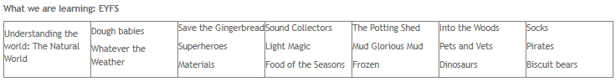
KS1 and KS2
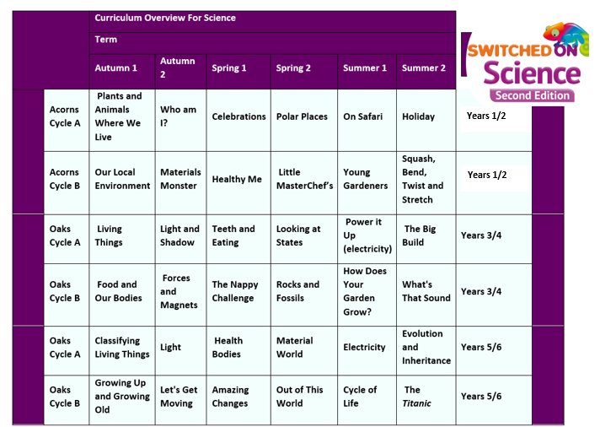
Curriculum Implementation
Implementation is how a scheme translates the objectives (intent) into activity. Everything a
pupil does and thinks in science is important, so it is crucial that activities provide regular
opportunities for pupils to engage in hands on practical activity as well as think about or
research scientific ideas and skills.

As a school we use the Rising Stars ‘Switched on Science’ scheme of work to ensure there is consistency throughout the school and focus on the key vocabulary in year group. Teachers map out the science topics in their long term plans and ensure each area is taught ready for transition into the next year group. In our Early Years Foundation Stage, the teaching staff focus on aspects in Understanding the World and Expressive Arts and Design to build the children’s knowledge, vocabulary and curiosity through extensive outdoor learning opportunities and we offer weekly forest school sessions across school for all ages. These foundations ensure as the children progress through the years, they take this enjoyment and inquisitive nature with them to learn new exciting skills.

Due to our mixed age provision, following our EYFS year, we teach our units on a 2 yearly basis for years 1/2, 3/4 and years 5/6. The units are organised in a way that ensures coverage but also addresses prior knowledge and where they are in their school journey- see pupil curriculum journey maps and individual subject content overviews which highlight this.

Science is taught weekly to all children (this is protected as a subject delivered when all children are in school not just full-time pupils) It is also interwoven in other lessons for cross curricular links to keep the ‘magic of science’ alive. This allows our children to use newly learned vocabulary in all aspects of learning and make links with science and the wider world. Our school is fortunate to have extensive grounds to explore and we use these to enhance our science lessons as well as provide curriculum rich resources. We embrace outdoor learning at every opportunity.

Switched on Science has been designed to cover all the requirements of the National Science curriculum in a way that is intended to develop pupils ’understanding of the concepts, practices and perspectives that underpin each discipline of science.

Throughout the scheme pupils are engaged in asking questions and using one of the five science enquiry activities:
• observation over time
• fair or comparative tests
• identification and classification
• research
• pattern seeking.

All activities have been planned so that they are relevant to the learning outcomes and pupil’s experiences, ensuring that they are timely and meaningful. Where appropriate they are hands-on, ensuring that pupils engage in regular first-hand experience using a range of equipment, including ICT where suitable, to enhance and deepen learning.

Communicating science and scientific vocabulary
Throughout Switch on Science, pupils are asked to communicate their science using different
approaches, e.g. writing, drama, poetry, discussion, modelling and using ICT (to create video
clips, etc.).

Engaging pupils in a range of approaches to communicating science ensures that all pupils
can share ideas and by listening to themselves articulate ideas, pupils engage in self-assessment, either reinforcing their learning or changing ideas and therefore moving learning on. By using different approaches to recording and communicating, all pupils can share their science, which means that teachers can access learning through assessment and use outcomes to plan next steps. This is particularly important in supporting some of our children with SEND who find communicating difficult or have difficulties in writing.

Key scientific vocabulary for each unit is listed (with definitions) so that teachers can share
with pupils the expectation that these words should be learned. These also form part of our Knowledge Trees. A pupil’s ability to use scientific words appropriately is an indicator of understanding of knowledge and skills. Teachers can use a pupil’s ability to use key words as part of assessment for learning, listening for how the words are used and, if necessary, asking follow-up questions to check depth of understanding through our Come Talk with Me sessions.
Switched on Science activities are designed to ensure that the expectations of literacy and mathematics are appropriate to each year group in science and therefore application of literacy and numeracy skills are embedded throughout. Where appropriate, links with other curriculum subjects are included in the introductory
section to topics and individual activities. This includes STEM suggestions for arts related visitors, such as engineers, photographers, artists, poets to work with pupils and visits to places where science and other subjects naturally link.

Professional Development of Staff and Use of Resources
All of our curriculum resources have in built CPD for staff delivering units. Some areas of this are shared with parents too, due to our flexi provision, many parents are joint educators and where relevant, we share training with them.

Resources
All teachers have access to the scheme of work we follow and there are resources preloaded onto Switched on Science to support teaching. We are well resources for science. Teachers are regularly asked if new products need to be ordered or refreshed and are encouraged to actively check they have the correct resources before a science lesson is taking place.

Health and Safety
All teaching staff are aware of the resources used for science and will counter any risks they see by making lessons safe as well as engaging. If equipment is broken or damaged this is replaced and staff made aware of changes to resources. Safeguarding of children and staff during practical lessons is of great importance and the teaching staff are aware of risks associated with equipment and children handling them. We adhere to CLEAPPS guidance and advice documents as well as using BeSafe!

Parental involvement
Due to the nature of our provision and our offer of flexi schooling, our parents and carers are considered as joint educators and therefore parental engagement is even more integral to our approach.

Things we do to help engage our parents in learning-
- The ‘Come Be’ with me programme above means that parents are engaged in all aspects of school life- we have subject specific Come Learn with me sessions too.
- Online Platform for sharing resources, videos and supporting work for days when children are not onsite but also to help guide learning across the term
- All overviews and weekly rotation/hours documents are shared with parents
- We have coffee mornings every 2- 3 weeks to ‘touch base’ with our parents on a variety of school development areas and use these to share new resources, learning activities or research in different subject areas too
- Parent consultation afternoons

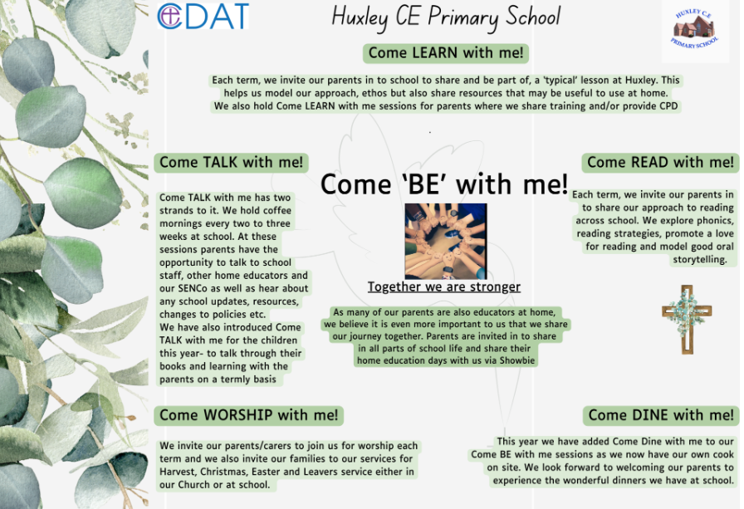

Curriculum Impact

The children are able to reflect on learning and its outcomes clearly and confidently, making links to the wider world where appropriate. The teaching staff see excited learners asking questions to enhance learning and act on this to meet the needs of their inquisitive minds.
We endeavour for our children to be confident and creative in their learning whilst understanding the importance of science. Science is included in staff meetings to ensure teaching staff are up to date with new information and support can be given to those who seek it. A map of skills is regularly updated and reviewed. When moderating work, pupil voice is also taken into account and a sample of children from each class will be asked to discuss their science learning through our Come Talk with Me sessions. From this we see the excitement and children reflecting positively on lessons they have witnessed and taken part in. This also gives the children a chance to showcase the new vocabulary and use it in the correct context.
Pupils develop their knowledge and skills through a series of planned activities linked to the curriculum which build on previous and personal knowledge. To assess the impact, teachers evaluate the knowledge and skills that pupils have gained against the original expectations of activities (the intent). This is indicated by the outcomes assigned to each activity. What and how well pupils have achieved will be accessed through using a range of approaches to assessment for learning. It is important that assessment supports a pupil’s journey through the science curriculum to ensure appropriate outcomes for each individual even more so in the context of our provision as a flexi school.
Assessment
The material in Switched on Science is written in such a way that assessment is an integral part of activities. The learning objectives at the beginning of each activity show the intention for learning and
these are then used as the basis for assessment, the criteria for which are outlined in the assessment section of the SoW-split into subject knowledge and working scientifically.
Assessment statements are differentiated so that teachers can assess the progress of different groups in their classroom, suggesting how the teacher could assess pupils to find out whether they are at Working Towards, At expectations or Exceeding using the progression grids within the Rising Stars Progression Frameworks.
A feature of Switched on Science is the application of ‘Working Scientifically Skills’ and ‘Knowledge and Understanding’ through regular problem solving activities. Challenging pupils to apply their learning in new contexts provides opportunities for them to further embed ideas and skills. Assessing how pupils respond to applying their knowledge and skills is an indicator of how successful their leaning has been.

Units are mapped out across a two-year cycle. Year group whole school journeys are considered so we are aware of previous units visited for different year groups and have highlighted this in plans and transition documents. This is also a major part of our yearly Curriculum Review meetings. Unit overview documents highlight previous learning and recap points.

The children all complete a Knowledge Tree at the start and end of each unit which demonstrate previous knowledge and then learnt knowledge. Knowledge trees are in books but also inform our Come Talk with me sessions.

Differentiation and Inclusion
We teach science to all children, whatever their ability and start point. It is a broad and balanced curriculum which is differentiated to ensure all children can access it with a hands-on learning approach but also in mind the different starting points of those who are identified as SEND or those who have not previously been in formal education prior to Huxley. Teachers work towards removing barriers to learning and participation and following the children’s interests where possible to teach this subject.

Monitoring of impact (including role of governors)
- Pupil Voice
- Book Looks- weekly book look cycle in staff meetings
- Headteacher pop in’s/Learning Walks
- Come Talk with me- book talks
- Knowledge Trees
- Subject Leader Time (add in subject specific here if relevant)
- Governor Termly Learning Walks
- Allocated Governor subject specific roles (TBC once new LGB established)
- Trust SIP visits
Reference to other relevant policies
This policy should be read in conjunction with our Behaviour and Relationships, Teaching and Learning Policy and Marking policy

Policy review- Jan 2026

