Reception Home Learning Suggestions Week Beginning 6th July 2020
 | Reading and stories | Phonics, reading and writing | Maths skills | Other
Monday | Watch ‘Zog’ Written by Julia Donaldson  https://www.youtube.com/watch?v=9_LmS3q4E6k  Read with your child  https://home.oxfordowl.co.uk/ | Watch Phonics session 23  https://www.youtube.com/watch?v=T0tEhcgBBRU  Super sentence – can you write a sentence about this picture?   |   https://wrm-13b48.kxcdn.com/wp-content/uploads/2020/06/Day-1-Zog.pdf  Zog is the biggest orange dragon!  Look at more complex patterns with our next stage of not just colour but size?  Lots of different positional language to figure out.  See resources below | Build a castle! A lego castle, box model, a wooden castle or sofa-cushions and balnkets castle.
Tuesday | Go on teach your monster read website  https://www.teachyourmonstertoread.com | Watch Phonics session 24  https://www.youtube.com/watch?v=iXdE-JtYuGo  Write a sentences to describe Zog. What amazing describing words can you use?  See resources below  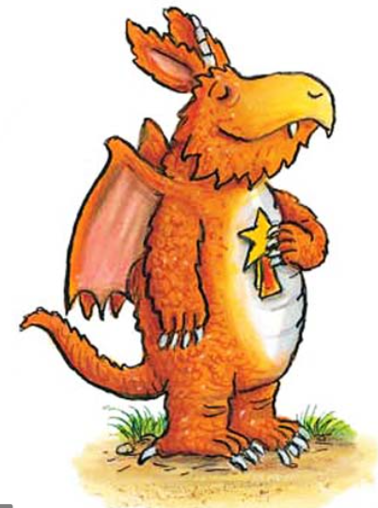 | https://wrm-13b48.kxcdn.com/wp-content/uploads/2020/06/Day-2-Zog.pdf  Zog has been so successful. Look at all his stars!  How many does he have?  See resources below | Dress up day! What will you be? A king, queen, knight, dragon, princess? Who else in your family will dress up with you? Stay dressed up all day and have a princesses and knights day!
Wednesday | Listen to your child read for 10 mins. Oxford owl or a book from home  https://home.oxfordowl.co.uk/ | Watch Phonics session 25  https://www.youtube.com/watch?v=vEXXQ4pPrXY  All the dragons are learning to fly.  Can you write a set of instruction on how to fly?  - First…………….. | https://wrm-13b48.kxcdn.com/wp-content/uploads/2020/06/Day-3-Zog.pdf  The dragons have many lessons. Flying is one of them. Can you count how many dragons there are, which dragons have gone and how many are left?  See resources below |   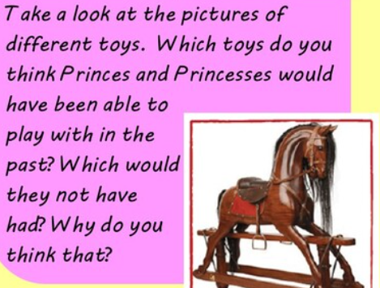
Thursday | Watch the animation of Zog on i-player  https://www.bbc.co.uk/iplayer/episode/b0bwdw8y/zog | Watch Phonics session 26  https://www.youtube.com/watch?v=papBILRQPCs |   https://wrm-13b48.kxcdn.com/wp-content/uploads/2020/06/Day-4-Zog.pdf  Zog studies for years at Dragon School.  Learning to roar and to breath fire and to fly.  What school rules do you think dragons will have?  They might be a bit different to the school rules you are used to!  Can you come up with 10 or even 20 rules  for dragons?  - Do not fly in the playground.  - Do not breathe fire inside!  - You must only eat princesses in the dining room. | Make your own shield and helmet  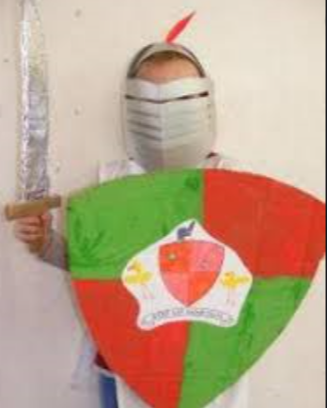
Friday | Go on teach your monster read website  https://www.teachyourmonstertoread.com | Practise Phase 3 tricky words https://youtu.be/R087lYrRpgY  Super sentence   | https://wrm-13b48.kxcdn.com/wp-content/uploads/2020/06/Day-5-Zog.pdf  Zog makes various attempts to fly and always remembers to practise just like his teacher tells him to. It’s time to be dragons! Can you time  your flights?  See resources below | In the story, Zog  learns to fly in dragon  school, can you pretend  to fly like Zog?…  Flying lesson 1:  Who can jump the  furthest into the sky?  With your friends and  family practice jumping  up high. Who can jump  up the highest?  Flying lesson 2:  Zog has to flap his  wings fast to fly up  high, how fast can  you flap your wings?
Please remember that these activities are suggestions only. Do not feel under pressure to complete all of these – you could pick and choose, repeat your favourites and definitely introduce your own! Whatever you get up to, please send us your photos, videos and messages via email. Naomi.coates@willowwood.cheshire.sch.uk.
Please keep yourselves happy and safe!

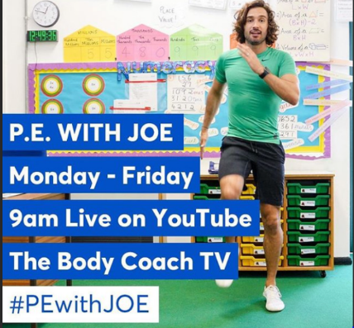
Keeping fit is really important for our health but it also makes us feel great. We know how much you love our daily wake and shake in Reception so why don’t you try P.E with Joe Wicks live on YouTube to start off your day!

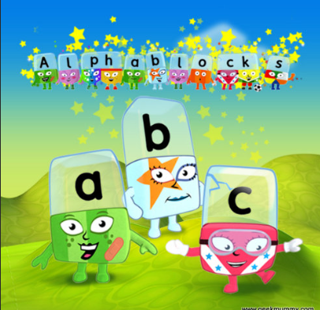
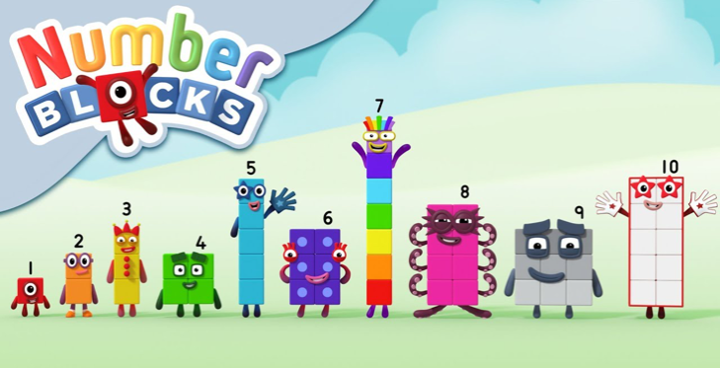
Remember these? Why not watch a few episodes to help with your numbers and phonics? Both programmes can be found on bbc iplayer.

Monday maths

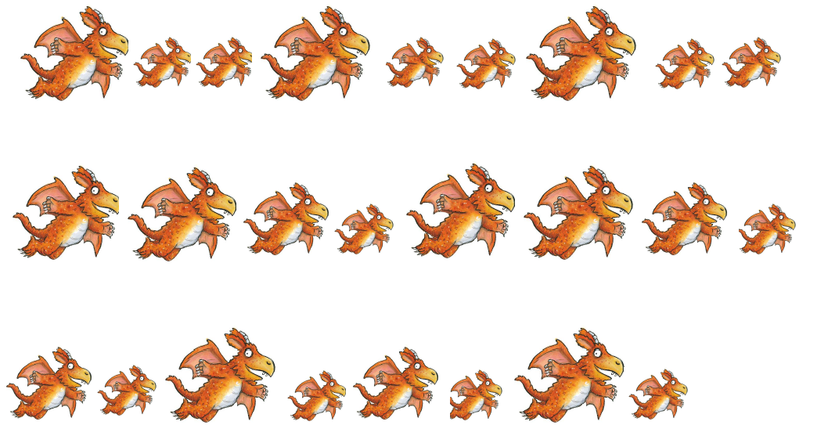
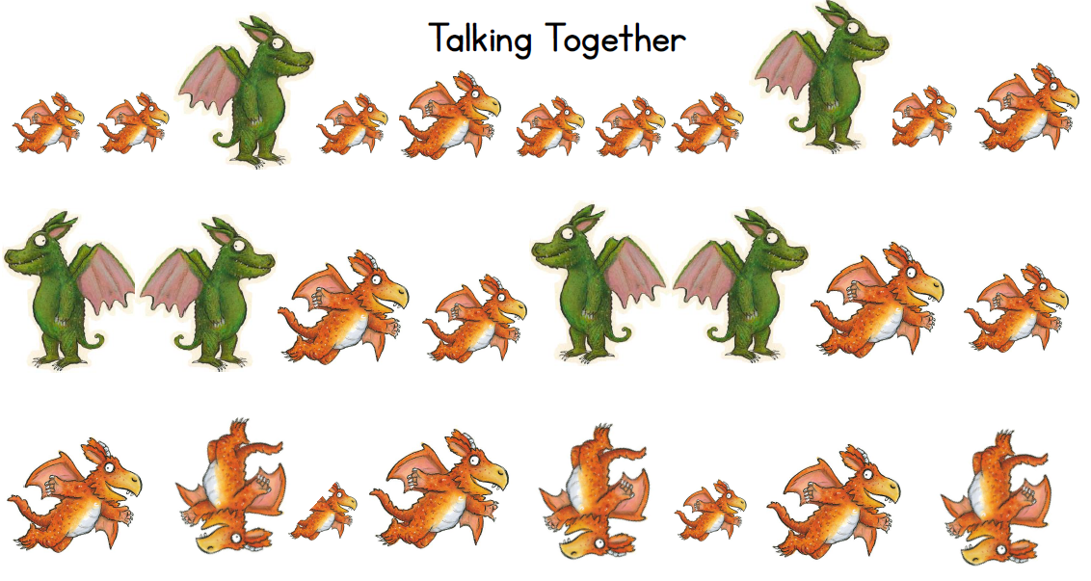

Tuesday maths

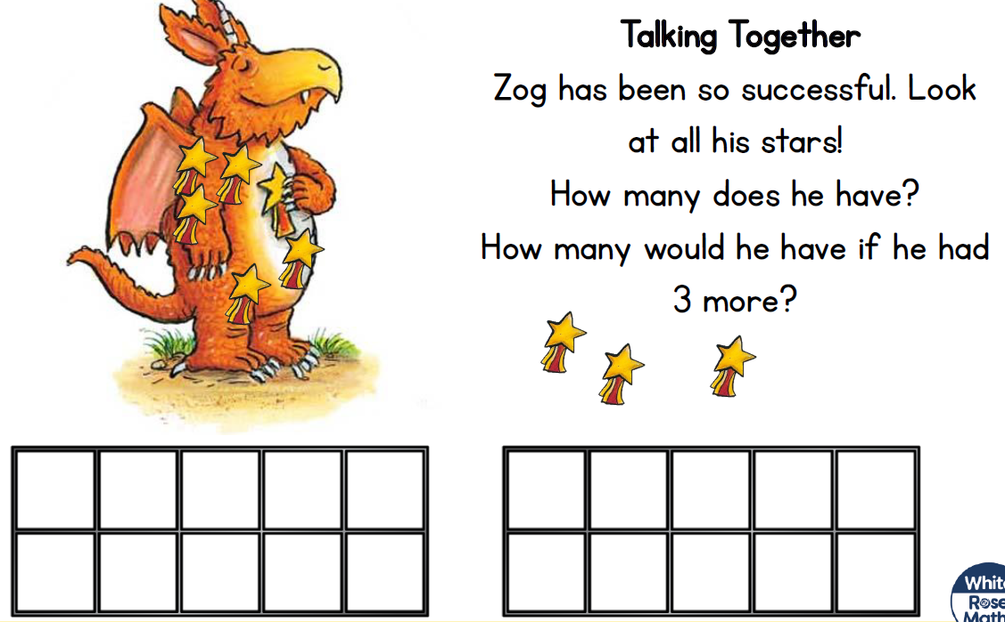
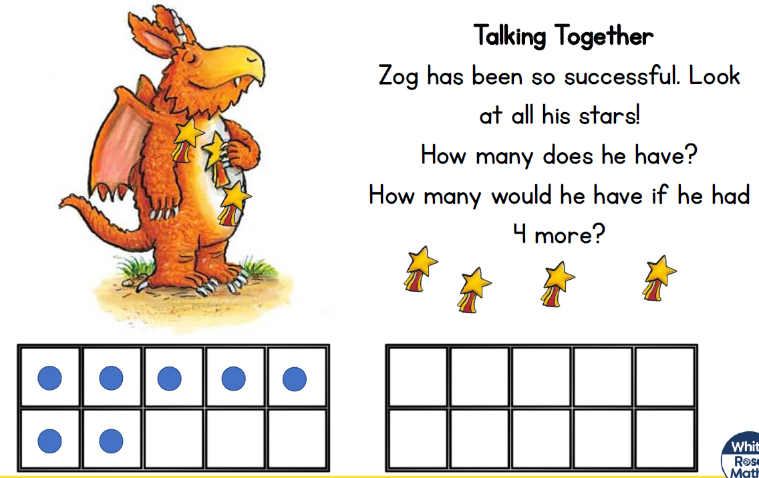
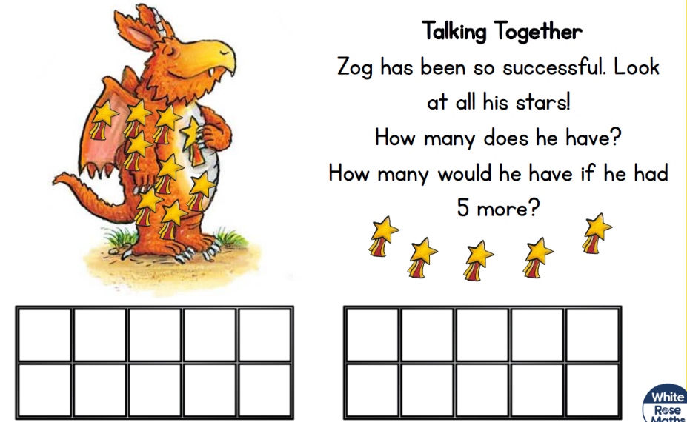
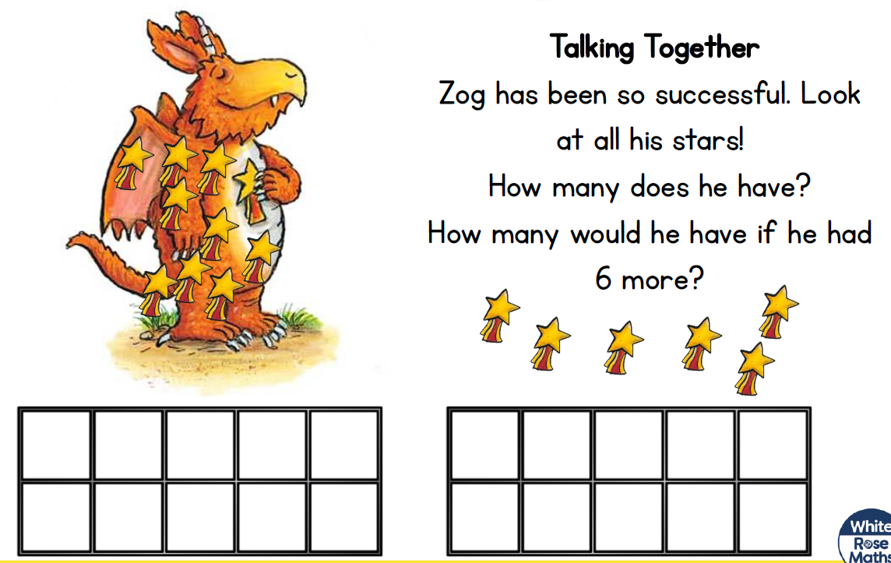

Friday maths
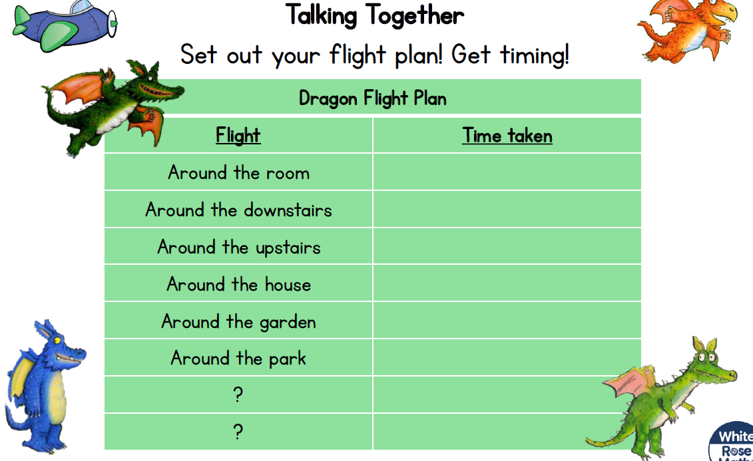

Super Sentences
Can you write a sentence to go with these pictures? Remember to use your super phonics to help sound out those words.


Tuesdays character description

