Dear Juniper and Mulberry

Hope you are all well. It has been good to see some of you when I am out and about doing my shopping. How you have grown!!

The sun was certainly shining last week. I hope you enjoyed the activities linked to sport and you were able to play some of these in your gardens.

This week’s Home Learning is all about ‘Rainforests’. It is a very interesting project. Please remember to post some of your work to our Facebook or Twitter pages for me to see.

Enjoy your week and remember if you need anything at all, please contact the school via email.

Mrs Williams

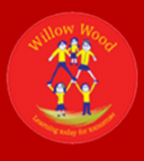
Mulberry and Juniper Summer Term 2 Learning Challenge, Week 5

Learning Project WEEK 5 THE RAINFOREST
Age Range: Year 3
Weekly Maths Tasks (Aim to do 1 per day) | Weekly Reading Tasks (Aim to do 1 per day)
- Ask your child to draw your own fraction wall and then use this to find equivalent fractions. This will support them over the week. https://www.bbc.co.uk/bitesize/clips/z46pvcw  - Get your child some skittles, smarties or different coloured sweets. Empty them out onto a plate and write down what fraction are red, what fraction are yellow, etc. The denominator is the total number of sweets and the numerators are the different colours. You could use coloured buttons, Lego, fruit etc.  - Get a square piece of paper or a post-it note and ask your child to investigate how many ways they can make ¼, ½ , ⅓ etc.  - Ask your child to practise adding and subtracting fractions on this game. Then play this rainforest coordinates game (theme).  http://www.scootle.edu.au/ec/viewing/L350/index.html#  - Encourage your child to research and compare temperatures and rainfall in the Amazon Rainforest and the UK month on month. Can they display their findings in a bar chart or table? Can they compare the yearly totals? | - Can your child create a rainforest canopy to curl up with a book under? This could be made from paper, bed sheets or anything else that’s suitable.  - Read online together about rainforests. Ask your child to take a look at these facts about rainforests to get started! Can they create a rainforest quiz?  - Ask your child to find a recipe involving chocolate and encourage them to make it. They can learn about where chocolate derives here.  - Ask your child to read food labels and identify any foods in the kitchen that contain: bananas, cocoa, chocolate, cinnamon or black pepper.  - Visit Authorfy.com and register for free. Your child can listen to Katherine Rundell’s masterclass on her book The Explorer, based in the Amazon rainforest.
Weekly Spelling Tasks (Aim to do 1 per day) | Weekly Writing Tasks (Aim to do 1 per day)
- Ask your child to mind map words associated with the rainforest. They can then put these words into alphabetical order.  - Practise spelling these words: young, touch, double, trouble, country. Can your child identify the spelling rule? The ‘u’ sound spelt ‘ou’.  - Your child could be a Crystal Explorer and improve their spelling. Can they list synonyms (words with the same meanings) for practised words? https://www.bbc.co.uk/bitesize/topics/zkbkf4j/articles/zbm8scw  - Choose 5 Common Exception words and draw a picture to represent each word, write the word underneath and use it in a sentence. http://www.crosslee.manchester.sch.uk/serve_file/253974  - Choose 10 new topic words related to the rainforest and learn to spell them. Write the definitions to form a rainforest glossary. | - Visit the Literacy Shed for this wonderful resource on The Alchemist’s Letter or write an acrostic poem using the letters: R A I N F O R E S T. https://www.literacyshedplus.com/en-gb/resource/the-alchemist-s-letter-ks2-activity-pack  - Ask your child to research how humans are destroying the rainforest. Get them to write an information report about this. Can they include maps that demonstrate how large the rainforests were compared to now? Include an introduction, 3 or 4 ways that rainforests are being destroyed and a conclusion. https://kids.mongabay.com/elementary/501.html  - Your child can look at images of the rainforest then write a setting description.  - Task your child with writing a ‘Defeating the Monster’ tale. The monster could be a rainforest predator such as a crocodile or boa constrictor.  - Your child could create their own tourist leaflet about rainforests. What could a tourist expect to see and do? How should they dress and what should they bring? Ask them to include illustrations of unusual living things!
Learning Project - to be done throughout the week
The project this week aims to provide opportunities for your child to learn more about the world’s rainforests. Learning may focus on the plants, animals and insects that inhabit the rainforest, food that originates there and weather patterns. It could look at plants and animals that can be found in the garden too.

- Amazing Animals- Ask your child to think about the following: How many different types of animals live in rainforests? Can they name any? What is their diet like? How do they hunt for their prey or hide from predators? Look at these 11 amazing rainforest animals. Encourage your child to choose one of the animals and create a poster all about them. https://www.rainforest-alliance.org/articles/11-amazing-rainforest-animals

- Layers of the Rainforest- Take a look at this information with your child, all about the layers of the rainforest. Ask your child to try creating their own diagram showing the layers of the rainforest and the animals you can find in each layer. Your child could cut and stick pictures, paint or draw! Can your child categorise the animals? https://www.rainforest-alliance.org/sites/default/files/2016-10/rainforest_layers.pdf

- Roar!- Have a go at this forest themed GoNoodle! Finished? Ask your child to try making up their own rainforest-themed dance routine to the same song - they could pretend to be a different animal for each dance move! Recommendation at least 2 hours of exercise a week

- One Step at a Time- Talk to family members about the deforestation of rainforests and think about how we could help by taking small steps at home. This article should help get them started! Can your child record their very own advert encouraging people to reduce, reuse, recycle? Encourage them to think about the impact on the environment, animals and their habitats, global warming and the tribes that occupy the rainforests. Alternatively, they could write a jingle about the benefits of recycling and perform this to the family. https://www.rainforest-alliance.org/articles/10-ways-kids-can-save-the-rainforest

- The Problem with Palm Oil- Take a look at the Greenpeace website and find out about the effects of palm oil on our planet. Discuss with your child how this affects animals around the world. Ask your child to identify all of the foods in the kitchen that contain palm oil. Can they suggest alternatives for your next shop? Task your child with planning an imaginary charity event to raise funds for The Orangutan Foundation. https://www.greenpeace.org.uk/challenges/palm-oil/

https://www.orangutan.org.uk/



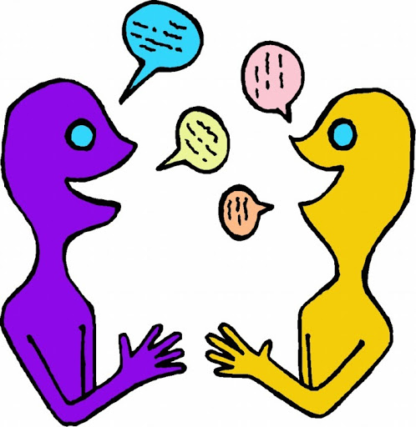

Additional learning resources parents may wish to engage with
Classroom Secrets Learning Packs - These packs are split into different year groups and include activities linked to reading, writing, maths and practical ideas you can do around the home.
Twinkl - to access these resources click on the link and sign up using your own email address and creating your own password. Use the offer code UKTWINKLHELPS.

#Teamwillowwood

