Reception Home Learning Suggestions Week Beginning 15th June 2020
 | Reading and stories | Phonics, reading and writing | Maths skills | Other
Monday | Watch ‘The princess and the Wizard’  https://www.youtube.com/watch?v=x8wPFHlua_A  Listen to your child read for 10 mins. Oxford owl or a book from home  https://home.oxfordowl.co.uk/ | Watch Phonics session 11  https://www.youtube.com/watch?v=iemIhNNSybw  Super sentence – can you write a sentence about this picture? 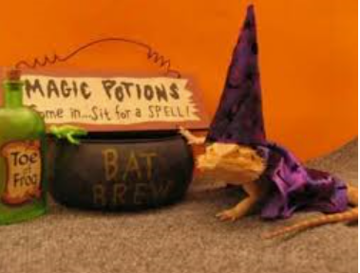 | 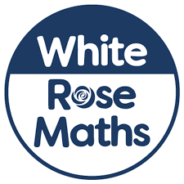  https://wrm-13b48.kxcdn.com/wp-content/uploads/2020/06/Day-1-The-Princess-and-the-Wizard.pdf  Days of the week! The wizard has a challenge for the princess every day! Can you order a very special pattern – your week!  Which day is missing in the pattern? (See resources) | Why not design your own outfit to go to the party in? What kind of party would it be? Or just design some super socks. I wonder what socks a princess or a wizard would wear?
Tuesday | Go on teach your monster read website  https://www.teachyourmonstertoread.com  Watch ‘Yucky worms’  https://www.youtube.com/watch?v=MV3A864z9W0 | Watch Phonics session 12  https://www.youtube.com/watch?v=9eIe4BHR4_s  Some of the challenges the wizard sets seem impossible! Make a list of your seven challenges and tick off as you complete them day by day! This could be a rainbow challenge! Each day could be a colour like the princess! Could some of the challenges help your grown ups? Could it be a way to be kind every day? | https://wrm-13b48.kxcdn.com/wp-content/uploads/2020/06/Day-2-The-Princess-and-the-Wizard.pdf  Wizard counting! The wizard loves counting when he waits for the princess to hide looking in his spell book! Make your own special wizard counting book! What different compositions of numbers will you make?  Make your special magic counting book by folding some paper to make a book shape or folding back to back to make a flip flap book. Will it have a special cover? On the top of each page write your numbers in order or take photos of numbers you see and stick them in! Draw or stick in photographs of objects you have collected for the number of that page. What will you collect? Talk about the different combinations you have put together to make that number. | Put on some music and have a dance! Get someone else in your house to stop the music when you are not looking. Freeze still like a stone statue! Can you do it ? How long can you freeze for? Who is the best statue in your house?
Wednesday | Listen to your child read for 10 mins. Oxford owl or a book from home  https://home.oxfordowl.co.uk/ | Watch Phonics session 13  https://www.youtube.com/watch?v=BOdSE-ATXI8  Can you write a spell Mr Wizard?  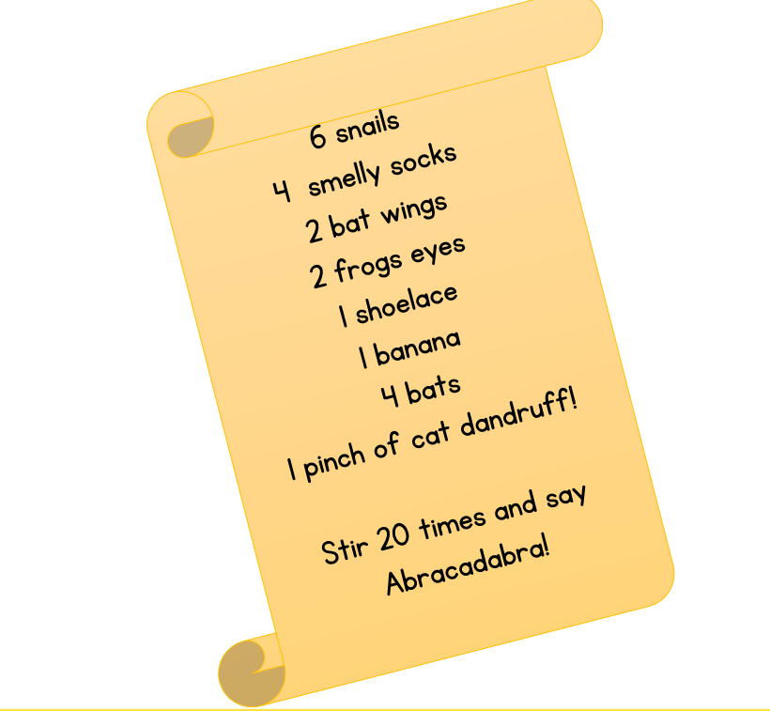Happy wizarding! | https://wrm-13b48.kxcdn.com/wp-content/uploads/2020/06/Day-3-The-Princess-and-the-Wizard.pdf  Pick someone to play with! One person decides to be the wizard and counts down from 20 (Or up!) The other person finds somewhere to hide. The wizard tries to find the hidden person. When you find them make sure you give them your most wicked, wizard laugh! See if you can find each other. Who is the best wizard? | Can you make a garden potion?  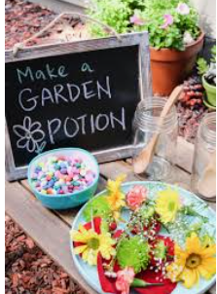
Thursday | Watch ‘spells’  https://www.youtube.com/watch?v=sWm4E6eBzw0 | Watch Phonics session 14  https://www.youtube.com/watch?v=dVau1GoS8wQ | https://wrm-13b48.kxcdn.com/wp-content/uploads/2020/06/Day-4-The-Princess-and-the-Wizard.pdf  Bad spells! The wizard has been doubling everything so there's far too much food at the princesses party! Can you help to halve what is on the plates so we are not too greedy | 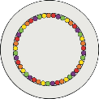  Fruity Sweets Colour Mixing  You will need: Fruity, rainbow-coloured sweets Still, warm water  Plate    Instructions  1. First, place the coloured sweets around the edge of the plate in a circle shape.  2.Then, get some warm, still water in a jug. Ask an adult for help.  3.Next, pour the warm water into the middle of the circle until it reaches the sweets.  4.Watch what happens.  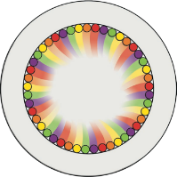  The Science Bit  The shells of coloured sweets are made from sugar. When sugar is put in warm water, it dissolves. As the colours meet, they mix, creating different colours.
Friday | Go on teach your monster read website  https://www.teachyourmonstertoread.com | Practise Phase 3 tricky words https://youtu.be/R087lYrRpgY  Super sentence  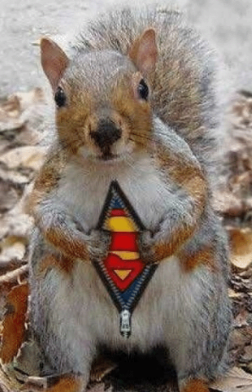 | https://wrm-13b48.kxcdn.com/wp-content/uploads/2020/06/Day-5-The-Princess-and-the-Wizard.pdf  The princesses crown has lost some of it’s jewels! It has to match the same on both sides! Can you help her create her beautiful crowns again by matching the shapes and putting them at the right distance? They need to be symmetrical! (see resources) | 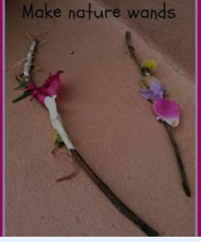
Please remember that these activities are suggestions only. Do not feel under pressure to complete all of these – you could pick and choose, repeat your favourites and definitely introduce your own! Whatever you get up to, please send us your photos, videos and messages via email. Naomi.coates@willowwood.cheshire.sch.uk.
Please keep yourselves happy and safe!

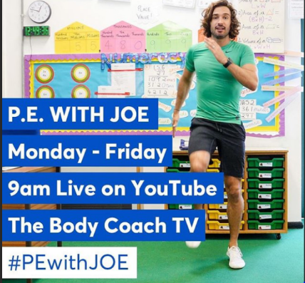
Keeping fit is really important for our health but it also makes us feel great. We know how much you love our daily wake and shake in Reception so why don’t you try P.E with Joe Wicks live on YouTube to start off your day!

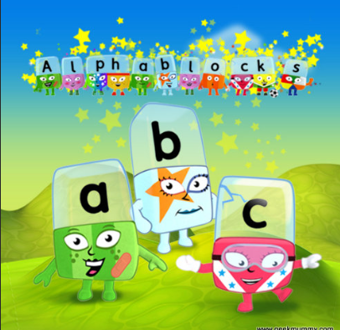
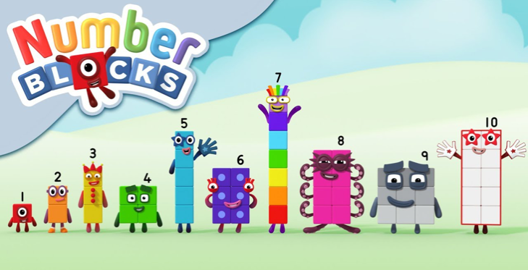
Remember these? Why not watch a few episodes to help with your numbers and phonics? Both programmes can be found on bbc iplayer.

Monday maths – Missing days of the week
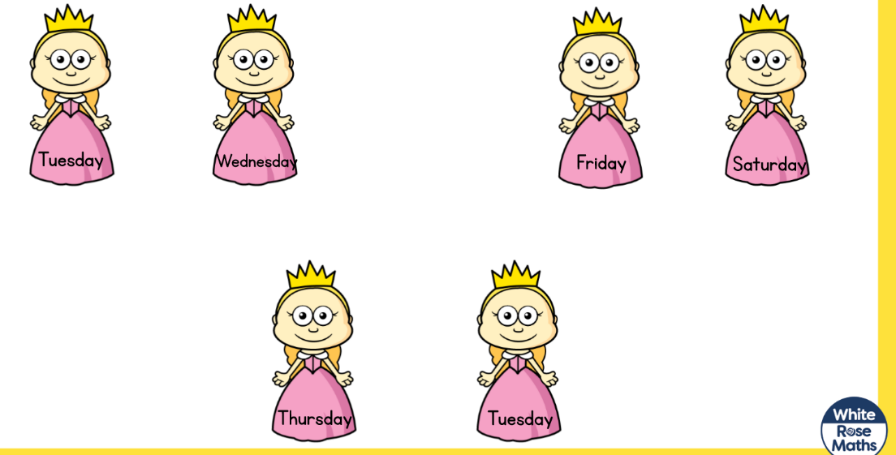
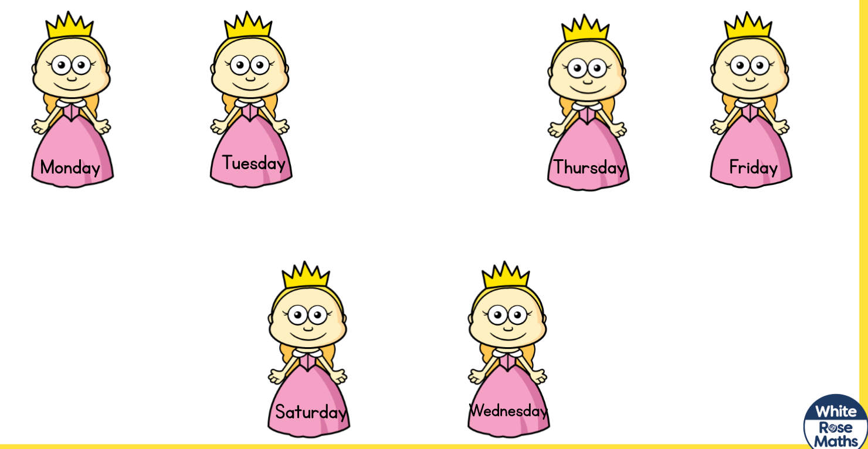

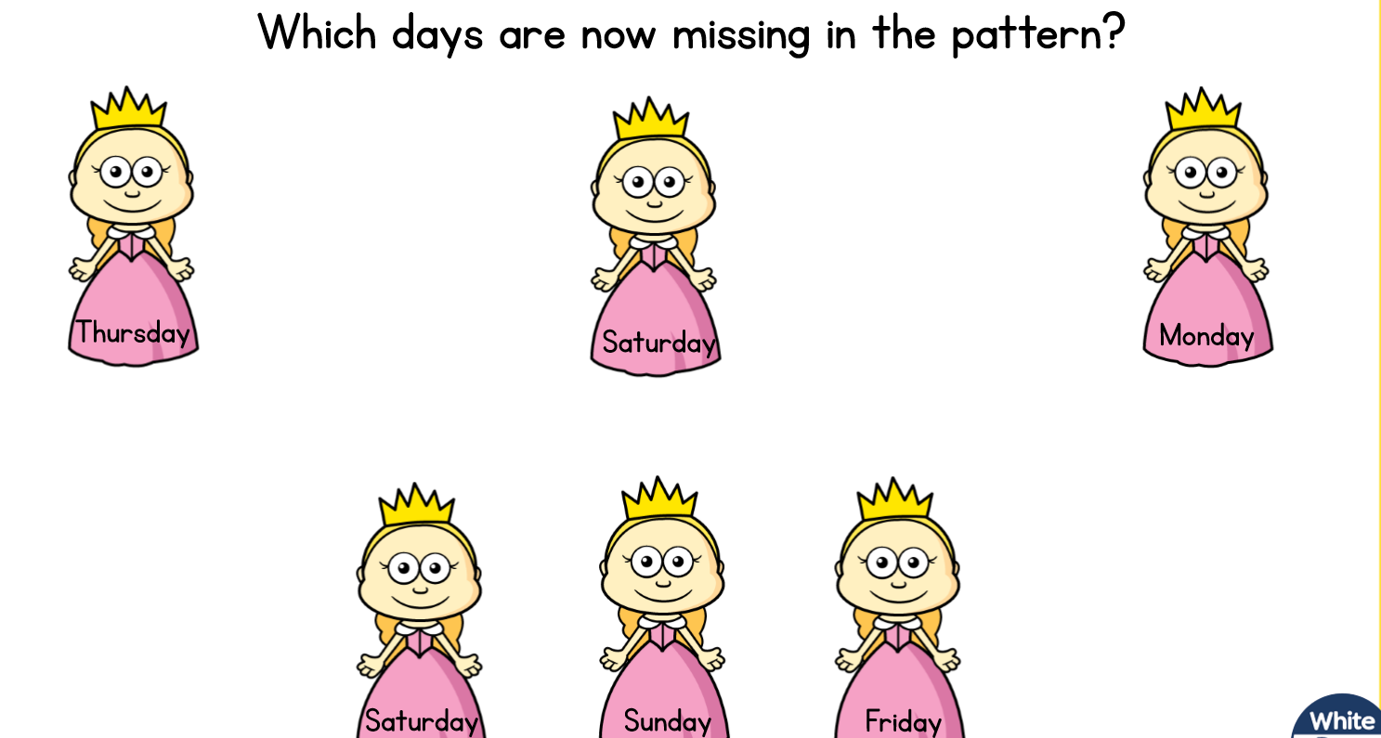

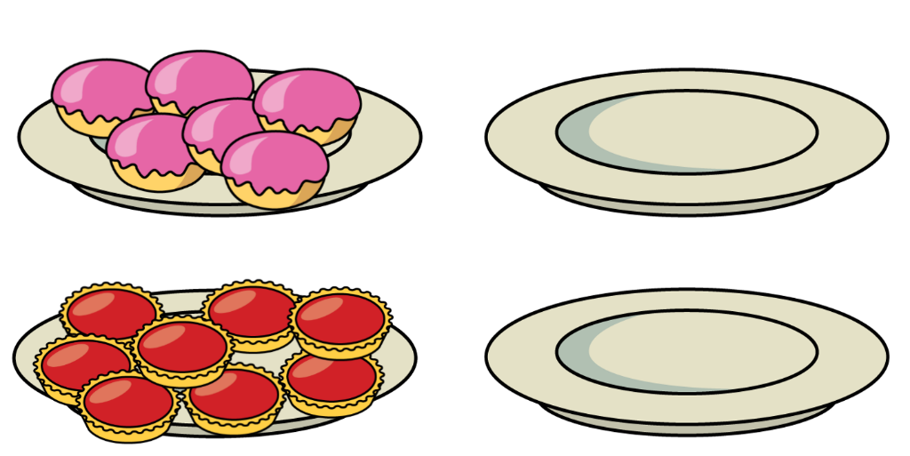
Thursday maths – doubling
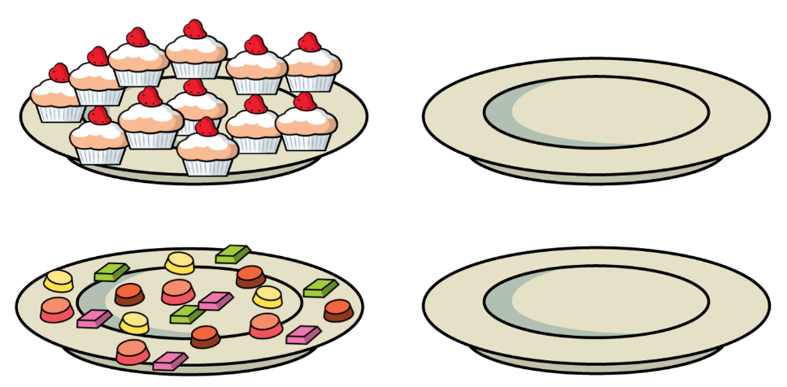

Home Learning 8th June

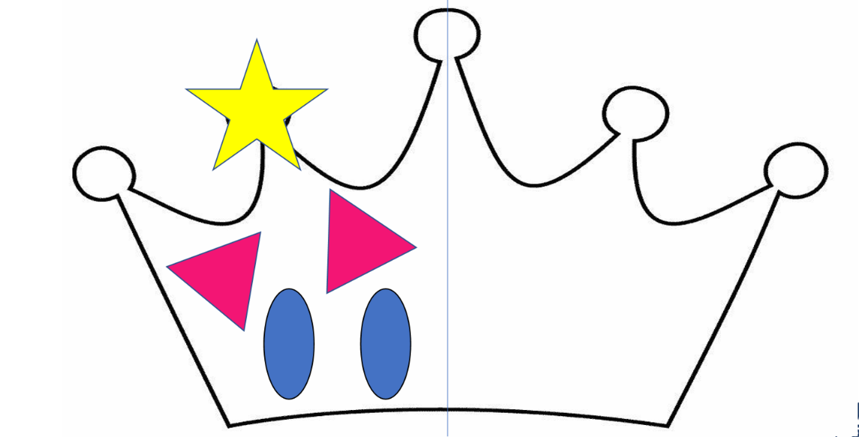
Maths Friday – symmetry
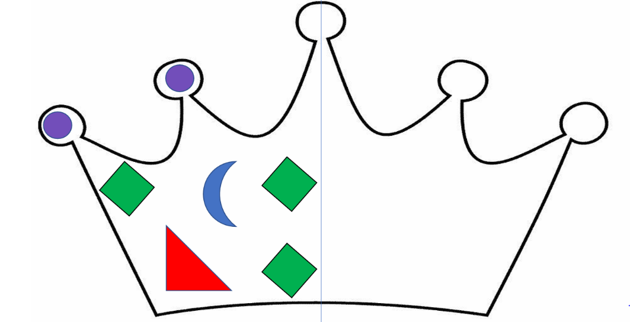

Super Sentences
Can you write a sentence to go with these pictures? Remember to use your super phonics to help sound out those words.

