Morning Nursery Session: 9am-12
Drop your child at the door as usual.
Pick up your child from 11.45am - use the front entrance of school.

Afternoon Nursery Session: 12-3pm
Drop your child at 12 o’clock - use the front entrance of school.

Collect your child from the door located on the keystage 1 playground-accessed via the small Crook Lane gate.

For 12 o’clock collection and drop offs
use the front entrance as normal

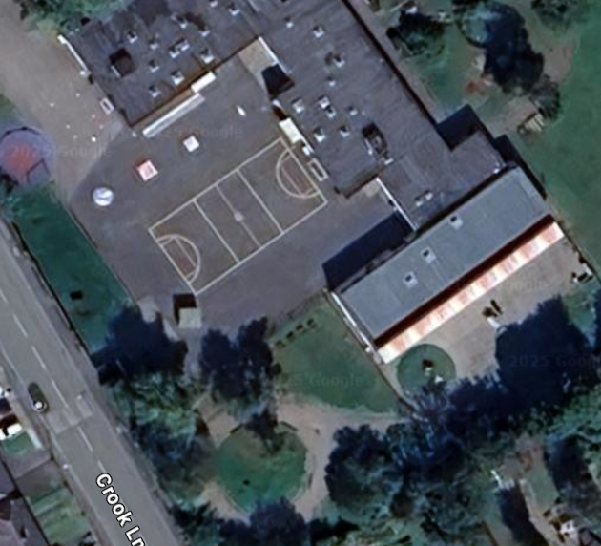
For 9am drop off
Use the normal Nursery door and gates

For 3pm collection
Crook Lane (small gate) and Key stage 1 playground
Nursery door

