Below are the first two pages of the next book we will start in literacy this week, Stone Age Boy.

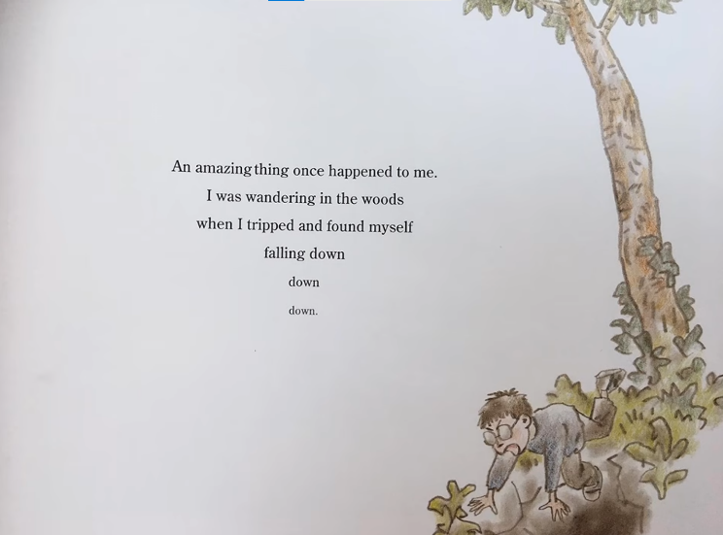
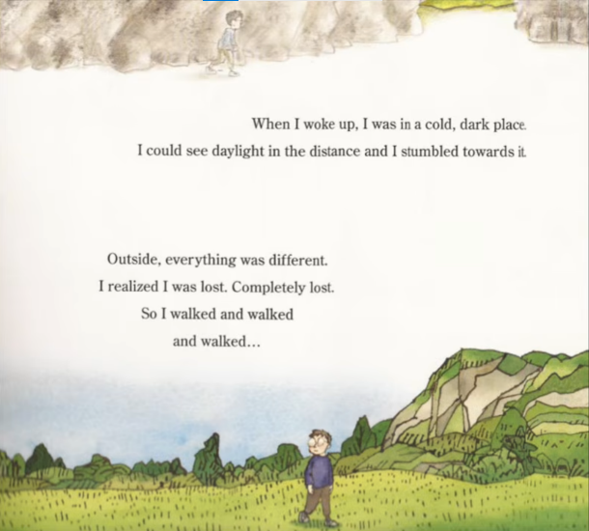
- What do you think will happen next?
- What might the boy see, hear or smell?
- How might the boy feel? Why?
You do not have to write down you answers. You could even draw some answers! Just be ready to discuss your answers in class tomorrow.

