Dean Valley Community Primary School

Articles – Rights of the Child

Article 12 – Respect for the views of every child.
Children will express their views and opinions during lessons and understand how to respect others when they give theirs. Their view will be considered and taken seriously, enabling children to present their ideas in a safe environment.

First-hand experiences which will engage our learners
Forest School/ Outdoor learning
Day visits out via coach
Cooking

Implementation
Children will focus on identifying and naming common plants, describing their basic structures (leaves, roots, stems, flowers), and understanding their basic needs for growth (light, water, soil) through observation and hands-on activities.
Key Learning Objectives:
Identify and Name:
Pupils should be able to identify and name a variety of common wild and garden plants, including deciduous and evergreen trees.

Diversity – Respecting different cultures.
In KS1 the children will learn to, how safe relationships with others. The will understand how to build relationships whilst respecting that people are from different backgrounds and may have differing views and opinions from their own.
They will understand through our study of food that ingredients come from all over the world. They will investigate different cultures and how food can be special for them.

Intent
For children to know;
our intent is to foster a love for the natural world, encouraging children to observe, question, and explore the fascinating world of plants, while developing their scientific skills and vocabulary.
We aim to ignite children's natural curiosity about plants, encouraging them to ask questions and explore the world around them.
We will provide opportunities for children to develop their scientific skills, including observing, comparing, and recording their findings through hands-on activities and investigations.

Summer 1 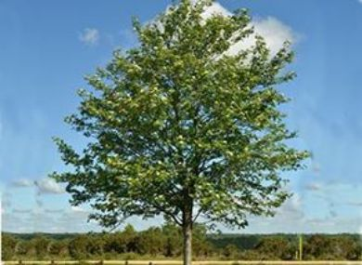 Year 2

CURRICULUM PATH

