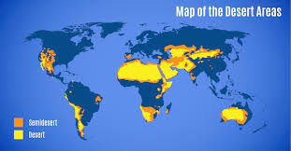
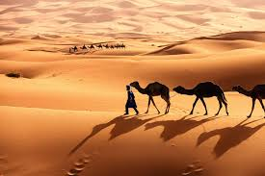
Year 6
Dean Valley Community Primary School
Life in Dry Lands: Adaptation, Environment, and Early Sikh Society

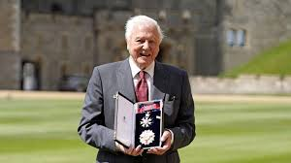
Intent
This curriculum topic aims to develop pupils’ understanding of how environment shapes life, exploring both the natural world and human societies through the lens of dry land environments. Pupils will investigate desert biomes, learning how living things are classified, how they adapt to survive, and how adaptation can lead to evolution over time. Through geographical enquiry, pupils will explore the physical characteristics, global distribution, uses, and threats facing desert environments.
Alongside this, pupils will study the Sikh Empire as an early non-European society, examining how belief systems, leadership, and settlement were influenced by environment and historical context. Pupils will develop historical skills such as chronology, interpretation, and evaluating significance while making connections between human adaptation, cultural values, and environmental challenges.
Across the topic, pupils will strengthen key disciplinary skills in science, geography, and history, including enquiry, comparison, analysis, and evaluation. The topic supports pupils in understanding resilience, sustainability, and respect for diversity, enabling them to make meaningful links between the natural environment, past societies, and the modern world.
We will also celebrate Sir David Attenbrough’s
by writing a biography and using stimulus
form his documentaries.
Diversity: Diversity drives the topic by exploring varied species, human adaptations, cultures, and perspectives, fostering empathy, inclusion, and global awareness.
Literacy – Writing: Intent
The literacy component of this topic aims to develop pupils’ ability to write persuasive, informative, and creative texts linked to learning about desert environments. Pupils will apply knowledge of habitats, adaptation, and survival to support reasoning, explanation, and description. Through varied writing opportunities, pupils will develop skills in planning, drafting, editing, and evaluating writing, while using ambitious vocabulary, appropriate grammatical features, and clear organisation. The unit supports pupils in writing for different audiences and purposes, strengthening both factual accuracy and creative expression.

Literacy – Writing: Implementation
Writing is taught through a modelled and scaffolded approach, closely linked to topic learning. Pupils write a persuasive piece exploring whether people should live in the desert, using debate and shared writing to develop arguments. Non-chronological reports are produced through research on desert animals, habitats, and adaptations. Creative writing tasks include a desert survival story, personification of the desert, and a mystery based on mirages. Vocabulary development, sentence modelling, and opportunities for editing and feedback are embedded throughout to support progression.

Implementation
The curriculum topic Dry Lands: Adaptation, Environment, and Early Sikh Society is implemented through a carefully sequenced, enquiry-led approach that integrates science, geography, and history. Learning begins with scientific exploration of desert biomes, where pupils investigate classification, adaptation, and evolution, using practical activities, diagrams, and comparative studies to secure key concepts. Geographical knowledge is developed through map work, fieldwork-style enquiries, and case studies that explore the location, physical features, human use, and threats to desert environments. Historical learning is taught chronologically, using timelines, maps, and a range of sources to explore the origins, beliefs, and significance of the Sikh Empire, with pupils analysing interpretations and evaluating historical significance. Vocabulary is explicitly taught and revisited across subjects, and prior knowledge is regularly activated to support progression. Opportunities for discussion, reasoning, and comparison are embedded throughout, enabling pupils to make meaningful connections between environment, adaptation, and human society while developing subject-specific skills and critical thinking.

