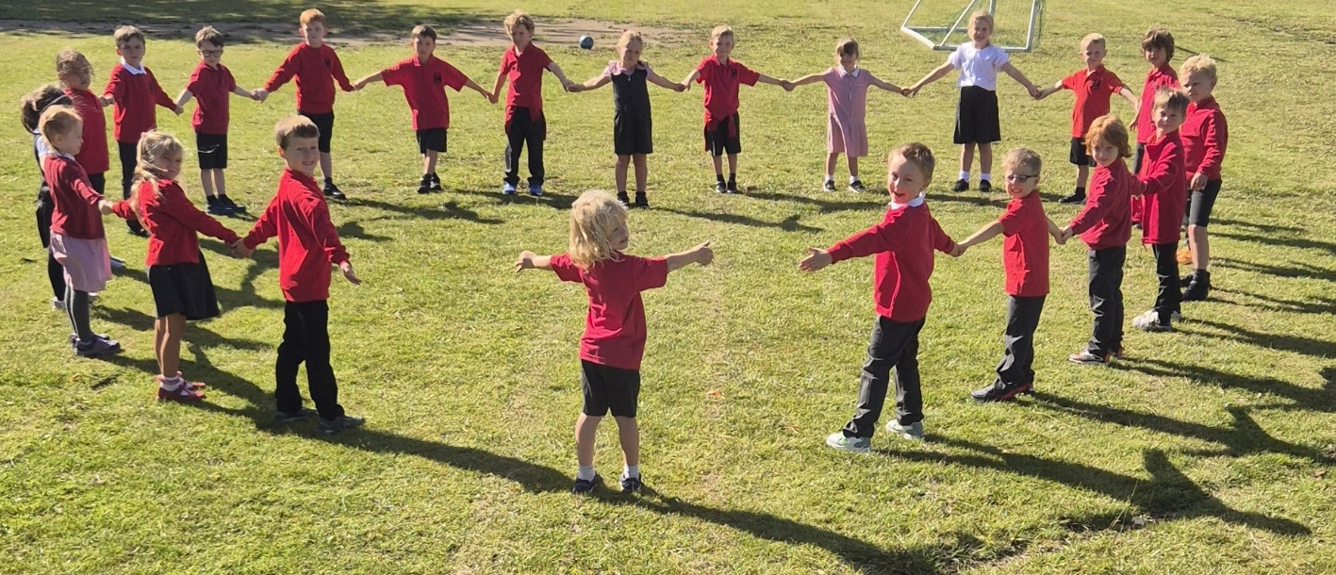

Welcome to the Autumn Term and Year 1!

The children have settled in fantastically to Year 1 already – they have all been absolutely amazing!

We’re really looking forward to a great year together!

Our Year 1 Team consists of me, Mrs Fisher (Class Teacher). Mrs Cox (Teaching Assistant - Monday, Tuesday, Wednesday) and Mrs Prout (Teaching Assistant - Thursday, Friday).

Your child will need a pair of indoor school shoes that will be kept in school.  Your child will change into these when entering school in the morning and after each outdoor session, i.e. daily mile and playtimes.  On any particular day your child will only need **one pair of outdoor shoes** that they change from.  If it is a reasonably dry day your child’s outdoor footwear could be trainers or boots.  If it is a snowy/wet day your child’s outdoor footwear could be wellies.  Please just have the outdoor footwear suitable for the weather that day.  We do not need to have wellies kept in school all the time because we can’t house so many different items of footwear for each child.

Indoor PE activities will take place on a Tuesday.  Please can your child have a pump bag with the contents of black shorts, white/red t-shirt and black pumps.  This pump bag is to be kept in school.  It will be sent home after each half term for a refresh!

Outdoor PE activities will take place on a Thursday.  An outdoor kit will be needed on a Thursday.  Each Thursday your child will need to bring a bag with the contents of black tracksuit bottoms, white/red t-shirt, black or red jumper,  pair of trainers.  Your child will bring this bag home on the same day, ready to be brought in the following Thursday.

On a number of Friday afternoons, we have the wonderful opportunity of Forest School.  We will spend the full afternoon outside completing Forest School activities.  We will aim to go out in all weather (unless torrential rain).  Your child will need to bring a bag with the contents of waterproof trousers/waterproof all in one suit, waterproof warm coat and wellies. Your child will bring this bag home on the same day. The dates for Forest School are on the School Spider Calendar.  We will be working on a three-week rota.

Week 1 WB 05.09.25 – Year 2

Week 2 WB 12.09.25 – Year 1

Week 3 WB 19.09.25 – Reception

Week 4 WB 26.09.25 – Year 2

Week 5 WB 03.10.25 – Year 1

Week 6 WB 10.10.25 – Reception

Week 7 WB 17.10.25 – Year 2

Week 8 WB 24.10.25 – Year 1

Over the next couple of weeks, the children will bring home a reading packet containing their reading book and reading diary.  Please ensure that your child has their reading packet in school on a THURSDAY so that your child’s book can be changed.  Please read regularly at home and record in the diary when you have listened to your child read.  Your child’s book will not be changed if a comment has not been recorded in their diary.

I would please ask that children do not bring toys into the classroom and that they remain at home to prevent them getting lost.

Just a reminder that children are not to play on the outdoor play equipment before or after school.

We aim to maintain a smooth transition from Reception to Year 1.  Please be sure to let me know if you have any queries.

If you are unable to catch me at the door during drop-off or pick-up, please contact me via [class1@deanvalley.cheshire.sch.uk](mailto:class1@deanvalley.cheshire.sch.uk)  and I will respond as soon as possible.

I look forward to teaching your children and working with you as supportive parents – here’s to a great year!

Kind regards,

Mrs A Fisher