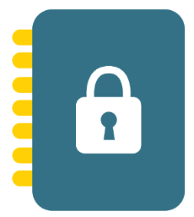

General Data Protection Regulation

Privacy Notice for our Pupils

What’s this about?
A new law is being made that keeps your information safe – things like your address, date of birth and phone number. The school and other people collect and use information for all kinds of reasons, and the new law tells them exactly what they are allowed to do with yours.
We collect some information about our pupils, like you. It’s our job to tell you how we will collect the information, how we will record it and how we will use it.
In this notice, you will see different names or terms used that you may not be familiar with, such as:
Data controller: This person (or group of people, like a school) is in charge of the information we collect.
Data processor: This person processes information for the data controller.
Data protection officer (DPO): This person makes sure we do everything the law says. The school’s DPO is a member of a company called Safeguarding Monitor Limited.
Personal data: This means any information that can be used to identify someone, such as your address and date of birth.


Who looks after your information?
The school is the data controller of the personal information you give us – we look at how and why your information is collected and used.
Sometimes the school has to give your information to other people, such as the government, but it will only give away your information when you say it’s ok or when the law says that they have to. When your data is given to someone else, they must look after it and keep it safe.

Why do we collect and use your information?
We will only collect your information when we need it to help us do our job or to follow the law. When we’ve collected it, here’s how we use it:

- To support your learning
- To monitor and report on your progress
- To provide appropriate support
- To assess the quality of our service
- To comply with the law regarding data sharing

What information do we collect?
The categories of information that the school collects, holds and shares include the following:
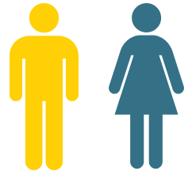
Your personal information
This is things like your name and address.

Your characteristics
This means information about you, like where you’re from, what language you speak and things like that.

Your attendance information
We will also record how many times you missed school and why you couldn’t come to school.

Your assessment information
We collect your test results when you sit a big test or exam.

Some of your medical information
We keep information about any times you’ve been ill and any special conditions you have that we need to know about to keep you safe.

Your special educational needs
We collect information that helps us teach you better, such as any special educational needs you may have.

Behavioural information
We record the number of times you’ve been excluded and why.

Do you have to give us your information?
You must give us quite a lot of the information we need, but there is some information that you can choose whether to let us have it or not.
When we ask you for information that you don’t have to give us, we will ask for your permission and let you know why we want it and what we will do with it. If you don’t want us to have the information, that’s your choice.
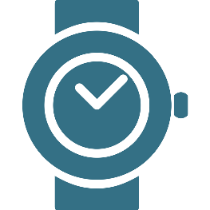
How long will we keep your information?
We don’t keep it forever, only for as long as we need it to help us do the thing we needed it for. We have a policy that tells us when to keep it and when to bin it.

Will your information be shared?

We won’t share your information with anyone else without your permission, unless the law says we can or should. We may share information with:

- Local Authorities and other educational establishments e.g. a High School or another primary school you are moving to
- The National Health Service e.g. the Doctors or Hospital
- Family Support Services such as the local Children’s Centre and Children’s/Adult’s Social Care
- The Police
The information that we share with them includes:

- Your personal details, e.g. name, age/date of birth or address
- Your school details and academic assessments, i.e. how are you getting on with your education
- Whether you have any additional needs that should be known about

Sometimes we have to share your information. We normally have to share it with the people in charge of all schools, the Department for Education (DfE). They may ask us to share things like:

- Pupils on roll at the school
- Attendance figures
- Performance data
They store some of their information in the National Pupil Database, and then share some of it with people looking to help schools and pupils like you. But don’t worry, the database is very safe and your information won’t get lost or given to anyone who shouldn’t have it.

Your parents can ask us to only share your name, address and date of birth, and nothing else, by sending an email to admin@highfield-blacon.cheshire.sch.uk. When you’re 16, it’s up to you to decide what information you want to share.

You can find out more online: https://www.cheshirewestandchester.gov.uk/your-council/data-protection-and-freedom-of/data-protection-and-freedom-of.aspx.

What are your rights?
You and your parents have the right to:

- Be told how we use your information.
- Ask to see the information we hold.
- Ask us to change information you think is wrong.
- Ask us to remove information when it’s not needed anymore.
- Ask us to only use your information in certain ways.
- Tell us you don’t want your information to be processed.
If the information we are collecting is information that you can choose not to give, you can tell us to stop collecting it at any time.

If you’re worried about how we get and use your information, you can speak to Ms Dowling, Headteacher at the school, who will be able to help you and answer any questions that you have. If you want to speak to somebody not at the school, you can call the people who look after information, called the Information Commissioner’s Office (ICO), on 0303 123 1113 or using their live chat.

Would you like to know more?
If you or your parents would like to find out more information about how we and/or the DfE collect, use and store your personal information, please visit our website www.highfield-blacon.cheshire.sch.uk

Four important things to understand
Now you’ve read this, we hope you understand that:

- The law allows us to get and use your information to help us do our job.
- We may share your information with others, but only when we really need to.
- We will ask for your permission to share your information whenever you have a choice.
- You can tell us not to share your information, even when you have said yes before.
If you have any questions, Ms Dowling, the Headteacher, will be happy to help you.

