Year 1 Home learning menu- week 3
See daily videos on our Google Classroom to support this plan
The Snail and the Whale  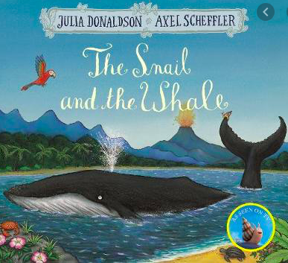 | Listen to Monday’s video for the introduction to The Snail and The Whale.  Do you think the Snail should go with the Whale? Write a sentence giving your opinion on if you think the snail should or shouldn’t go with the Whale. Make sure you explain your opinion by using the word ‘because’ in your sentence! | Can you make actions to the Snail and The Whale?  Read the shortened version of The Snail and The Whale below. Can you use our talk for writing signs to give actions to the shortened story?  Tell someone in your house the story using the actions you have made.  Can you write a sentence saying if you did or did not like the story and use ‘because’ to explain why? | Listen to Wednesday’s video for the rest of The Snail and The Whale story.  Whilst you’re listening to the story have your pen and paper at the ready. As you’re listening to the story you need to write down or quickly sketch, every place the snail visits!  Using the pictures and instructions on the video can you make your own story telling wheel? | EXTRA! EXTRA! Beached Whale!  Using the Template below can you write your own newspaper report for the beached-up whale?  You will need to include:  What happened to the whale?  How did the people find out the whale was on the beach?  Who went to the beach to help?  Did they manage to save the whale? | Watch The Snail and The Whale!  https://www.bbc.co.uk/iplayer/episode/m000cslw/the-snail-and-the-whale
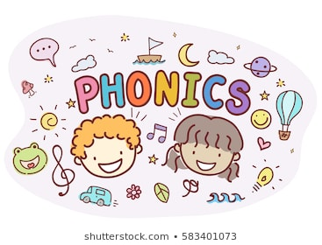 | Read and write words containing the alternative pronunciations of the a grapheme:  hat, splash, band, laptop, grand, bacon, apron, angel, apricot, bagel, fast, bath, grass, after, path, was, what, squad, want, wander | Read and write words containing the alternative pronunciations of the y grapheme:  yes, yell, yawn, yellow, yet, by, why, dry, reply, sky, gym, crystal, pyramid, myth, happy, funny, hairy, smelly, crunchy. | Read and write tricky words:  many, laughed, because, different, any, eyes, friends, once, please | Read and write words containing the alternative pronunciations of the ch grapheme:  church, chick, crunch, pinch, chirping, school, chemist, chord, chorus, technical, chef, chalet, brochure, machine. | Read and write words containing the alternative pronunciations of the ou grapheme:  loud, proud, sound, round, mountain, you, soup, group, could, would, should, mould, shoulder, boulder.
RE  Families and celebrations |   Have the opportunity to reflect on what it means to be a member of a family. Think about what it means to be a member of the school family.  How do members of a family show they love one another? When do we celebrate in the family?  Look at pictures of different types of families.  Tell the chn “Today we are going to think about what it means to be a family.”  What do the chn think it means to be a family. Accept all answers.  What is your favourite time with your family? Ask chn to think, pair, share ideas for what they do with their families.  Chn draw a picture of their families and write what they do with their families.
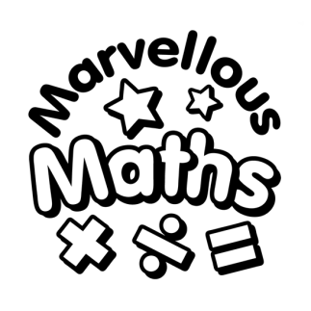 | Make a number line.  Make your own number line 1-20! Watch Monday’s PowerPoint to count to 20 together and get some inspiration for your number line. Your number line can be as creative or as simple as you like.  Send us a picture on google classroom! | Workout additions on your number line.  .  Can you use your number line to help you with addition by counting on? Watch the PowerPoint for some examples.  Complete the questions at the end and send us a picture on google classroom! | Make all the numbers 10-20 with 10s and ones.  Make all the numbers from 10-20 using tens and ones.  Watch the PowerPoint for examples and complete the worksheet below.  Make sure you put the tens before the ones e.g. 1 ten and 9 ones = 19. | Write the calculations of the number bonds 11-20  Watch the math song below.  https://www.youtube.com/watch?v=MmLMU8BqyKw  Watch the PowerPoint and complete the activity. | Try this online Math game using calculations to 20.  https://uk.splashlearn.com/place-value-games?adCampaign=11001994758&adGroup=107605592523&adID=460799936546&adTag=online%20maths%20games&gclid=EAIaIQobChMI3MvJzbCX7gIVGoBQBh3VNQePEAAYAiAAEgKR-vD_BwE&ipad_blocker_disabled=1
See the “Where in the World?” challenge power point for more fun activities.

